FMUSER FUQ-41019J Digital Decoder 8x IP + 1x ASI Input to 8x CVBS Output MPEG-2-H.264-AVS+ Video MPEG1 Layer 2-AC3 Audio Decoding LCD-Webserver Control Broadcast Signal Distribution
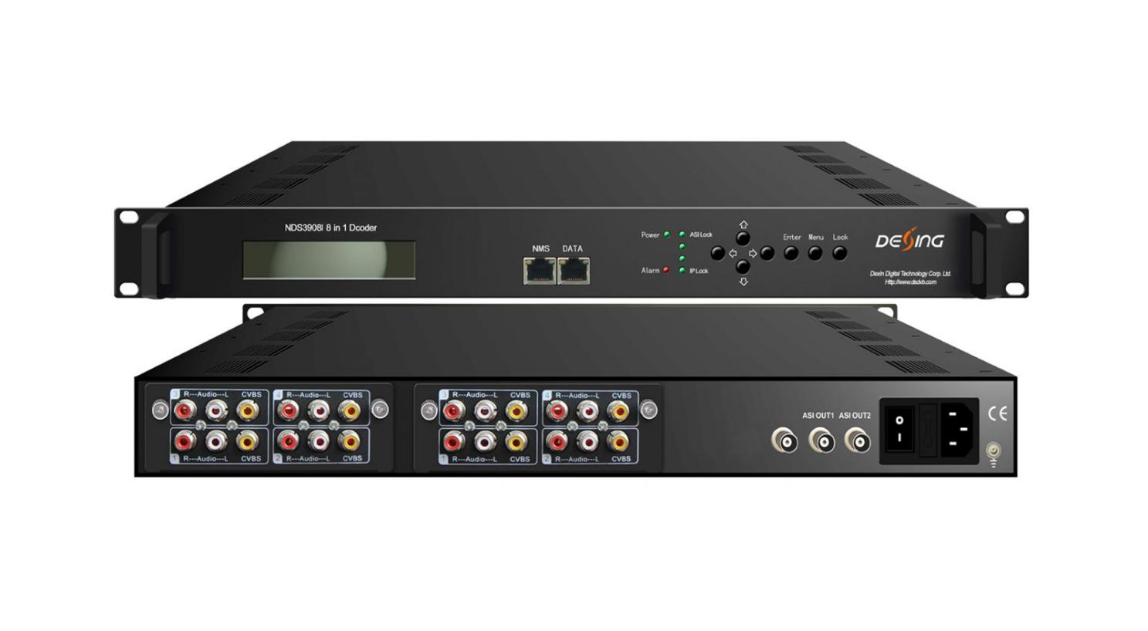8*IP + ASI input→ 8*CVBS output

Product Overview
The FMUSER FUQ-41019J decodes up to 8 IP or ASI inputs to CVBS outputs. It processes MPEG-2, H.264, AVS+ video and MPEG1 Layer 2, AC3 audio from transport streams. Featuring pluggable modules, LCD display, and web-server remote management, it is ideal for broadcast integration and reliable signal distribution.

Key feature
Supports 8 IP and 1 ASI inputs for versatile TS stream reception.
Delivers 8 channels of CVBS video and unbalanced stereo audio outputs.
Decodes MPEG-2, H.264, AVS+ video and MPEG1 Layer 2, AC3 audio.
Features real-time bit rate monitoring for optimized performance.
Managed via LCD display and web-server interface.
Principle Chart
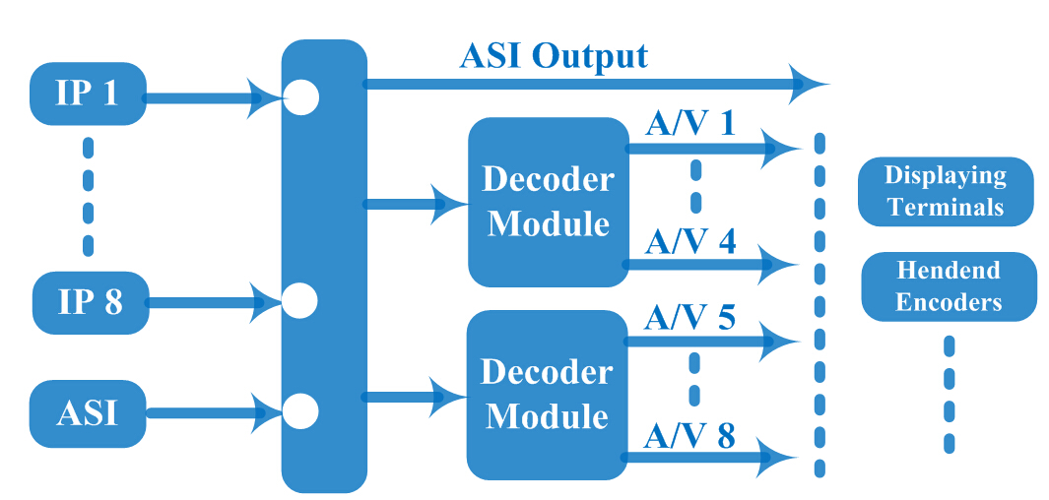

Specification
Input | 8*IP (MPTS/SPTS) (100Mbps Ethernet) (RJ45)
Input | IP Protocol |  | UDP and RTP (Unicast/multicast)
Input | 1* ASI (BNC)
Decode | Video Format |  | MPEG-2/H.264/AVS+
Decode | Interface |  | 8* CVBS（RCA）
Decode | Video Resolution |  | 576i@25fps, 480i@29.97fps
Decode | Audio Format |  | MPEG-1 Layer 2, AC3 (2.0)
Decode | Interface |  | 8*Unbalanced stereo (RCA)
General |  | Operation | LCD display/Control button; Web-server
 |  | Language | Chinese/English
 |  | Dimension (LxWxH) | 44 mm×482 mm×410mm
 |  | Environment | 0~45℃(Work)；-20~80℃(Storage)
 |  | Power Supply | 220VAC±10%，50Hz
 |  | Consumption | <25W

About Us
FMUSER is a company specializing in broadcasting and television transmission systems and integrating hotel IPTV systems. The company was established in 2009 and has served over 180 countries worldwide. More than 20,000 television stations, radio stations, and hotel clients from different.

Contact:Tomleequan Email：sales@fmuser.com whatsapp: +8613922702227

