FMUSER FUQ-41086D HD IRD 8 Tuner Inputs DVB-S-S2-S2X DVB-S2-S2X Outputs UDP-RTP Dual Mode BISS Decryption Diseqc Broadcast IPTV
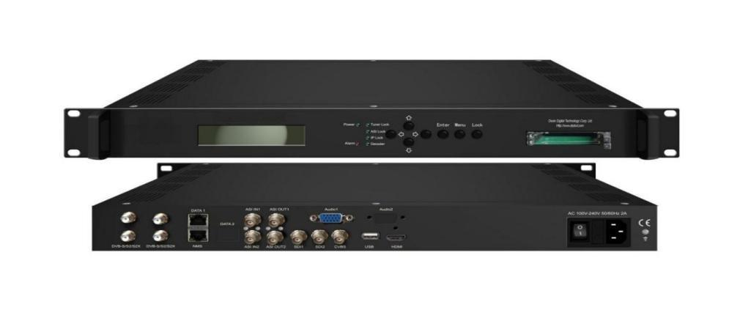
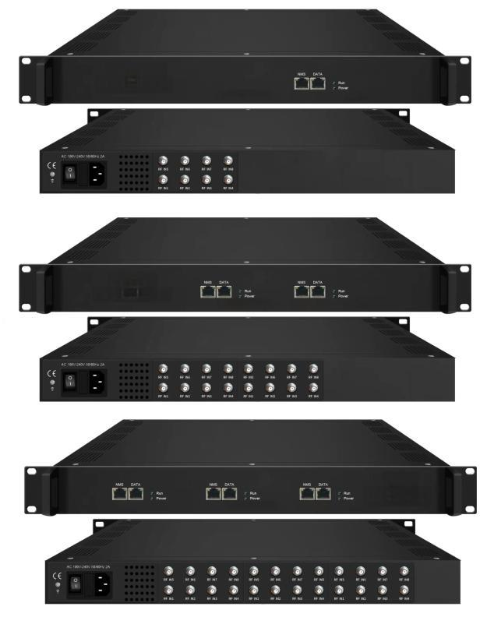
Product overview
The FMUSER FUQ-41086D HD IRD supports up to 24 tuner inputs for DVB-S/S2/S2X, DVB-C/T, and ISDB-T standards. It processes signals in Passthrough mode for 8 MPTS output or Mux mode for 2 MPTS / 512 SPTS over UDP/RTP. Managed via web-based NMS, it includes features like Biss decryption and Diseqc function. Ideal for broadcast and IPTV systems.
Key feature
Supports expandable tuner inputs for up to 24 tuners via optional cards, compatible with DVB-S/S2/S2X, DVB-C/T, and ISDB-T.
Features dual output modes: Passthrough mode for 8 MPTS or Mux mode for 2 MPTS / 512 SPTS over UDP/RTP unicast/multicast.
Enables advanced PID handling including remapping and pass-through (up to 256 PIDs per channel) exclusively in Mux mode.
Includes security with Biss decryption (64 keys per tuner) and Diseqc function, managed via NMS.
Inner Principle Chart (Per Card/8 Input):
Version 1: Passthrough Mode
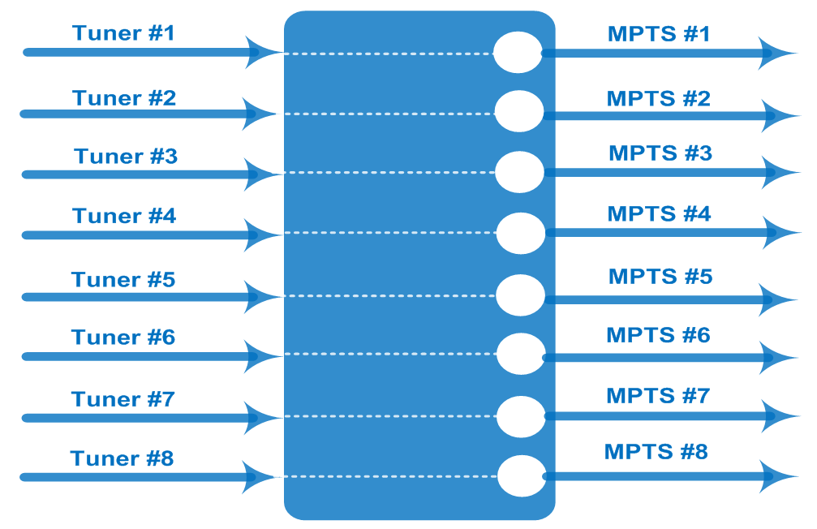

Version 2: Mux Mode (MPTS and SPTS output Switchable)
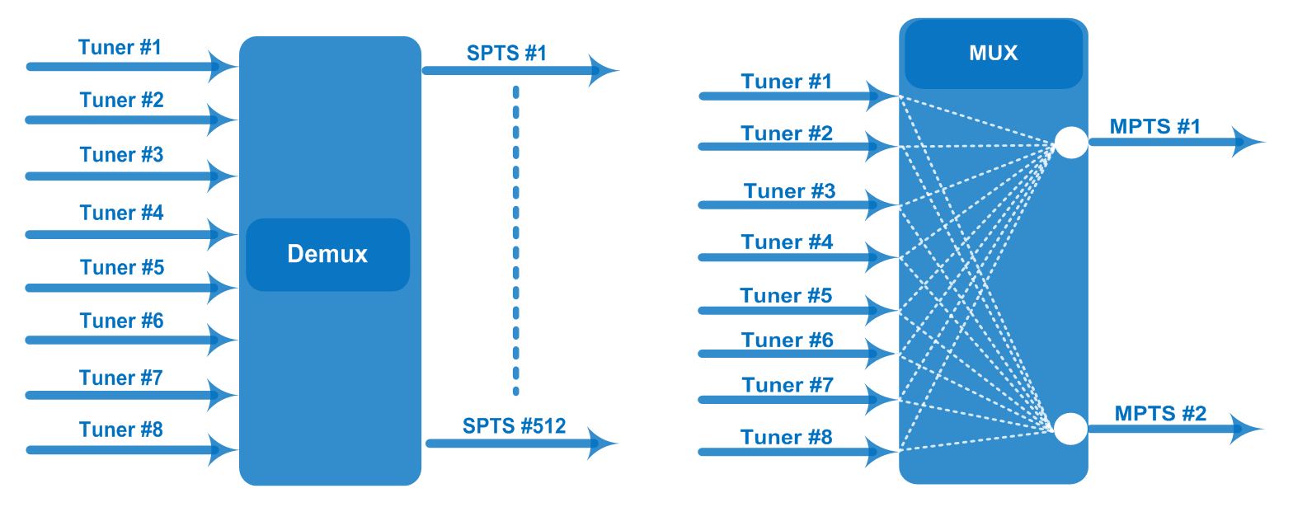
Specifications (Per Card/8 Input)

Input / Output | 8 Tuner input (DVB-S/S2/S2X or/and DVB-C/T/T2/ISDB-T), F Type  8 MPTS out thru bypassing over UDP/RTP thru Data port (Version 1)  100/1000Mself-adaption, unicast/multicast
Mux (Version 2) | Max number of managing PID: 256 (for 2 MPTS out thru multiplexing) or 512 SPTS out
Mux (Version 2) | Functions | PID remapping (automatically/ manually)
Mux (Version 2) | Functions | PID pass-through
Tuner Section | DVB-S | Input Frequency |  | 950-2150MHz
Tuner Section | DVB-S | Symbol Rate |  | 0.5~45 Msps
Tuner Section | DVB-S | Constellation |  | QPSK
Tuner Section | DVB-S | FEC |  | 1/2, 2/3, 3/4, 5/6, 7/8
Tuner Section | DVB-S2 | Input Frequency |  | 950-2150MHz
Tuner Section | DVB-S2 | Symbol Rate |  | QPSK/8PSK/16APSK: 0.5~45 Msps  32APSK:0.5~40 Msps
Tuner Section | DVB-S2 | Constellation |  | QPSK/8PSK/16APSK/32APSK
Tuner Section | DVB-S2 | FEC |  | QPSK: 1/2, 3/5, 2/3, 3/4, 4/5, 5/6, 8/9,9/10  8PSK: 3/5, 2/3, 3/4, 5/6, 8/9, 9/10  16APSK: 2/3, 3/4, 4/5, 5/6, 8/9, 9/10  32APSK: 3/4, 4/5, 5/6, 8/9
Tuner Section | DVB-S2 | Max input bitrate per tuner |  | ≤170 Mbps
Tuner Section | DVB-S2X | Symbol Rate |  | QPSK/8PSK/16APSK: 0.5~45 Msps;  8APSK/32APSK: 0.5~40 Msps
Tuner Section | DVB-S2X | Constellation |  | QPSK/8PSK/16APSK/8APSK/32APSK
Tuner Section | DVB-S2X | FEC |  | QPSK: 1/2, 3/5, 2/3, 3/4, 4/5, 5/6, 8/9, 9/10, 13/45, 9/20, 11/20  8PSK: 3/5, 2/3, 3/4, 5/6, 8/9, 9/10, 23/36, 25/36, 13/18  8APSK: 5/9-L, 26/45-L  16APSK: 2/3, 3/4, 4/5, 5/6, 8/9, 9/10,1/2-L, 8/15-L, 5/9-L, 26/45, 3/5, 3/5-L, 28/45, 23/36, 2/3-L, 25/36, 13/18, 7/9, 77/90  32APSK: 3/4, 4/5, 5/6, 8/9, 2/3-L, 32/45, 11/15, 7/9
Tuner Section | DVB-S2X | Max input bitrate per tuner |  | ≤170 Mbps
Tuner Section | DVB-S2X | Signal Strength |  | -65 ~ -25dBm
Tuner Section | DVB-C | Input Frequency |  | 60 ~890 MHz
Tuner Section | DVB-C | Standard |  | J.83A, J.83C | J.83B
Tuner Section | DVB-C | Constellation |  | 16/32/64/128/256 QAM | 64/256 QAM
Tuner Section | DVB-T/T2 | Input Frequency |  | 60 ~890 MHz
Tuner Section | DVB-T/T2 | Bandwidth |  | 6/7/8 M
Tuner Section | ISDB-T | Input Frequency |  | 60 ~890 MHz
System | Web management:100M NMS port
System | Language: English and Chinese
System | Ethernet software upgrade
General | Dimensions |  | 482mm×328mm×44mm (WxLxH)
General | Weight |  | 3.5kg
General | Temperature |  | 0~45℃(operation), -20~80℃(storage)
General | Power supply |  | AC 110V±10%, 50/60Hz Or AC 220V±10%, 50/60Hz
General | Consumption |  | ≤25W (1card inside)  ≤50W (2 cards inside)  ≤75W (3 cards inside)

Order Guide
DX3908-8 | 8 FTA DVB-S/S2/S2X Tuner Input, Version 1 or Version 2
DX3908-16 | 16 FTA DVB-S/S2/S2X Tuner Input, Version 1 or Version 2
DX3908-24 | 24 FTA DVB-S/S2/S2X Tuner Input, Version 1 or Version 2
DX3928-8 | 8 FTA DVB-C/T/ISDB-T Tuner Input, Version 1 or Version 2
DX3928-16 | 16 FTA DVB-C/T/ISDB-T Tuner Input, Version 1 or Version 2
DX3928-24 | 24 FTA DVB-C/T/ISDB-TTuner Input, Version 1 or Version 2

About Us
FMUSER is a company specializing in broadcasting and television transmission systems and integrating hotel IPTV systems. The company was established in 2009 and has served over 180 countries worldwide. More than 20,000 television stations, radio stations, and hotel clients from different.

Contact:Tomleequan Email：sales@fmuser.com whatsapp: +8613922702227

