FMUSER FUQ-4109Y HD IRD Multi-Source Input 1RF DVB-C-DVB-S-S2-ISDB-T, 1ASI 1IP Input MPEG-2 H.264 Decoding ISDB-T Multiplexing CI Descrambling SNMP-Web Management for Broadcast Systems
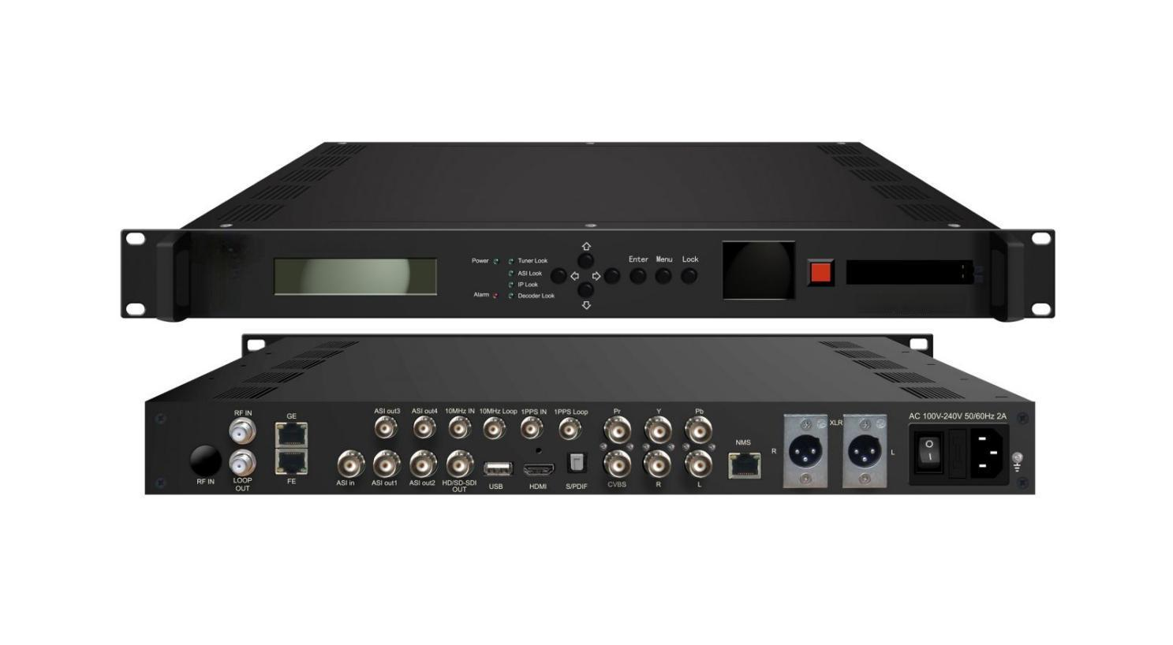Product overview
The FUQ-4109Y Series HD IRD decodes TS signals from ASI, RF tuner (supporting DVB-C/DVB-S/S2/ISDB-T), or IP sources into audio/video. It processes signals through HD decoding compliant with MPEG-2 and H.264 standards, and performs ISDB multiplexing for ASI and IP outputs. The device includes a CI descramble module and supports management via SNMP/web, LCD, and keyboard control. Ideal for broadcast systems requiring reliable signal decoding and multiplexing in headend or distribution environments.
Key Feature
Supports multi-source inputs including RF (DVB-C/DVB-S/S2/ISDB-T), ASI, and IP
Delivers high-definition decoding up to 1080i with MPEG-2 and H.264 compliance
Performs ISDB-T multiplexing for ASI and IP outputs
Features CI descrambling with DVB-CSA module via PCMCIA interface
Offers integrated management via SNMP/web, LCD, and keyboard control
Principle Chart
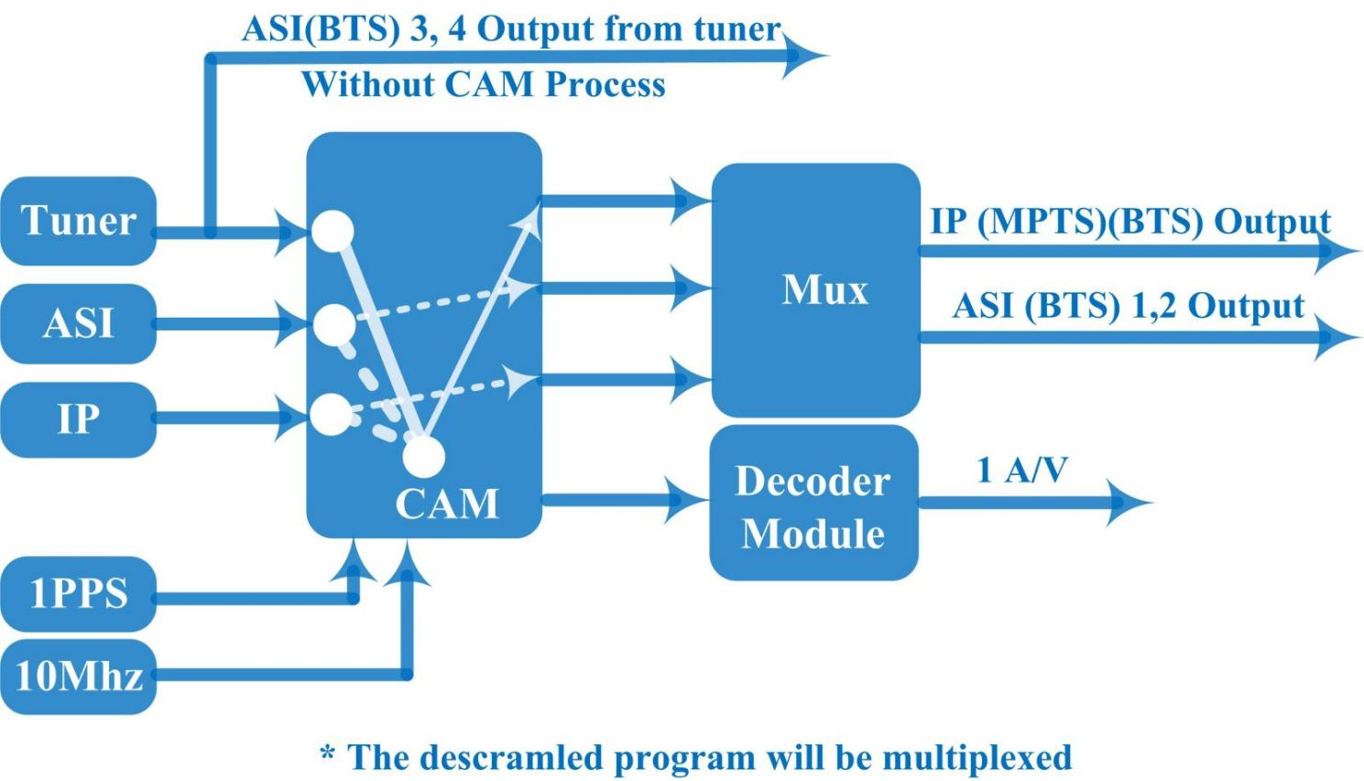

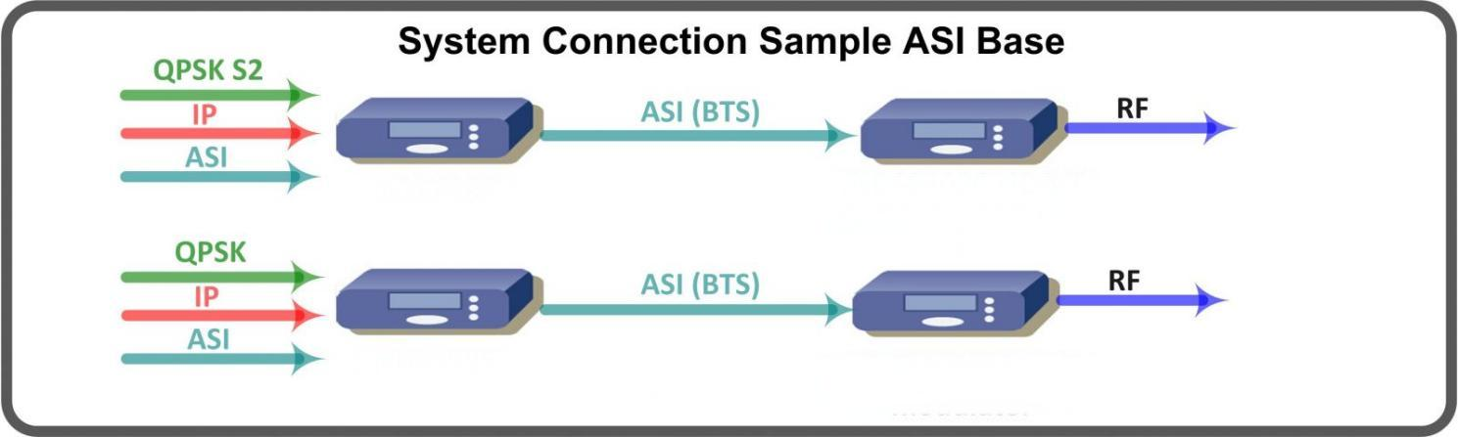

Specifications
Input | 1RF Input (DVB-C/DVB-S/S2/ISDB-T optional)
Input | 1ASI Input (support 188/204 package format)
Input | 1 IP MPTS Input (100Mbps, RJ45 Port) over UDP/RTP protocol
Input | GPS 10Mhz Clock Input
Input | GPS 1PPS Signal Input
Demodulating Section | DVB-C | Standard |  | J.83A(DVB-C), J.83B, J.83C
Demodulating Section | DVB-C | Input Frequency |  | 30 MHz~1000 MHz
Demodulating Section | DVB-C | Constellation |  | 16/32/64/128/256 QAM
Demodulating Section | DVB-S | Input Frequency |  | 950-2150MHz
Demodulating Section | DVB-S | Symbol rate |  | 1-45Msps
Demodulating Section | DVB-S | Signal Strength |  | - 65- -25dBm
Demodulating Section | DVB-S | Constellation |  | 1/2, 2/3, 3/4, 5/6, 7/8 QPSK
Demodulating Section | DVB-S2 | Input Frequency |  | 950-2150MHz
Demodulating Section | DVB-S2 | Symbol rate |  | 1~45 Msps
Demodulating Section | DVB-S2 | Code rate |  | 1/2, 3/5, 2/3, 3/4, 4/5, 5/6, 8/9, 9/10
Demodulating Section | DVB-S2 | Constellation |  | QPSK, 8PSK (16 APSK, 32 APSK on request)
Demodulating Section | DVB-S2 | Roll off |  | 0.20, 0.25, 0.35
Demodulating Section | ISDB-T | Input Frequency |  | 30-1000MHz
ASI Output | ASI 1&2 output BTS after multiplexing, ASI 3&4 for tuner pass-through
IP Output | 1 IP MPTS output (100M, RJ45 Port) over UDP/RTP protocol
Video Output | 1xCVBS(BNC): 576i@25fps, 480i@29.97fps
Video Output | 1xYPbPr(BNC): 1080i@25, 29.97, 30fps; 720p@50, 59.94fps
Video Output | 1xHD/SD-SDI(BNC): 1080i@25, 29.97, 30fps; 720p@50, 59.94fps; 576i@25fps; 480i@29.97fps
Video Output | 1 x HDMI: 1080i@25, 29.97, 30fps; 720p@50, 59.94fps
Audio Output | Stereo unbalanced audio: BNC interface
Audio Output | Stereo balanced audio: XLR interface
Audio Output | Digital audio: SPDIF
Video Decoding | MPEG-2, H.264
Audio Decoding | MPEG1 layer 2, AC3, HE-AAC (v2), LC-AAC
ISDB-T multiplexing | Support 256 PID mapping per channel (Automatically or manually)
ISDB-T multiplexing | PCR accurate adjusting
ISDB-T multiplexing | Generate PSI/SI table automatically
ISDB-T BTS parameters | Modes：mode1(2k), mode2(4k), mode3(8k)
ISDB-T BTS parameters | Guard Interval：1/4,1/8,1/16,1/32
ISDB-T BTS parameters | Code Rate：1/2,2/3,3/4,5/6,7/8
ISDB-T BTS parameters | Constellations: DQPSK/QPSK/16QAM/64QAM
ISDB-T BTS parameters | Layer Mode：A, A+B, A+B+C
ISDB-T BTS parameters | Number of Segment: 1-13
ISDB-T BTS parameters | Bandwidth：6MHz,7MHz,8MHz
SFN parameters | Maximum time delay：0ms ～ 1000ms
SFN parameters | Device delayed time shifting：-1000ms ～ +1000ms
SFN parameters | Device ID:0 ～ 30
DVB-CI Parameters | Descrambler: DVB-CSA
DVB-CI Parameters | Smart Card interface: ISO7816
DVB-CI Parameters | Interface Card Separation: PCMCIA
System | Support SNMP/Web management, LCD + keyboard control
System | English and Chinese interface conversion
System | Ethernet software upgrade
General | Dimensions |  | 482mm*455mm*44.5mm
General | Approx weight |  | 3.2kg
General | Power |  | <20W(Max)
General | Temperature |  | 0~45℃(Operating), -20~80℃(Storage)

Order Information:
FU-41091 DVB-C HD IRD;
FU-41092 DVB-S HD IRD;
FU-41095 DVB-S2 HD IRD;
FU-41096 ISDB-T HD IRD;

Technical Comparison:
 |  | FU-408X /FU-400X | FU-4109X | R&S®AVG050 ISDB-T BTS Gateway
Stream In | IP input | Over ,UDP, RTP (100 Base-T) | Over UDP/RTP (100 Base-T) | Over IPv4,UDP, RTP (1000 Base-T)
Stream Out | ASI out | ASI 1&2 mirrored output BTS after multiplexing; ASI 3&4 for tuner pass-through | ASI 1&2 mirrored output BTS after multiplexing; ASI 3&4 for tuner pass-through | ASI 1&2 mirrored output for BTS in an MPEG-2 transport stream with ancillary data
Stream Out | IP out | 8 SPTS output over UDP, 100M Base-T (-FU-408X)  32 SPTS output over UDP, 1000M Base-T (-FU-400X) | 1 IP MPTS output over UDP/RTP (1000 Base-T) | 2 × IP streams with individual IP addresses, UDP ports and FEC configuration in line with SMPTE 2022-1/2
Decryption | BISS | Yes | N/A | Yes
Reference | 10MHz REF | N/A | Yes | Yes
Reference | 1PPS | N/A | Yes | N/A
ISDB-T Parameters | Modulation Constellation | N/A | DQPSK/QPSK/16QAM/64QAM | QPSK/16QAM/64QAM
ISDB-T Parameters | PSI/SI | N/A | PAT, PMT, NIT, SDT, TOT, TDT | PAT, PMT, NIT, SDT, TOT, BIT
ISDB-T Parameters | SFN Adapter | N/A | Yes | Yes
Decoding | Standard | Support H.264 and MPEG2 decode and output V/A via various interfaces | Support H.264 and MPEG2 decode and output V/A via various interfaces | N/A
Decoding | LCD Monitor | Yes | Yes | N/A

About Us
FMUSER is a company specializing in broadcasting and television transmission systems and integrating hotel IPTV systems. The company was established in 2009 and has served over 180 countries worldwide. More than 20,000 television stations, radio stations, and hotel clients from different.

Contact:Tomleequan Email：sales@fmuser.com whatsapp: +8613922702227

