FMUSER FUQ-4213J EIT Multiplexer 12 ASI Inputs 2 ASI Outputs 2 Gigabit IP Outputs ISO13818-EN300468 Compliant EIT Multiplexing Digital TV Headend 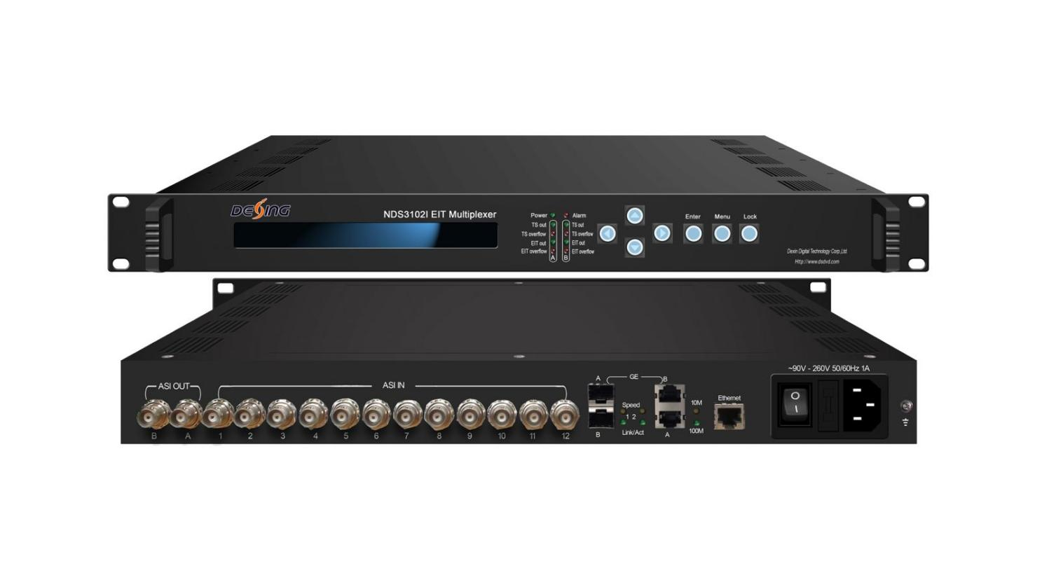Product overview
The FMUSER FUQ-4213J EIT Multiplexer automates EIT table multiplexing with program streams, featuring 12 ASI inputs, 2 ASI outputs, and 2 IP gigabit outputs. It processes signals by editing PSI/SI information and adjusting PCR, while supporting TS over UDP transmission. Controlled via LCD/keyboard and NMS, it complies with ISO13818/EN300468 standards. Ideal for DTV head-end systems, it eliminates external EPG servers.
Key feature
Automatically multiplexes EIT tables with program streams, removing EPG infrastructure.
Features 12 ASI inputs and 2 ASI outputs for flexible transport stream handling.
Edits PSI/SI information and ensures ISO13818/EN300468 compliance.
Provides dual IP gigabit outputs for TS over UDP up to 215Mbps, supporting unicast/multicast.
Offers centralized control via LCD/keyboard and NMS for real-time management.
Specifications
Input | Supporting both packet and byte mode TS input
Input | Supporting 188/204Byte transport stream packet
Input | 12 ASI inputs
Input | ASI input connector: BNC, impedance 75Ω
ASI Output | Two separate ASI outputs
ASI Output | Maximum bit rate: 215Mbps
IP Output | Two separate gigabit outputs
IP Output | Maximum output bit rate: 215 Mbps
IP Output | UDP output, support unicast and multicast
Miscellaneous | Size | 44mm X 482mm X 410mm
Miscellaneous | Environment | 0~45℃(operation)；-20~80℃(storage)
Miscellaneous | Power | 220VAC±10%，50Hz
Miscellaneous | Consumption | 25W

About Us
FMUSER is a company specializing in broadcasting and television transmission systems and integrating hotel IPTV systems. The company was established in 2009 and has served over 180 countries worldwide. More than 20,000 television stations, radio stations, and hotel clients from different.

Contact:Tomleequan Email：sales@fmuser.com whatsapp: +8613922702227

