FMUSER FUQ-4213J EIT Multiplexer 512 SPTS-MPTS Input-Output UDP-RTP IP TS CA PID PSI-SI Editing Web-Based Broadcast Telecom Headend
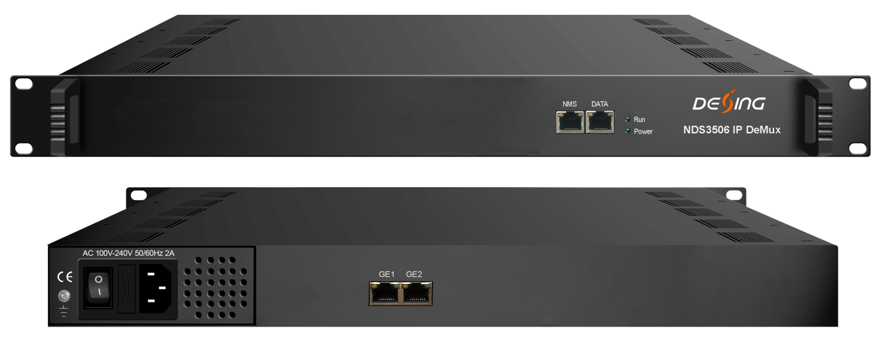Product overview
The FUQ-4213K EIT Multiplexer is a modular head-end device for IP TS conversion, featuring a 1U chassis that supports up to 3 independent cards. Each card processes 512 SPTS or MPTS inputs to 512 SPTS outputs, with CA filter and PSI/SI editing for stream management. It includes web-based configuration and monitoring, ideal for broadcast systems requiring secure and compliant operations.
Key feature
Enables web-based operation for configuration and monitoring via intuitive interface.
Specifications
Input | 512 SPTS or MPTS IP input over UDP, RTP, Unicast and Multicast (per card)
Output | 512 SPTS IP output UDP, RTP, Unicast and Multicast (per card)
Multiplexing | Support CA PID filtering, PID re-mapping
Multiplexing | Support accurate PCR adjusting
Multiplexing | Support PSI/SI rebuilding and editing
General | Dimension(WxLxH) | 482mm×410mm×44mm
General | Weight | 3.6kg
General | Temperature | 0~45℃(working )，-20~80℃(storage)
General | Power supply | 100~240VAC，50/60Hz
General | consumption | 20W

Working Principle (per daughter card)

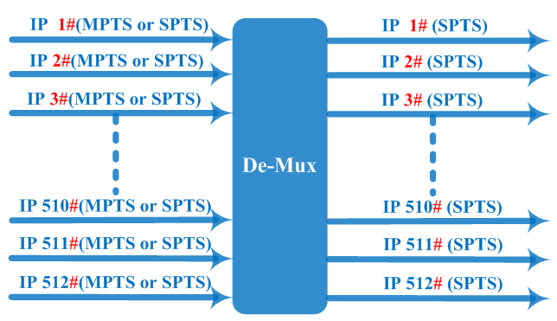

About Us
FMUSER is a company specializing in broadcasting and television transmission systems and integrating hotel IPTV systems. The company was established in 2009 and has served over 180 countries worldwide. More than 20,000 television stations, radio stations, and hotel clients from different.

Contact:Tomleequan Email：sales@fmuser.com whatsapp: +8613922702227

