FMUSER FUQ-4214 IP Multiplexer 512 IP Inputs 2 ASI-2 IP Outputs UDP ISO13818 EN300468 PCR Adjust PSI-SI Editing Digital TV Headend CATV 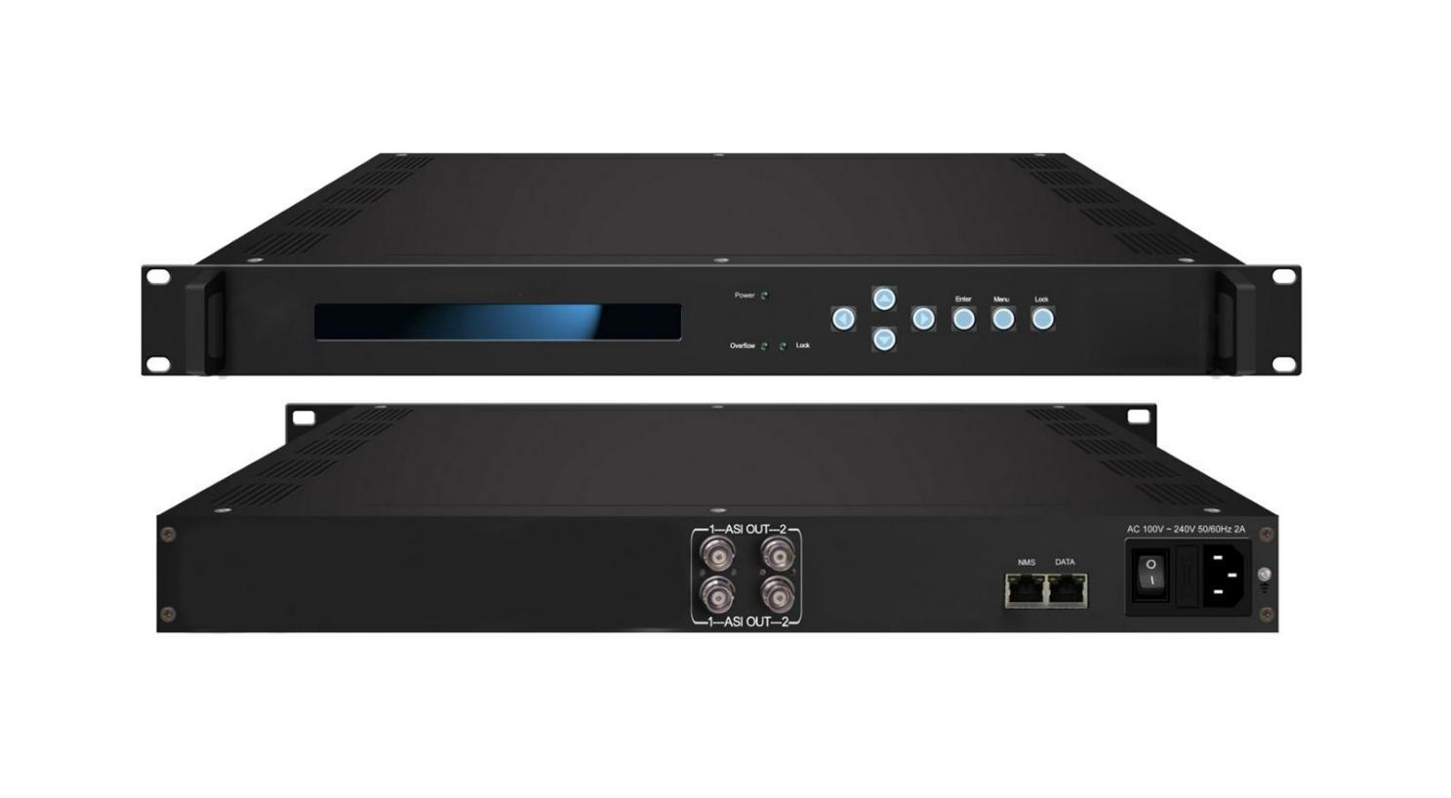Product overview
The FMUSER FUQ-4214 IP Multiplexer is a high-performance TS processor with 512 IP inputs (SPTS/MPTS) and 2 TS stream outputs. It multiplexes signals, enabling PCR adjusting, PID remapping, and PSI/SI editing. With web-based NMS and front-panel control, it suits digital TV head-end systems and CATV applications.
Key feature
Supports up to 512 SPTS/MPTS inputs over UDP, compliant with ISO13818 and EN300 468.
Features dual outputs: 2 ASI groups (each with 2 ports) and 2 IP outputs for reliable transmission.
Enables advanced processing including PCR adjusting, PID remapping, and PSI/SI editing for up to 2048 PIDs per channel.
Includes buffer memory for overflow protection, with LCD/keyboard and web-based NMS for easy management.

Principle Chart

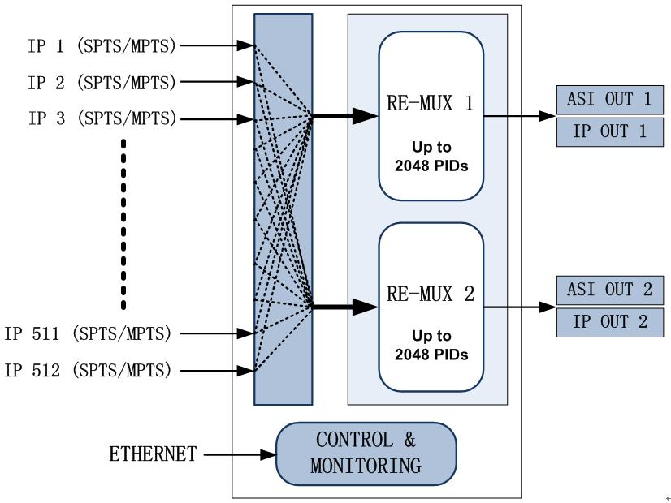

Specifications
Input | IP (RJ45,GE) | 512 x MPTS/SPTS, Unitcast/Multicast, UDP Protocol  IGMP V2/V3
Re-multiplex | PID re-mapping (auto or manually available)
Re-multiplex | PCR accurate adjusting
Re-multiplex | Automatic generating PSI/SI table
Re-multiplex | PID passthrough
Re-multiplex | Support multiplex maximum 2048 PIDs each output channel
Output port | ASI | 2 x independent channels of ASI output (each channel has 2 ports) (up to 210Mbps)
Output port | IP(RJ45,GE) | 2 x IP (Unitcast/Multicast), UDP Protocol (up to 230Mbps)
NMS port | Ethernet port | GE
General | Dimension | 482mmx410mmx44mm(WxLxH)
General | Weight | 2.0kg
General | Temperature | 0~45℃(operation), -20~80℃(storage)
General | Power supply | 110VAC±10%，50/60Hz; 220VAC±10%，50/60Hz
General | Consumption | <25w

About Us
FMUSER is a company specializing in broadcasting and television transmission systems and integrating hotel IPTV systems. The company was established in 2009 and has served over 180 countries worldwide. More than 20,000 television stations, radio stations, and hotel clients from different.

Contact:Tomleequan Email：sales@fmuser.com whatsapp: +8613922702227

