FMUSER FUQ-4214 IP Multiplexer 512 IP Inputs 2 ASI 2 IP Outputs UDP SPTS-MPTS ISO13818 EN300468 Multiplex Insert CATV Systems 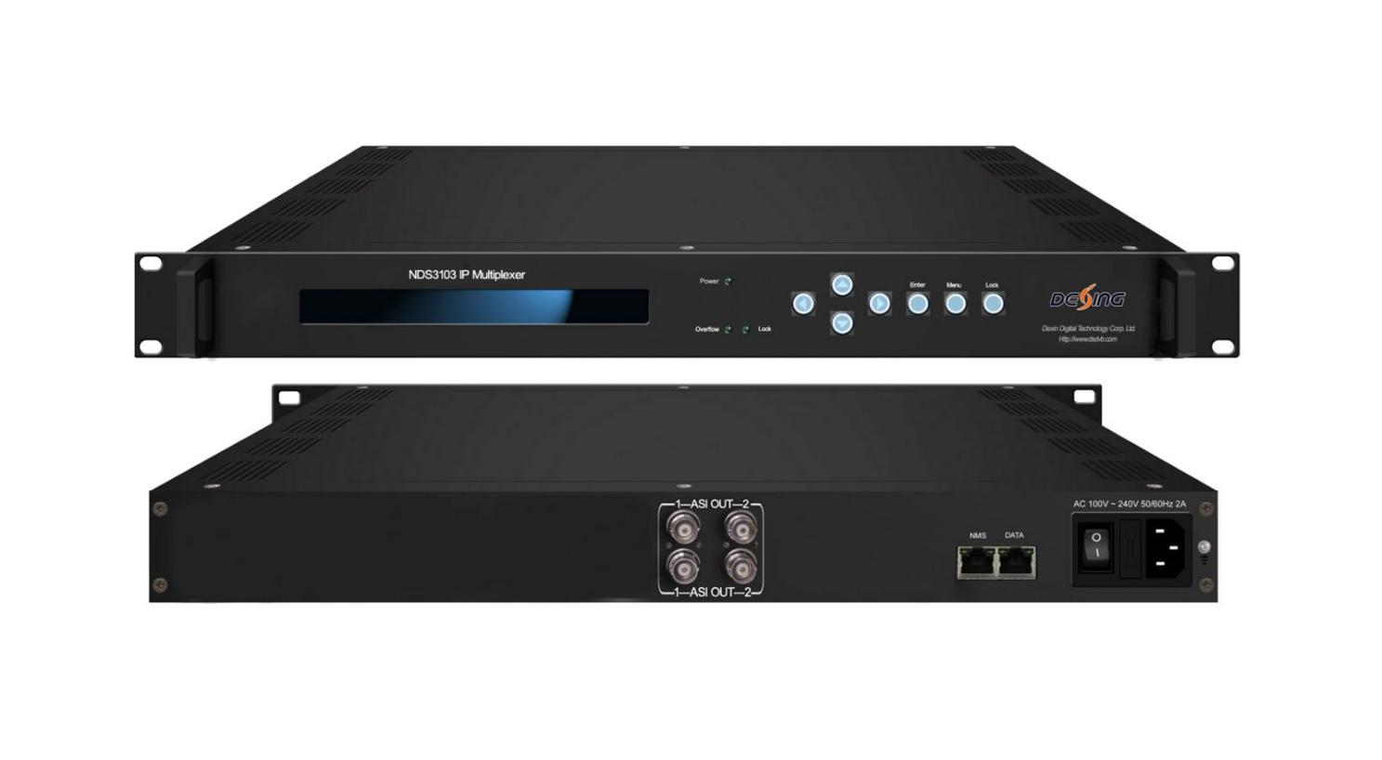Product overview
The FMUSER FUQ-4214 IP Multiplexer processes transport streams with 512 IP inputs (UDP SPTS/MPTS) and delivers 2x2 ASI ports plus 2 IP outputs. It multiplexes programs while inserting EPG, CA, and data services with PSI/SI rebuilding. This 1RU rack-mount unit features web-based NMS and front-panel controls. Ideal for CATV integration and DVB digital headends requiring reliable TS processing.

Key feature
- Multiplexes 512 UDP inputs with SPTS/MPTS support and PID remapping (up to 2048 PIDs/channel)
- Delivers 2 independent ASI output groups (4 ports total) + 2 IP outputs over UDP
- Ensures broadcast compliance with ISO13818 & EN300468 including PCR adjustment
- Supports EPG/CA insertion, PSI/SI editing, and huge buffer memory for stability
- Provides web-based NMS, LCD, and keyboard control interfaces

Principle Chart

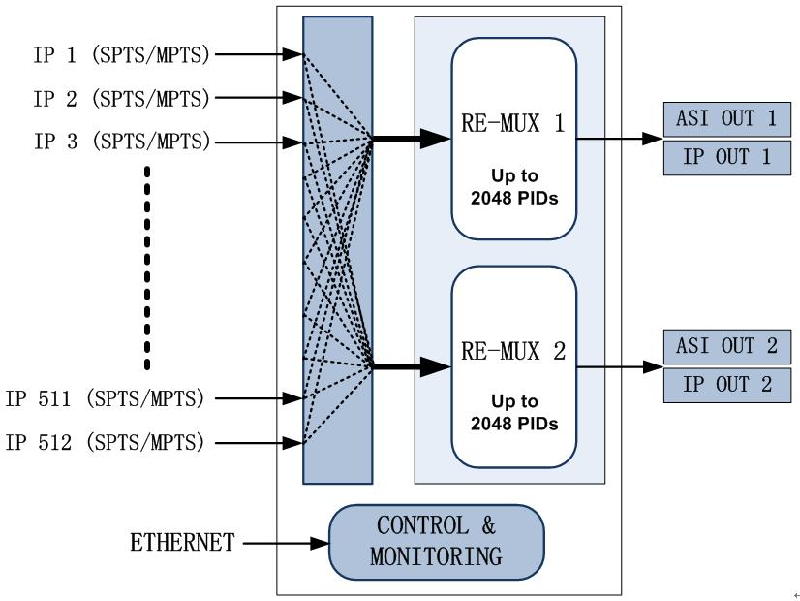

Specifications
Input | IP (RJ45,GE) | 512 x MPTS/SPTS, Unitcast/Multicast, UDP Protocol  IGMP V2/V3
Re-multiplex | PID re-mapping (auto or manually available)
Re-multiplex | PCR accurate adjusting
Re-multiplex | Automatic generating PSI/SI table
Re-multiplex | PID passthrough
Re-multiplex | Support multiplex maximum 2048 PIDs each output channel
Output port | ASI | 2 x independent channels of ASI output (each channel has 2 ports) (up to 210Mbps)
Output port | IP(RJ45,GE) | 2 x IP (Unitcast/Multicast), UDP Protocol (up to 230Mbps)
NMS port | Ethernet port | GE
General | Dimension | 482mmx410mmx44mm(WxLxH)
General | Weight | 2.0kg
General | Temperature | 0~45℃(operation), -20~80℃(storage)
General | Power supply | 110VAC±10%，50/60Hz; 220VAC±10%，50/60Hz
General | Consumption | <25w

About Us
FMUSER is a company specializing in broadcasting and television transmission systems and integrating hotel IPTV systems. The company was established in 2009 and has served over 180 countries worldwide. More than 20,000 television stations, radio stations, and hotel clients from different.

Contact:Tomleequan Email：sales@fmuser.com whatsapp: +8613922702227

