FMUSER FUQ-4216B Dual-Channel TS Re-Multiplexer 12 ASI Input to ASI-IP Output ISDB-T-ISDB-Tb PSI-SI SFN Support Network Managed for Broadcast 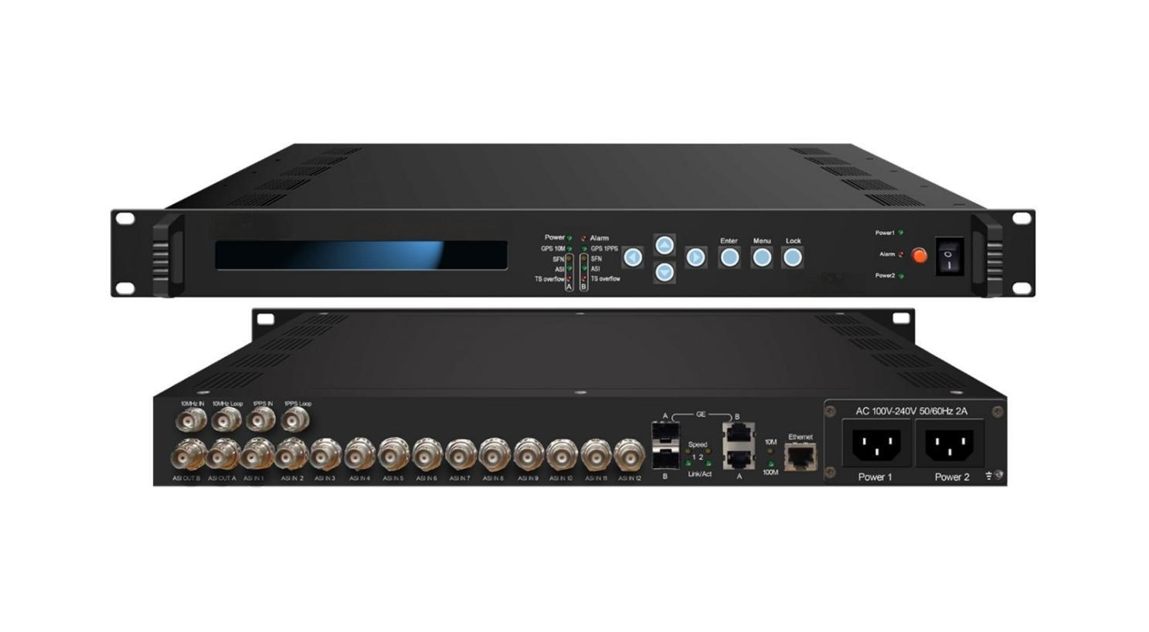Product overview
The FUQ-4216B is a TS re-multiplexer compliant with ISDB-T/ISDB-Tb standards, handling up to 12 inputs with ASI and IP outputs. It processes transport streams through re-multiplexing, supporting PSI/SI table editing and SFN support. Featuring network control via NMS/SNMP, it is ideal for professional broadcast systems in Japan and South America.
Key feature
Supports ISDB-T/ISDB-Tb standards for compliant broadcasting.
Features dual independent re-multiplexing channels for simultaneous processing.
Enables PSI/SI table editing and generation with descriptor insertion.
Provides IP and ASI outputs over UDP protocol.
Allows remote network management via NMS/SNMP for upgrades.
Specifications
Signal inputting | 12 ASI input
Signal inputting | 188/204Byte transmission stream packet
Signal inputting | TS packet mode and suddenly code rate mode
Signal inputting | GPS 10mhz reference clock inputting
Signal inputting | GPS 1pps signal inputting
Re-multiplexing | 2 separate channels TS re-multiplexer
Re-multiplexing | PCR accurate adjusting
Re-multiplexing | PSI/SI table automatically generating
Modulation parameter | mode：mode1(2k) mode2(4k) mode3(8k)
Modulation parameter | Guard interval：1/4 1/8 1/16 1/32
Modulation parameter | Coding rate：1/2 2/3 3/4 5/6 7/8
Modulation parameter | constellation：DQPSK QPSK 16QAM 64QAM
Modulation parameter | Layer：A A+B A+B+C
Modulation parameter | Bandwidth: 6MHz 7MHz 8MHz
SFN parameter | Maximum time delay：0ms ～ 1000ms
SFN parameter | Off set：-1000ms ～ +1000ms
SFN parameter | Device ID ：01 ～ 30
Output | 2 ASI output(BNC)
Output | 2 IP output(UDP protocol)
Output | RS encoding output supporting
Output | GPS 1pps and GPS 10Mhz loop-out(BNC)
General | Demission：44mmx482mmx410mm
General | Temperature：0～45℃(operation) -20～80℃（storage）
General | Power supply：220VAC±10%，50/60Hz，10W

Principle Chart
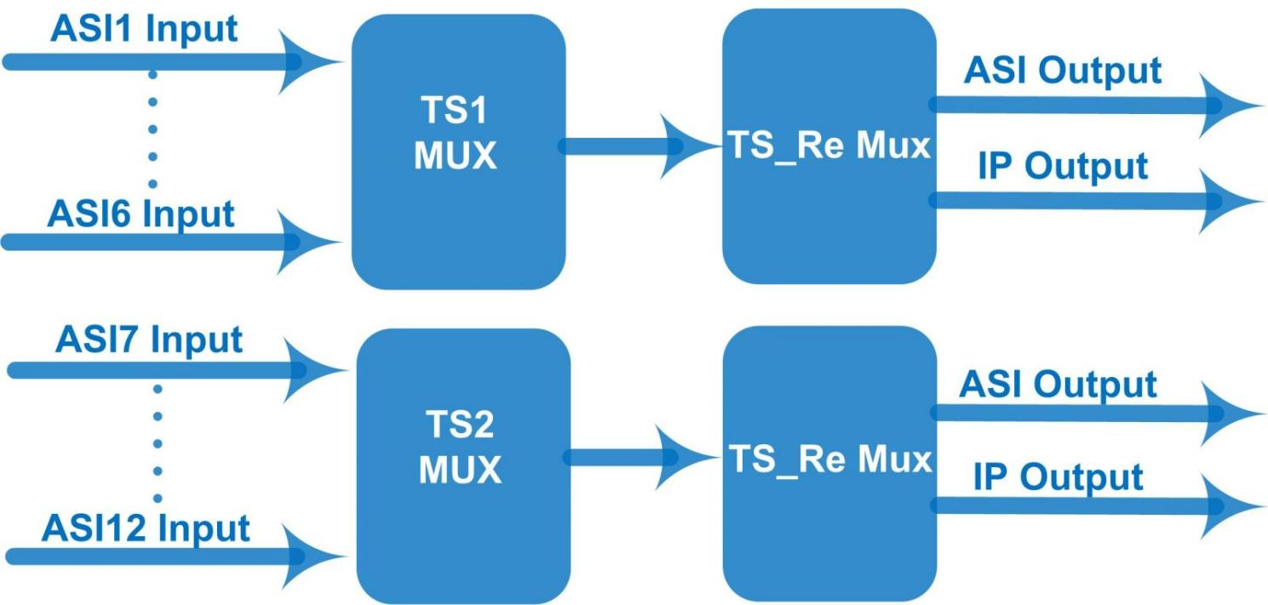

About Us
FMUSER is a company specializing in broadcasting and television transmission systems and integrating hotel IPTV systems. The company was established in 2009 and has served over 180 countries worldwide. More than 20,000 television stations, radio stations, and hotel clients from different.

Contact:Tomleequan Email：sales@fmuser.com whatsapp: +8613922702227

