FMUSER FUQ-4216B ISDB-T Dual Multiplexer 12 ASI Inputs 2 IP UDP Outputs PSI-SI Editing PCR Adjustment SFN-Ready for Broadcast Headend 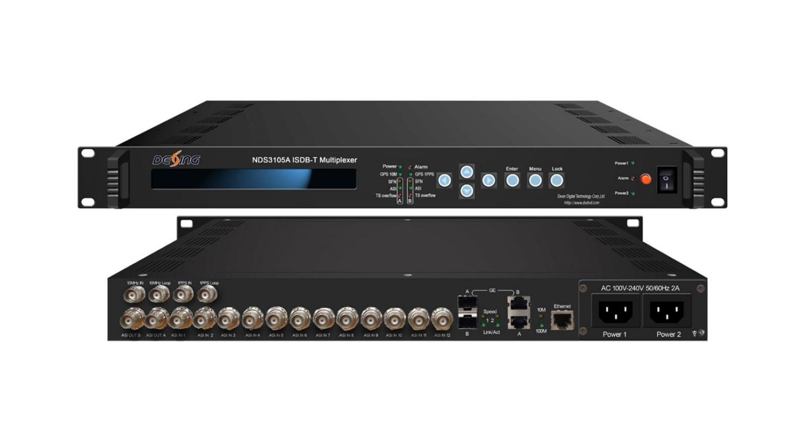Product overview
The FUQ-4216B ISDB-T Multiplexer is a dual-channel TS re-multiplexer with 12 ASI inputs and 2 IP outputs over UDP. It processes transport streams by re-multiplexing, editing PSI/SI tables, and generating IIP packets. Supporting remote upgrades and network management, this device is ideal for broadcast headend applications in regions like Japan and South America.
Key feature
Supports dual-channel TS re-multiplexing compliant with ISDB-T/ISDB-Tb standards.
Enables PSI/SI table editing and IIP packet generation.
Features 12 ASI inputs and 2 IP outputs over UDP.
Facilitates SFN operations and hierarchical transmission.
Includes PID filtering/re-mapping and accurate PCR adjusting.
Specifications
Signal inputting | 12 ASI input
Signal inputting | 188/204Byte transmission stream packet
Signal inputting | TS packet mode and suddenly code rate mode
Signal inputting | GPS 10mhz reference clock inputting
Signal inputting | GPS 1pps signal inputting
Re-multiplexing | 2 separate channels TS re-multiplexer
Re-multiplexing | PCR accurate adjusting
Re-multiplexing | PSI/SI table automatically generating
Modulation parameter | mode：mode1(2k) mode2(4k) mode3(8k)
Modulation parameter | Guard interval：1/4 1/8 1/16 1/32
Modulation parameter | Coding rate：1/2 2/3 3/4 5/6 7/8
Modulation parameter | constellation：DQPSK QPSK 16QAM 64QAM
Modulation parameter | Layer：A A+B A+B+C
Modulation parameter | Bandwidth: 6MHz 7MHz 8MHz
SFN parameter | Maximum time delay：0ms ～ 1000ms
SFN parameter | Off set：-1000ms ～ +1000ms
SFN parameter | Device ID ：01 ～ 30
Output | 2 ASI output(BNC)
Output | 2 IP output(UDP protocol)
Output | RS encoding output supporting
Output | GPS 1pps and GPS 10Mhz loop-out(BNC)
General | Demission：44mmx482mmx410mm
General | Temperature：0～45℃(operation) -20～80℃（storage）
General | Power supply：220VAC±10%，50/60Hz，10W

Principle Chart
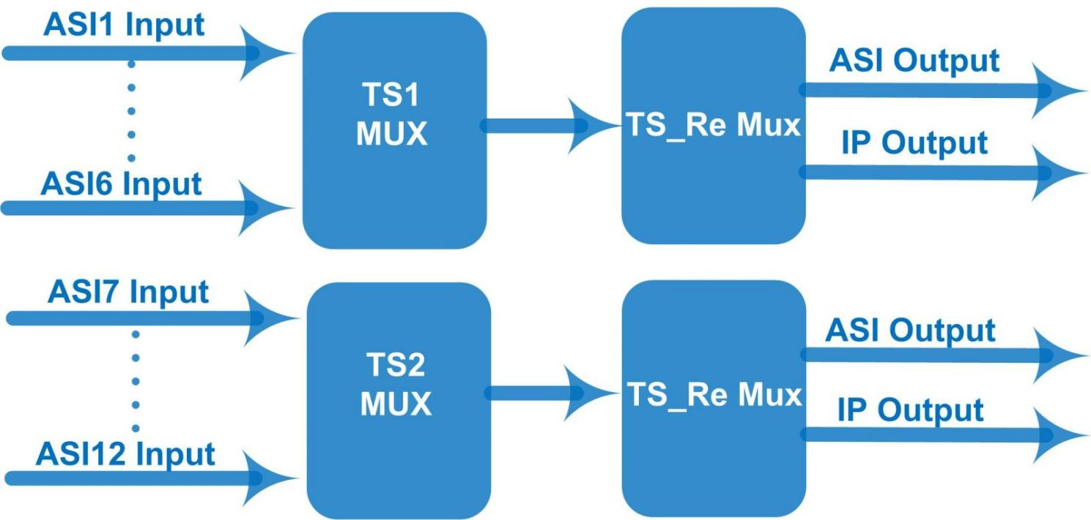

About Us
FMUSER is a company specializing in broadcasting and television transmission systems and integrating hotel IPTV systems. The company was established in 2009 and has served over 180 countries worldwide. More than 20,000 television stations, radio stations, and hotel clients from different.

Contact:Tomleequan Email：sales@fmuser.com whatsapp: +8613922702227

