FMUSER FUQ-4218B TS Re-Multiplexer 8 ASI & 512 IP Inputs 4 ASI & IP Outputs UDP RTP RTSP Interfaces PID Re-Mapping EPG Insertion Digital TV Headend 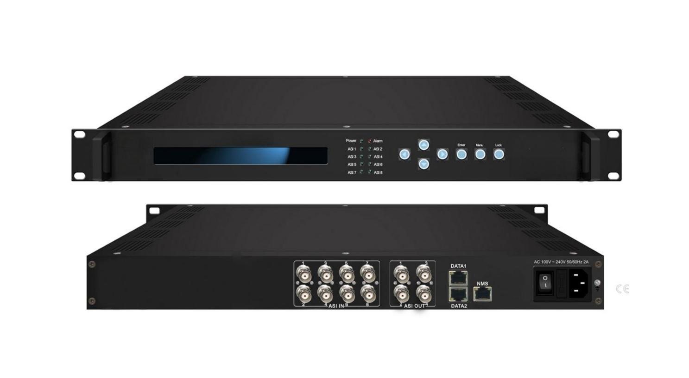Product overview
The FUQ-4218A is an advanced TS re-multiplexer supporting up to 8 ASI and 512 IP inputs with dual ASI and IP outputs. It performs program multiplexing, PID re-mapping, and EPG insertion for signal processing. This device features LCD/keyboard and Web-based NMS for efficient control. Ideal for digital TV head-end systems and CATV broadcasting applications.
Key feature
Includes integrated management via LCD/keyboard and Web-based NMS for network control.
Principle Chart

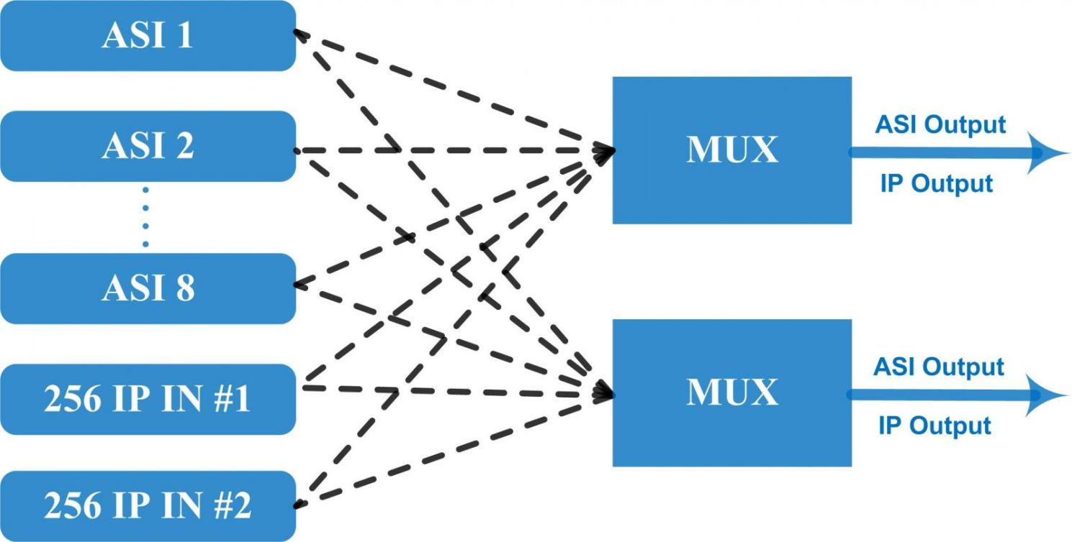

Specifications

Input | 8 ASI input+512 IP input DATA 1 and DATA 2 over UDP protocol
Re-multiplex | PID re-mapping
Re-multiplex | PCR accurate adjusting
Re-multiplex | PSI/SI (PAT, PMT) tables auto generation and edition
Output port | ASI | 2 groups separate outputs (each group has 2 channels)
Output port | IP | MPTS over UDP, RTP/RTSP output (RJ45), 1000Mbps Ethernet, DATA 1 and DATA 2
PID | Output range | 0x0000—0x1FFF
PID | PID transparent | Any PID transparent and mapping achievable
PID | Amount of output PID | 180
NMS port | Ethernet port | 10/100M/1000M self adaption
General | Dimensions | 482mm×300mm×44mm (WxLxH)
General | Weight | 3.5kg
General | Temperature | 0~45℃(operation), -20~80℃(storage)
General | Power supply | AC 110V±10%, 50/60Hz Or AC 220V±10%, 50/60Hz

About Us
FMUSER is a company specializing in broadcasting and television transmission systems and integrating hotel IPTV systems. The company was established in 2009 and has served over 180 countries worldwide. More than 20,000 television stations, radio stations, and hotel clients from different.

Contact:Tomleequan Email：sales@fmuser.com whatsapp: +8613922702227

