FMUSER FUQ-4218K Tuner Input Multiplexer 16 Tuners 2 ASI Inputs DVB-S-S2-S2X-C-T ISDB-T ATSC IP Outputs 4 MPTS BISS Descrambling CATV Headend System 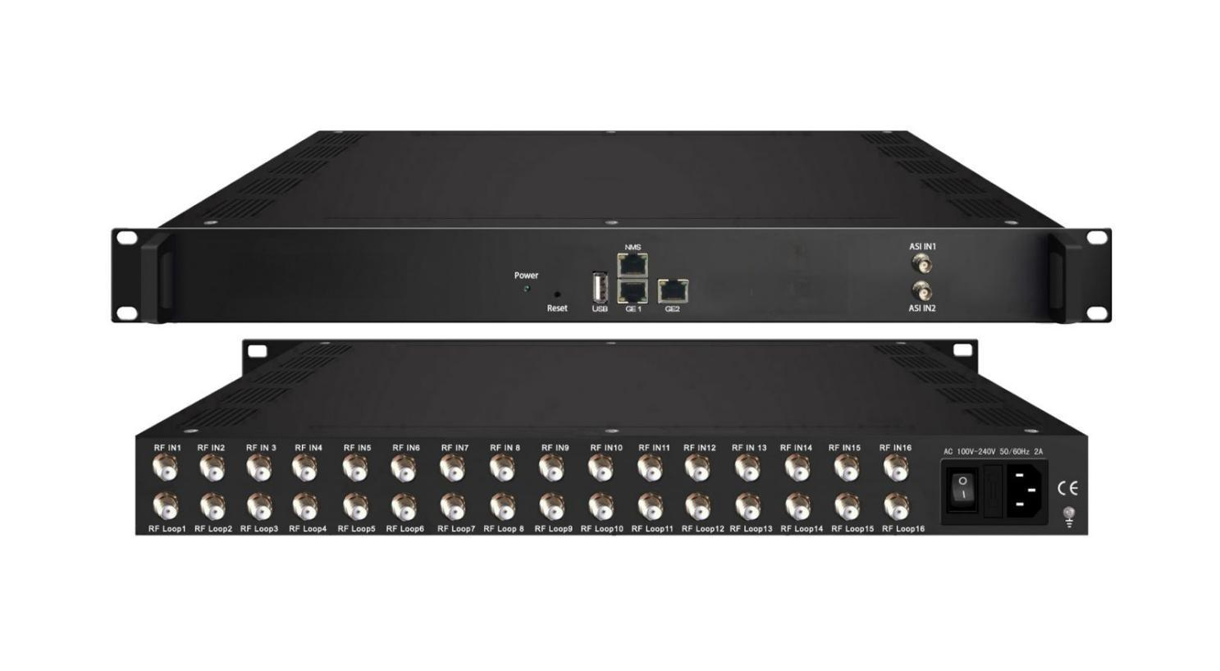Product overview
The FUQ-4218K Tuner Input Multiplexer processes 16 tuner inputs (configurable for DVB-S/S2/S2X, DVB-C/T, ISDB-T, or ATSC) and 2 ASI inputs, multiplexing them into 4 IP outputs (MPTS). It features BISS descrambling, PID re-mapping, and PSI/SI table generation for optimized signal delivery. With web-based management and 2 GE mirrored ports, it suits CATV broadcasting and headend consolidation projects.
Key feature
Web-Based Control: Remote configuration via intuitive browser interface
Working Principle
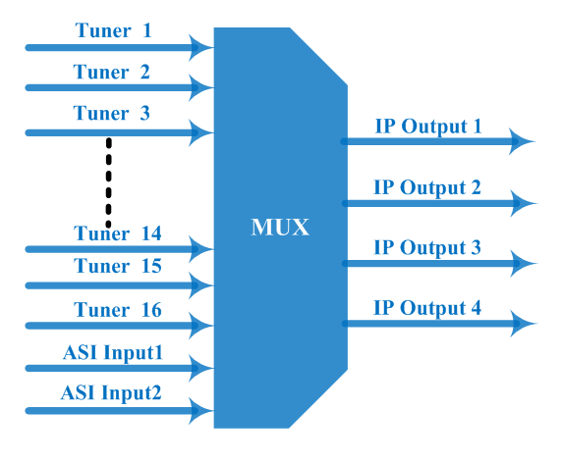

Specifications

Input | 16 tuners input, (DVB-C, DVB-T/(T), ISDBT, S/S2/S2X, ATSC optional), F type  2 ASI input, BNC interface
Tuner Section |  | DVB-C | Input Frequency |  |  | 30 ~1000 MHz
Tuner Section |  | DVB-C | Standard |  |  | J.83A(DVB-C), J.83B, J.83C
Tuner Section |  | DVB-C | Constellation |  |  | 16/32/64/128/256 QAM
Tuner Section |  | DVB-T/(T) | Input Frequency |  |  | 30 ~1000 MHz
Tuner Section |  | DVB-T/(T) | Bandwidth |  |  | 6/7/8 M
Tuner Section | Version 1 | DVB-S | Input Frequency |  |  | 950~2150MHz
Tuner Section | Version 1 | DVB-S | Symbol rate |  |  | 1~45 Msps
Tuner Section | Version 1 | DVB-S | FEC |  |  | 1/2, 2/3, 3/4, 5/6, 7/8
Tuner Section | Version 1 | DVB-S | Constellation |  |  | QPSK
Tuner Section | Version 1 | DVB-S | Signal Strength |  |  | - 65~ -25dBm
Tuner Section | Version 1 | DVB-S | Max input bitrate |  |  | ≤120 Mbps
Tuner Section | Version 1 | DVB-S2 | Input Frequency |  |  | 950~2150MHz
Tuner Section | Version 1 | DVB-S2 | Symbol rate |  |  | 1~45 Msps
Tuner Section | Version 1 | DVB-S2 | FEC |  |  | 1/2, 3/5, 2/3, 3/4, 4/5, 5/6, 8/9, 9/10
Tuner Section | Version 1 | DVB-S2 | Constellation |  |  | QPSK, 8PSK
Tuner Section | Version 1 | DVB-S2 | Max input bitrate |  |  | ≤120 Mbps
Tuner Section | Version 2  (New) | DVB-S | Input Frequency |  |  | 950~2150MHz
Tuner Section | Version 2  (New) | DVB-S | Symbol rate |  |  | 0.5~45Msps
Tuner Section | Version 2  (New) | DVB-S | Signal Strength |  |  | - 65- -25dBm
Tuner Section | Version 2  (New) | DVB-S | FEC |  |  | 1/2, 2/3, 3/4, 5/6, 7/8
Tuner Section | Version 2  (New) | DVB-S | Constellation |  |  | QPSK
Tuner Section | Version 2  (New) | DVB-S | Max input bitrate |  |  | ≤120 Mbps
Tuner Section | Version 2  (New) | DVB-S2 | Input Frequency |  |  | 950~2150MHz
Tuner Section | Version 2  (New) | DVB-S2 | Symbol rate |  |  | QPSK/8PSK /16APSK :0.5~45 Msps  32APSK: 0.5~40Msps;
Tuner Section | Version 2  (New) | DVB-S2 | FEC |  |  | QPSK: 1/2, 3/5, 2/3, 3/4, 4/5, 5/6, 8/9, 9/10  8PSK: 3/5, 2/3, 3/4, 5/6, 8/9, 9/10  16APSK: 2/3, 3/4, 4/5, 5/6, 8/9, 9/10  32APSK: 3/4, 4/5, 5/6, 8/9, 9/10
Tuner Section | Version 2  (New) | DVB-S2 | Constellation |  |  | QPSK, 8PSK, 16APSK, 32APSK
Tuner Section | Version 2  (New) | DVB-S2 | Max input bitrate |  |  | ≤120 Mbps
Tuner Section | Version 2  (New) | DVB-S2X | Input Frequency |  |  | 950~2150MHz
Tuner Section | Version 2  (New) | DVB-S2X | Symbol rate |  |  | QPSK/8PSK /16APSK :0.5~45 Msps  8APSK/32APSK: 0.5~40Msps
Tuner Section | Version 2  (New) | DVB-S2X | FEC |  |  | QPSK: 1/2, 3/5, 2/3, 3/4, 4/5, 5/6, 8/9, 9/10, 13/45, 9/20, 11/20  8PSK: 3/5, 2/3, 3/4, 5/6, 8/9, 9/10  8APSK: 5/9-L, 26/45-L  16APSK: 2/3, 3/4, 4/5, 5/6, 8/9, 9/10, 1/2-L, 8/15-L, 5/9-L, 26/45, 3/5, 3/5-L, 28/45, 23/36 , 2/3-L, 25/36, 13/18, 7/9, 77/90  32APSK: 3/4, 4/5, 5/6, 8/9, 2/3-L, 32/45, 11/15, 7/9
Tuner Section | Version 2  (New) | DVB-S2X | Constellation |  |  | QPSK, 8PSK, 8APSK, 16APSK, 32APSK
Tuner Section | Version 2  (New) | DVB-S2X | Max input bitrate |  |  | ≤120 Mbps
Tuner Section |  | ISDB-T | Input Frequency |  |  | 30~1000MHz
Tuner Section |  | ATSC | Input Frequency |  |  | 50 MHz~960MHz
Tuner Section |  | ATSC | Bandwidth |  |  | 6M
Tuner Section |  | ATSC | Constellation |  |  | 8VSB
Re-multiplex |  | PID re-mapping
 |  | PCR accurate adjusting
 |  | Automatic generating PSI/SI table
PID |  | Output range |  |  | 0x0000—0x1FFF
 |  | PID transparent |  |  | Any PID transparent and mapping achievable
 |  | Amount of output PID per input |  |  | 128
BISS descrambling |  | Mode 1, Mode E (Up to 850Mbps) (descramble individual program)
Output |  | 4 IP (MPTS) output over UDP and RTP/RTSP protocol through GE1 and GE2 port, Unicast and Multicast
System |  | Remote management |  | Web-server Management
 |  | Language |  | English
 |  | Upgrade |  | USB, web management
Miscellaneous |  | Dimension |  | 482mm×410mm×44mm (W×L×H)
 |  | Approx weight |  | 3.5kg
 |  | Environment |  | 0~45℃(work)；-20~80℃（Storage）
 |  | Power requirements |  | 100~240VAC, 50/60Hz
 |  | Power consumption |  | 20W

Tuner Input Options:

- 8 DVB-C Tuners + 8 ATSC Tuners
- 8 DVB-S2/S2X Tuners + 8 DVB-(T) Tuners
- 8 DVB- S2/S2X Tuners + 8 ISDB-T Tuners
- 16 DVB-S/S2/S2X/DVB-C/(T) /ISDB-T/ATSC Tuners

About Us
FMUSER is a company specializing in broadcasting and television transmission systems and integrating hotel IPTV systems. The company was established in 2009 and has served over 180 countries worldwide. More than 20,000 television stations, radio stations, and hotel clients from different.

Contact:Tomleequan Email：sales@fmuser.com whatsapp: +8613922702227

