FMUSER FUQ-4312D 4-input SD Encoder CVBS-S-Video-SD-SDI MPEG-2 AES-EBU Audio TS over UDP output Broadcast Headend System
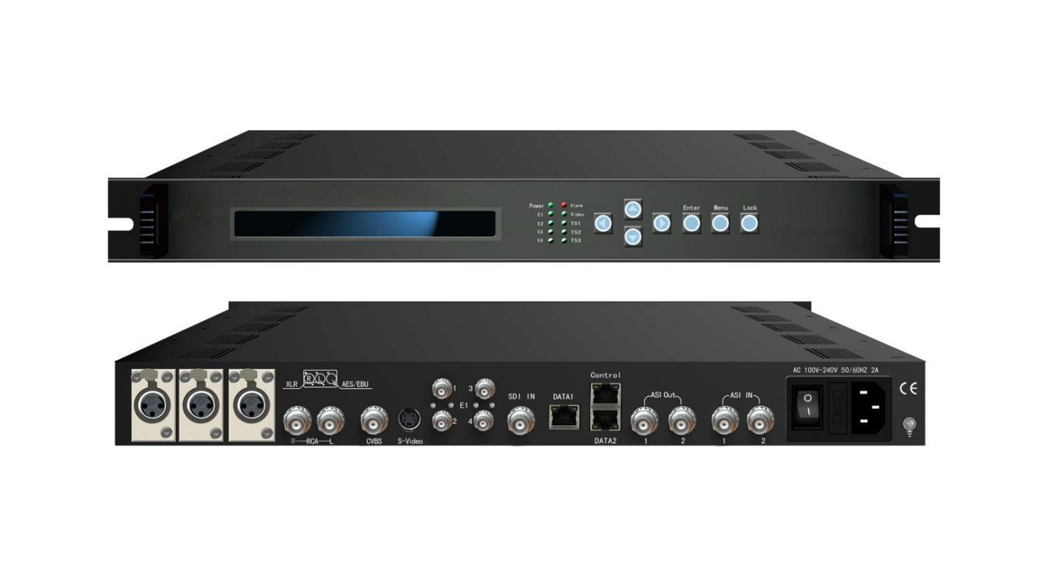Product overview
The FMUSER FUQ-4312D is a professional MPEG-2 SD encoder with 4 inputs (CVBS, S-Video, SD-SDI, and analog/AES/EBU audio). It processes PAL/NTSC signals (720×480/576) with de-interlacing and outputs ASI or UDP/IP transport streams. This 1U rack-mount unit supports dual control via LCD and web interface, ideal for broadcast headends and IP-based contribution networks.
Key feature
Controls via LCD panel & web interface with GOP customization
Principle Chart
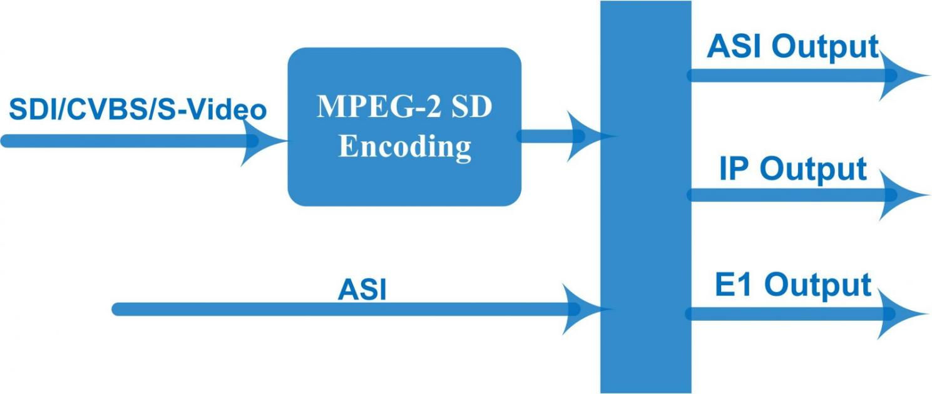

Specifications

input | Video | Analog composite video(CVBS), BNC interface
input | Video | S-Video interface
input | Video | SD-SDI, BNC interface
input | Audio | Analog stereo audio(balanced), XLR interface
input | Audio | Analog stereo audio(unbalanced), BNC interface
input | Audio | AES / EBU digital audio, XLR interface
input | Audio | SD-SDI embedded audio
Video | Resolution | 720×480_59.94i, 720×576_50i
Video | Encoding | MPEG-2 MP@ML
Video | Bit-rate | 0.8Mbps~19.5Mbps
Video | Rate Control | CBR/VBR
Video | GOP Structure | IIII, IPPP, IBPB, IBBP
Video | Aspect Ratio | 4:3; 16:9
Video | Advanced Pretreatment | De-interlacing, noise reduction, sharpening
Audio | Encoding | MPEG-1 Layer 2
Audio | Sampling rate | 48KHz, 44.1KHz, 32KHz
Audio | Bitrate | 64Kbps—384Kbps
Stream output |  | 2-way ASI output, BNC interface
 |  | E1 output –Optional
 |  | TS output over UDP,100/1000Base-T Ethernet interface (UDP unicast / multicast)
System function |  | LCD/keyboard, network management(NMS)  Chinese and English language
 |  | Ethernet software upgrade
General | Dimensions  (WxDxH) | 482mm×455mm×44.5mm
General | Temperature range | 0~45℃(operation), -20~80℃(storage)
General | Power Requirements | AC 110V±10%,50/60Hz or AC 220V±10%,50/60Hz

About Us
FMUSER is a company specializing in broadcasting and television transmission systems and integrating hotel IPTV systems. The company was established in 2009 and has served over 180 countries worldwide. More than 20,000 television stations, radio stations, and hotel clients from different.

Contact:Tomleequan Email：sales@fmuser.com whatsapp: +8613922702227

