FMUSER FUQ-4313B Dual Channel Audio Encoder Analog Balanced XLR AES-EBU Input ASI IP UDP-RTP Output MPEG1 Layer 2 AAC Encoding for Broadcast Workflows
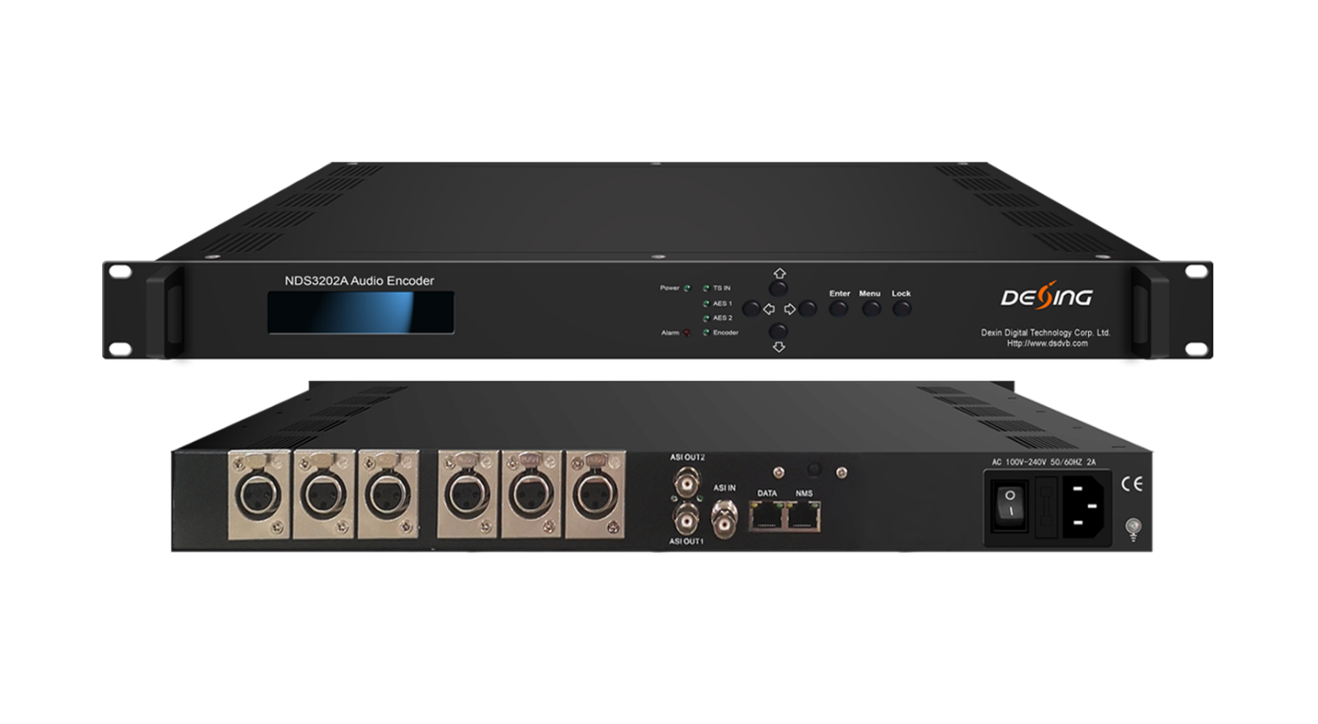Product overview
The FMUSER FUQ-4313B is a dual-channel audio encoder supporting analog balanced audio and AES/EBU digital audio inputs via XLR interfaces, with outputs for ASI multiplexing and IP/UDP/RTP. It encodes audio signals using MPEG1 Layer 2 and AAC formats. Control is available via LCD/keyboard or Web GUI, featuring hot-pluggable dual/single PSU options. Ideal for digital broadcasting and robust broadcast workflows.
Key feature
Enables flexible control via LCD/keyboard or Web GUI, with hot-pluggable dual/single PSU options.* MPEG1 Layer 2 and AAC encoding
Principle Chart
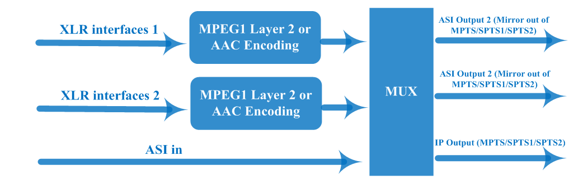

Specifications
Input | Analog balanced audio, XLR interfaces
Input | AES / EBU digital audio, XLR interface
Input | 1*ASI input, BNC interface
Encoding | Encoding | MPEG1 Layer 2, AAC
Encoding | Sample rate | 48KHz
Encoding | Sample accuracy | 16bit
Encoding | Bit-rate | 64/96/128/192/256/320/384kbps
Encoding | Sound Track | left, right, stereo (AAC is only for stereo)
Multiplexing | Maximum PID Number | 64
Output | 2 independent ASI outputs, BNC interface (Mirror out of MPTS/SPTS1/SPTS2)
Output | IP output over UDP/RTP protocol, 100M/1000M Self-adaptive rj45 interface (unicast / multicast)
System function | LCD/keyboard, Web GUI management  Chinese and English language
System function | Ethernet software upgrade
General | Dimensions (W×D×H) | 482mm×350mm×44mm
General | Temperature range | 0~45℃(operation), -20~80℃(storage)
General | Power Requirements | AC 110V±10%,50/60Hz  AC 220V±10%,50/60Hz
General | Power Consumption | <15W
General | Weight | About 3.2kg

About Us
FMUSER is a company specializing in broadcasting and television transmission systems and integrating hotel IPTV systems. The company was established in 2009 and has served over 180 countries worldwide. More than 20,000 television stations, radio stations, and hotel clients from different.

Contact:Tomleequan Email：sales@fmuser.com whatsapp: +8613922702227

