FMUSER FUQ-4315B 4-Channel Encoder 4× CVBS-S-Video-YPbPr Input ASI-IP Output MPEG-2 MPEG-1 Layer II Encoding Multiplexing for Cable Headends Satellite Broadcasting
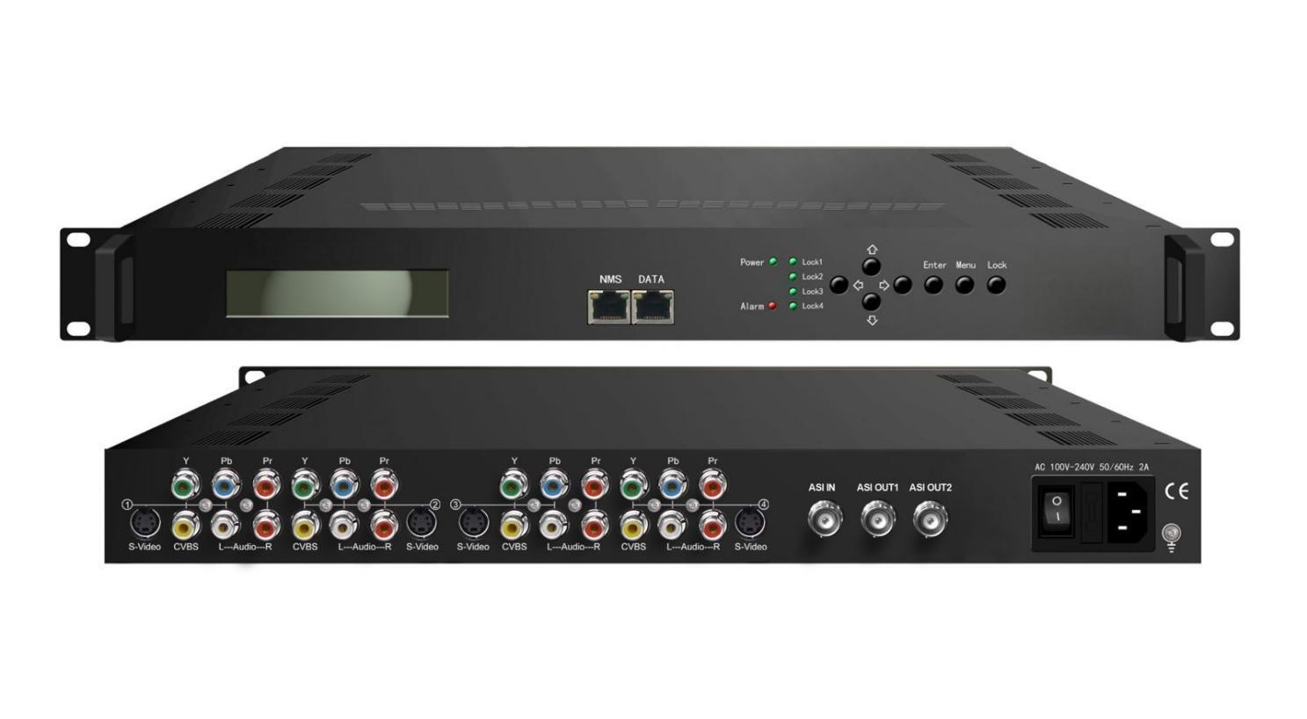Product Overview
The FUQ-4315E is a 4-channel encoder with CVBS/S-Video/YPbPr inputs, supporting MPEG-2 video and MPEG-1 Layer II audio encoding. It processes signals through ASI input multiplexing to generate MPTS streams, with outputs via IP and ASI. This unit features LCD+keyboard control and Web NMS/SNMP management. Ideal for digital headends in cable and satellite broadcasting systems.
Key feature
- Integrates 4× CVBS/S-Video/YPbPr inputs and 1× ASI input for flexible signal integration.
- Supports MPEG-2 video encoding at 1-19.5Mbps and MPEG-1 Layer II audio encoding.
- Provides ASI and IP outputs with UDP/RTP multicast/unicast capability.
- Ensures stream stability through CBR and PCR adjustment.
- Enables PSI/SI editing and PID remapping/passthrough, managed via LCD+keyboard or Web NMS/SNMP.

Principle Chart
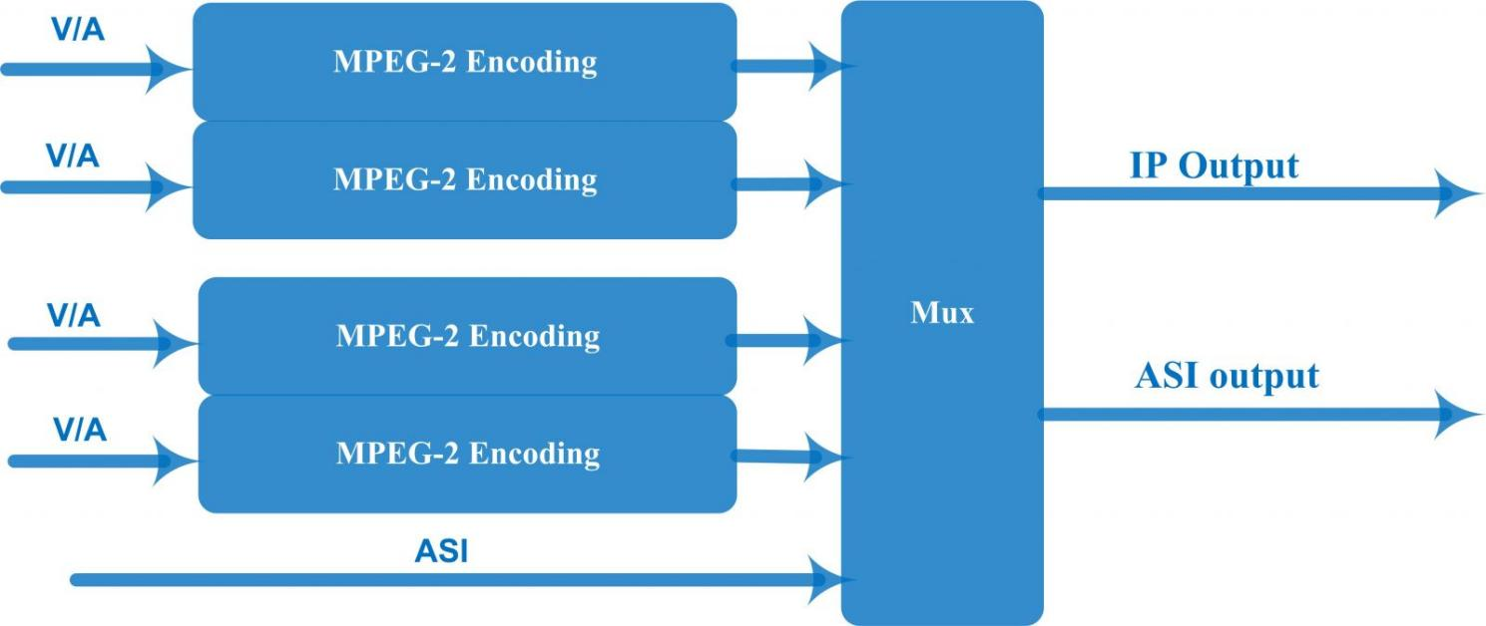

Specifications
Input | 4xS-Video/YPbPr/CVBS (RCA)
Input | 1×ASI input
Encoding | Video | Format | MPEG-2 MP@ML (4:2:0)
Encoding | Video | Interface | S-Video/YPbPr/CVBS*4(RCA)
Encoding | Video | Bitrate | 1-19.5Mbps
Encoding | Video | Resolution | 720*480_60i, 720*576_50i
Encoding | Video | Rate mode | VBR/CBR
Encoding | Video | Chroma | 4:2:0
Encoding | Video | Aspect | 16:9,4:3, 1:1, 2.21:1
Encoding | Audio | Format | MPEG1 Layer II
Encoding | Audio | Interface | 4*Stereo or 8*mono (RCA)
Encoding | Audio | Sample rate | 48KHz
Encoding | Audio | Bitrate | 64kbps,96kbps,128kbps,192kbps,256kbps,320kbps
Stream output | 1*ASI
Stream output | 1 IP over UDP/RTP, 10/100Base-T Ethernet interface (unicast / multicast)
System | Local interface | LCD + control buttons
System | Remote management | Web NMS Management
System | Language | English
General | Dimension  (W*D*H) | 482mm×300mm×44.5mm
General | Weight | 3.5kg
General | Temperature | 0~45℃(Operation) ; -20~80℃(Storage)
General | Power | AC 100V~240V
General | Consumption | 25W

About Us
FMUSER is a company specializing in broadcasting and television transmission systems and integrating hotel IPTV systems. The company was established in 2009 and has served over 180 countries worldwide. More than 20,000 television stations, radio stations, and hotel clients from different.

Contact:Tomleequan Email：sales@fmuser.com whatsapp: +8613922702227

