FMUSER FUQ-4322AB HD Encoder 2 Inputs HDMI-HD-SDI 3 Outputs ASI-IP HEVC-H.265 H.264 Encoding OSD Insertion Broadcasting Live Streaming
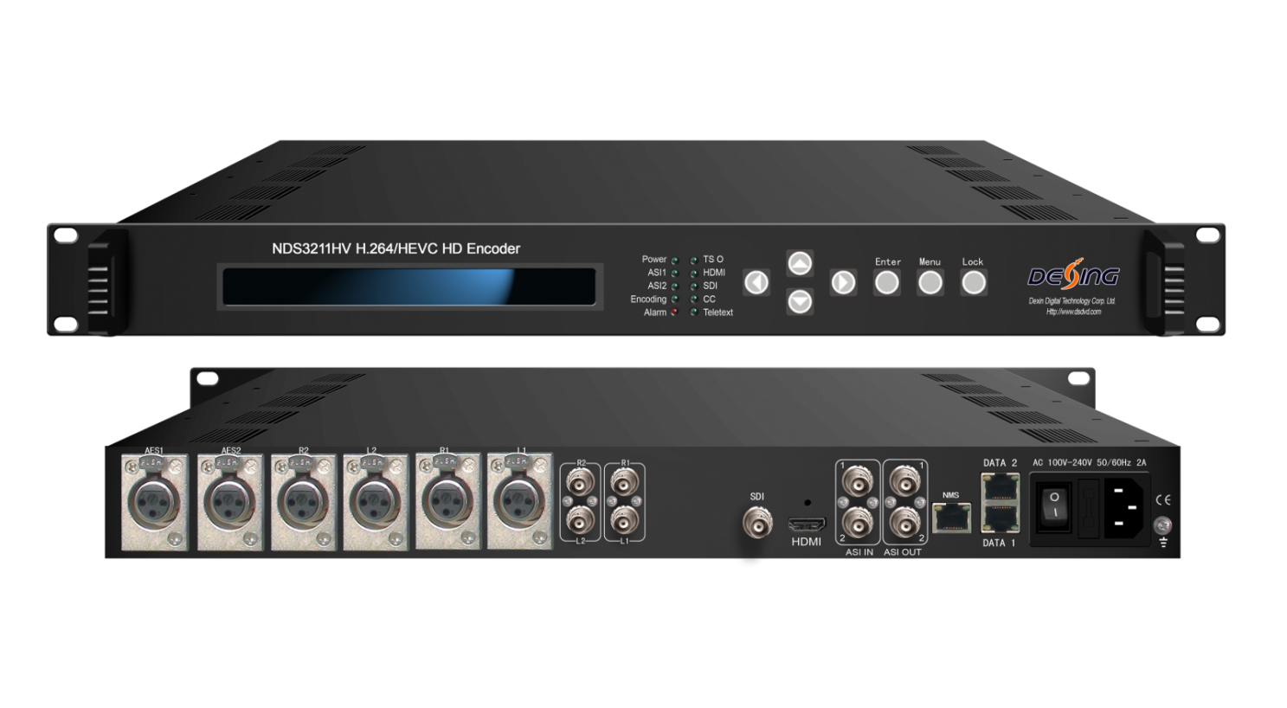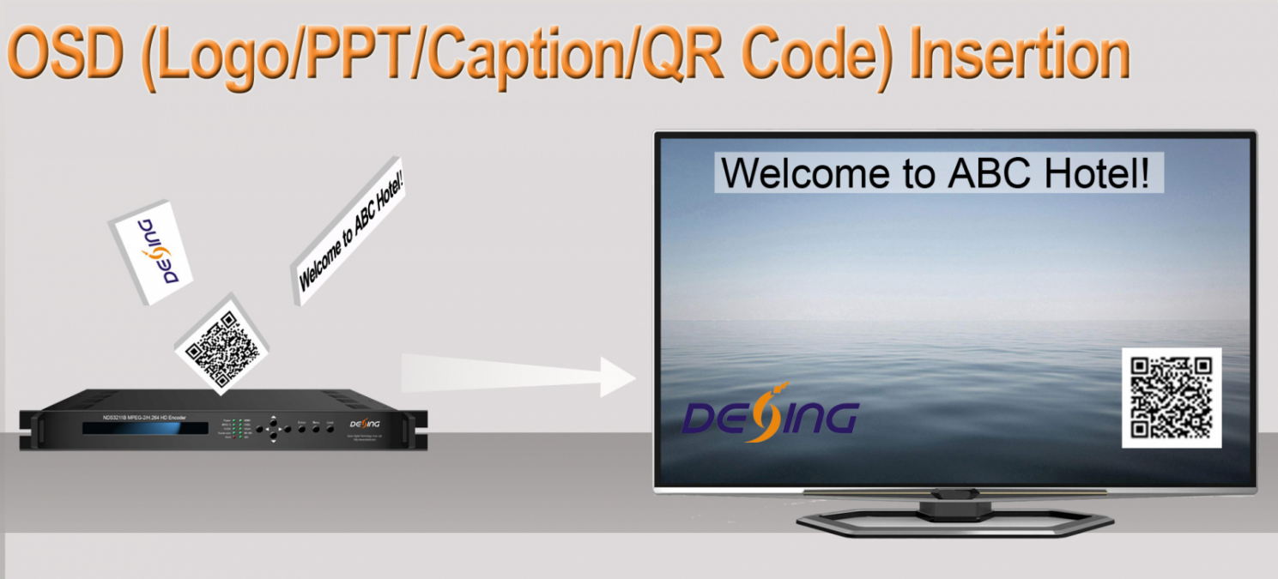
Product overview
The FMUSER FUQ-4322AB is a professional HD encoder supporting HEVC/H.265 and H.264 video encoding. It accepts inputs from HDMI and HD-SDI sources and outputs via ASI or IP with OSD insertion. Control is managed through web management. Ideal for broadcasting applications like live streaming and television transmission.Multiple audio and video encoding formats are available to meet customers’ various requirements. It supports 2 stereo (4 mono) to mix with the video to form a stream output. The encoded program will finally output in TS through ASI/IP port.
Key feature
- Supports HEVC/H.265 and H.264 HD video encoding with B-frame support.
- Features OSD insertion for QR codes, logos, and captions.
- Offers flexible audio encoding supporting 2 stereos or 4 mono channels with MPEG-1 Layer II, HE-AAC, and LC-AAC.
- Provides multiple output options including ASI and IP over UDP/RTP/RTSP.
Inner Principle Chart
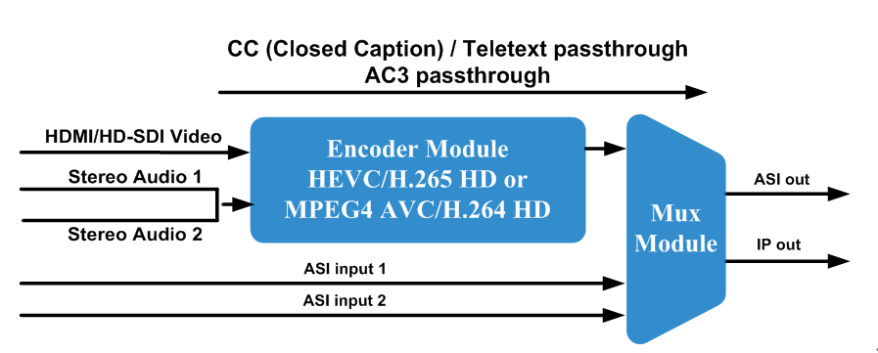

- Supports HEVC/H.265 and H.264 HD video encoding with B-frame support.
- Features OSD insertion for QR codes, logos, and captions.
- Offers flexible audio encoding supporting 2 stereos or 4 mono channels with MPEG-1 Layer II, HE-AAC, and LC-AAC.
- Provides multiple output options including ASI and IP over UDP/RTP/RTSP.
Specifications
Video | Interface | 1×HDMI, 1×HD-SDI
Video | Resolution | Input |  | Output
Video | Resolution |  |  | MPEG-4 AVC/H.264 HD | HEVC/H.265 HD
Video | Resolution | 1920×1080p@60/59.94 |  | 1920×1080p@60/59.94 | 1920×1080p@60/59.94
Video | Resolution | 1920×1080p@50 |  | 1920×1080p@50 | 1920×1080p@50
Video | Resolution | 1920×1080i@60/59.94 |  | 1920×1080i@60  1920×1080p@60/30 | 1920×1080p@60
Video | Resolution | 1920×1080i @50 |  | 1920×1080i@50  1920×1080p@50/25 | 1920×1080p@50
Video | Resolution | 1280×720p@60/59.94 |  | 1280×720p@60/59.94 | 1280×720p@60/59.94
Video | Resolution | 1280×720p@50 |  | 1280×720p@50 | 1280×720p@50
Video | Encoding | HEVC/H.265 HD; MPEG-4 AVC/H.264 HD
Video | Bitrate Range | HEVC/H.265: 0.5 – 20.00 Mbps  MPEG-4 AVC/H.264: 4 – 20.00 Mbps
Video | Rate Control | CBR/VBR
Video | GOP Structure | IPPP, IBBP
Video | Chroma | 4:2:0
Audio | Interface | 2×XLR, 2×AES, 2×RCA, 1×SDI (support maximum 2 stereos synchronous processing), 1×HDMI,
Audio | Encoding | MPEG-1 Layer II, HE-AAC (v1&v2), LC-AAC, DD AC3 passthrough
Audio | Sampling rate | 48KHz
Audio | Bit-rate | 48Kbps~384Kbps
Stream Input |  | 2 ASI Input for remux
Stream output |  | 2×ASI output ports, BNC interface
 |  | 1 IP (MPTS) over UDP / RTP /RTSP, 1000 Base-T Ethernet interface*2 with independent IP addresses (multicast/unicast)
System function |  | LCD/keyboard and web management
 |  | Language: English
 |  | Ethernet software upgrade
General |  | Dimensions | 482mm×405mm×44.5mm (W × D × H)
 |  | Temperature | 0~45℃(Operation), -20~80℃(Storage)
 |  | Power | AC110V±10%, 50/60Hz; AC 220V±10%,50/60Hz
 |  | Consumption | 15W

- Supports HEVC/H.265 and H.264 HD video encoding with B-frame support.
- Features OSD insertion for QR codes, logos, and captions.
- Offers flexible audio encoding supporting 2 stereos or 4 mono channels with MPEG-1 Layer II, HE-AAC, and LC-AAC.
- Provides multiple output options including ASI and IP over UDP/RTP/RTSP.
Technical Comparison
- Supports HEVC/H.265 and H.264 HD video encoding with B-frame support.  - Features OSD insertion for QR codes, logos, and captions.  - Offers flexible audio encoding supporting 2 stereos or 4 mono channels with MPEG-1 Layer II, HE-AAC, and LC-AAC.  - Provides multiple output options including ASI and IP over UDP/RTP/RTSP.  - Supports HEVC/H.265 and H.264 HD video encoding with B-frame support.  - Features OSD insertion for QR codes, logos, and captions.  - Offers flexible audio encoding supporting 2 stereos or 4 mono channels with MPEG-1 Layer II, HE-AAC, and LC-AAC.  - Provides multiple output options including ASI and IP over UDP/RTP/RTSP. | FU-4322B | FU-4322A | FU-4322HV
Chipset | Magnum | Magnum | Fujitsu
Video Encoding | MPEG-2 HD/SD;  MPEG-4 AVC/H.264 HD/SD | MPEG-2 HD/SD;  MPEG-4 AVC/H.264 HD/SD | HEVC/H.265 HD  MPEG-4 AVC/H.264 HD
Bit Rate | 0.20 – 60.00 Mbps | 0.25Mbps~60.5Mbps | HEVC/H.265: 0.5 – 20.00 Mbps  MPEG-4 AVC/H.264: 4 – 20.00 Mbps
HDMI Resolution | HD | HD/SD | HD
Audio Encode | MPEG-1 Layer II,  HE-AAC (v1&v2),  LC-AAC,  DD AC3 (2.0),  DD AC3 passthrough (for SDI in) | MPEG-1 Layer II,  HE-AAC (v1&v2),  LC-AAC;  DD AC3 passthrough | MPEG-1 Layer II, HE-AAC (v1&v2), LC-AAC,  DD AC3 passthrough (for SDI and HDMI)
Audio Channel | Up to 4 stereos | Up to 2 stereos | Up to 2 stereos
Rate Control | CBR | CBR/VBR | CBR/VBR
Aspect Ratio | 16:9, 4:3, 14:9 | 16:9, 4:3, 1:1, 2.35:1 | - Supports HEVC/H.265 and H.264 HD video encoding with B-frame support.  - Features OSD insertion for QR codes, logos, and captions.  - Offers flexible audio encoding supporting 2 stereos or 4 mono channels with MPEG-1 Layer II, HE-AAC, and LC-AAC.  - Provides multiple output options including ASI and IP over UDP/RTP/RTSP.
Chroma | 4:2:0, 4:2:2 | 4:2:0, 4:2:2 | 4:2:0
One-seg | N/A | Yes | N/A
Video Buffer | Yes | N/A | N/A
ASI In & Mux | N/A | 1 ASI input for remux | 2 ASI input for remux
IP out | 1SPTS over UDP/RTP | MPTS/8*SPTS over UDP/RTP, | 1 MPTS over UDP / RTP /RTSP
Low Delay | 150ms, 200ms, 350ms, 650ms | 1400ms - 5000ms, 1ms stepping | N/A
Closed Caption | EIA 608 and EIA 708 | EIA 608 and EIA 708 | EIA 608
OSD Function | Yes | N/A | Yes
Management | Web-server | Web-server, SNMP | Web-server

- Supports HEVC/H.265 and H.264 HD video encoding with B-frame support.
- Features OSD insertion for QR codes, logos, and captions.
- Offers flexible audio encoding supporting 2 stereos or 4 mono channels with MPEG-1 Layer II, HE-AAC, and LC-AAC.
- Provides multiple output options including ASI and IP over UDP/RTP/RTSP.

About Us
FMUSER is a company specializing in broadcasting and television transmission systems and integrating hotel IPTV systems. The company was established in 2009 and has served over 180 countries worldwide. More than 20,000 television stations, radio stations, and hotel clients from different.

Contact:Tomleequan Email：sales@fmuser.com whatsapp: +8613922702227

