FMUSER FUQ-4322B Professional 4K Encoder Dual HDMI 2.0 Inputs 4 ASI Outputs IP MPTS UDP-RTP H.265 HEVC H.264 Broadcast Streaming
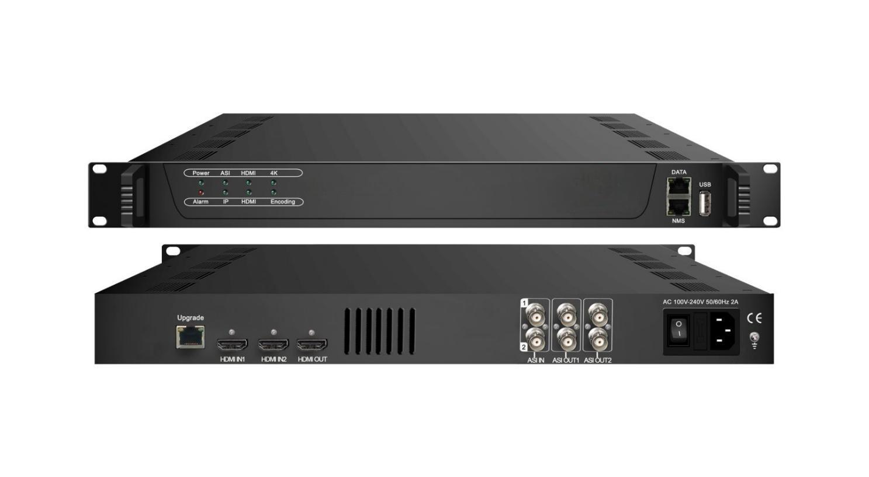Product Overview
The FMUSER FUQ-4322B is a 4K encoder featuring dual HDMI 2.0 inputs with hot redundancy, supporting H.265/HEVC and H.264/AVC video encoding. It outputs 1 TS via 4 ASI ports and 1 MPTS over IP with real-time bit-rate monitoring. Controlled via web-based NMS, it is ideal for broadcast and streaming applications.
Key feature
Supports dual HDMI 2.0 inputs with hot redundancy and loop-out for 1080P/4K conversion.
Encodes video in H.265/HEVC and H.264/AVC formats with CBR control (1–23Mbps).
Outputs via 4 ASI ports and 1 MPTS over IP (UDP/RTP, unicast/multicast).
Features broadcast enhancements including logo insertion, captioning, and QR code insertion.
(1080P and 4K convert to each other)

Specifications
Input | 1×HDMI input (2.0) with 2 HDMI port, HDCP 2.2/1.4
Input | 2 ASI input, BNC interface
Input | 32 IP input over UDP and RTP protocol
Video Input | Resolution |  |  | Chroma
Video Input | 3840×2160_60P,3840×2160_59.94P, 3840×2160_50P,3840×2160_30P, 3840×2160_29.96P,3840×2160_25P,  3840×2160_24P,1920×1080_60P,  1920×1080_59.94P,1920×1080_50P, 1920×1080_30P ,1920×1080_25P 1920×1080_24P, |  |  | RGB, YCbCr 4:4:4, YCbCr 4:2:2,  YCbCr 4:2:0 (2160P_50/60Hz only)
Video Encoding | Encoding | H.265/HEVC, H.264/AVC
Video Encoding | Chroma | 4:2:2, 4:2:0
Video Encoding | Bit-rate | 1Mbps~23Mbps
Video Encoding | Rate Control | CBR
Audio Encoding | Encoding | MPEG-1 Layer 2, LC-AAC
Audio Encoding | Sampling rate | 48KHz
Audio Encoding | Bit-rate | 64Kbps~256Kbps each channel
Multiplexing | 2 ASI input multiplexed with local 1 channel of TS
Multiplexing | PID remapping (automatically or manually)
Multiplexing | Accurate PCR adjusting
Multiplexing | Generate PSI/SI table automatically
Stream output | 1*ASI output through 4 BNC interfaces
Stream output | 1 MPTS over UDP/RTP, 1000M/100M Base-T Ethernet interface (unicast/ multicast)
System function | LCD/keyboard operating, web NMS supporting
System function | Ethernet software & hardware upgrade
Miscellaneous | Dimension (W× L× H) |  | 482mm×455mm×44mm
Miscellaneous | Approx weight |  | 4kg
Miscellaneous | Temperature |  | 0~45℃(work), -20~80℃（Storage）
Miscellaneous | Power |  | AC 100V-220V±10%, 50/60Hz
Miscellaneous | Consumption |  | 25W

Principle Chart
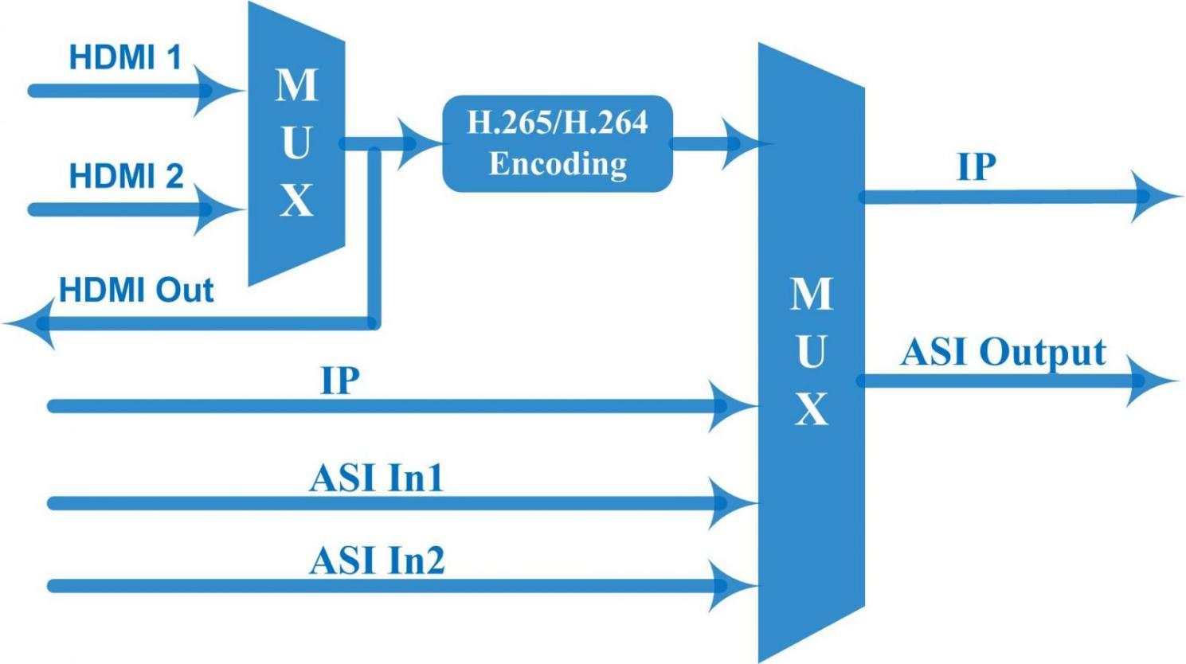

About Us
FMUSER is a company specializing in broadcasting and television transmission systems and integrating hotel IPTV systems. The company was established in 2009 and has served over 180 countries worldwide. More than 20,000 television stations, radio stations, and hotel clients from different.

Contact:Tomleequan Email：sales@fmuser.com whatsapp: +8613922702227

