FMUSER FUQ-4322C HD Encoder 4-Input HDMI-SDI-YPbPr-CVBS 4-Output ASI-IP MPEG-2 H.264 Encoding OSD Insertion Broadcast Applications
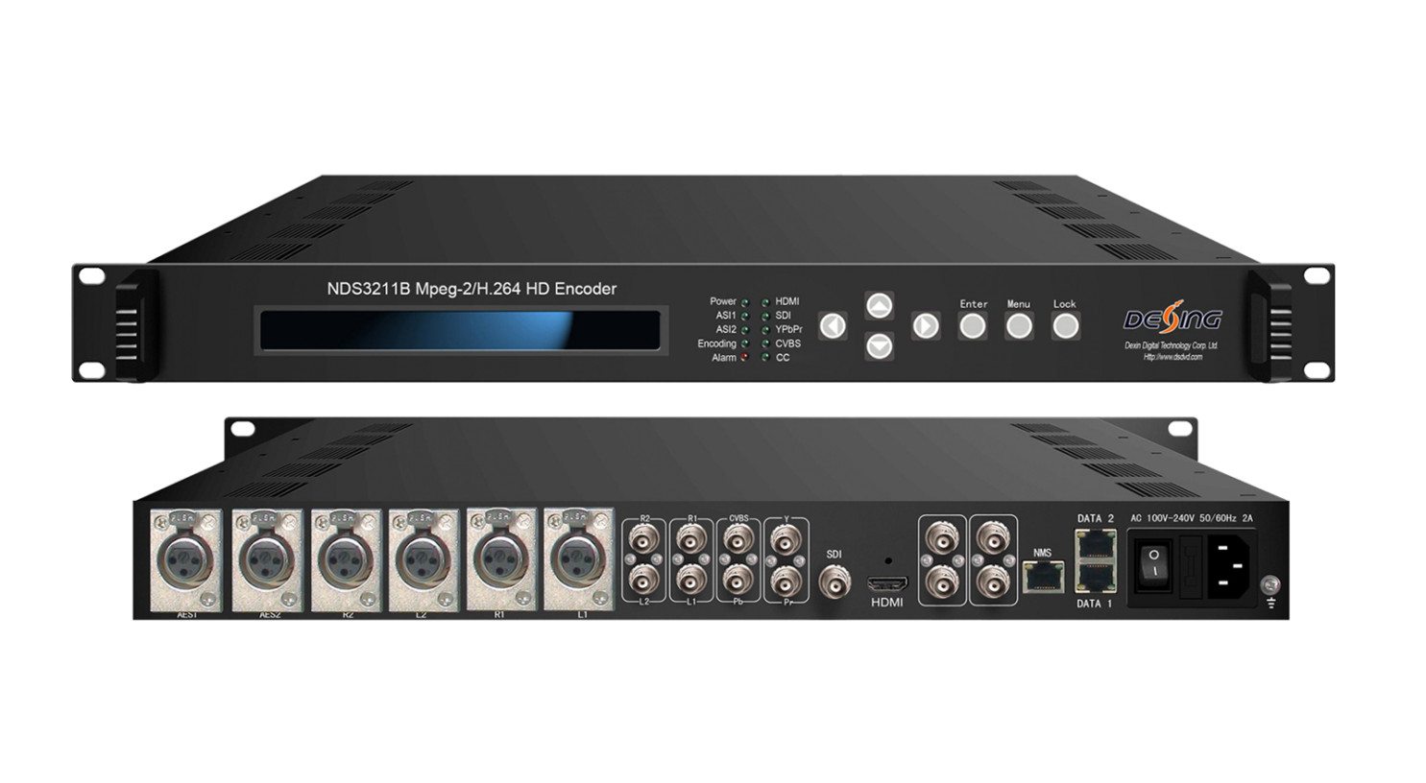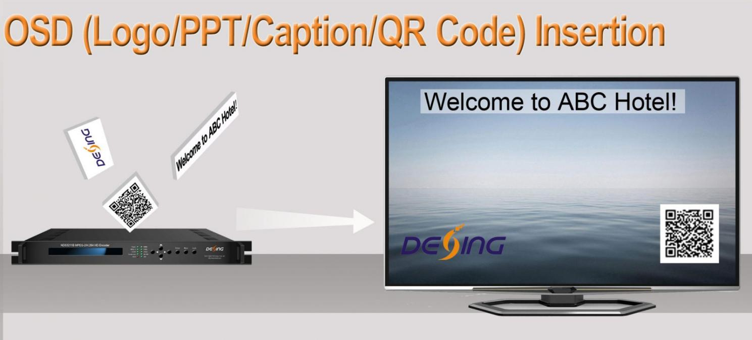

Product overview
The FUQ-4322C HD encoder supports MPEG-2 and H.264 encoding, with inputs including HDMI, SDI, YPbPr, CVBS for video and AES, BNC, XLR for audio, and outputs TS streams via ASI or IP. It processes signals by encoding them with OSD insertion for QR codes, logos, and captions. The device features LCD/keyboard and web management interfaces for control. Ideal for broadcast applications such as television broadcasting and network integration.
Key feature
Supports MPEG-2 and H.264 video encoding for resolutions like 1080i/p and 720p.
Encodes audio in MPEG-1 Layer II, HE-AAC, LC-AAC, and DD AC3 formats with passthrough.
Enables OSD insertion of QR codes, logos, and captions during encoding.
Delivers streams via ASI output and IP over UDP/RTP for MPTS distribution.
Features LCD/keyboard and web management interfaces for configuration.
Inner Principle Chart
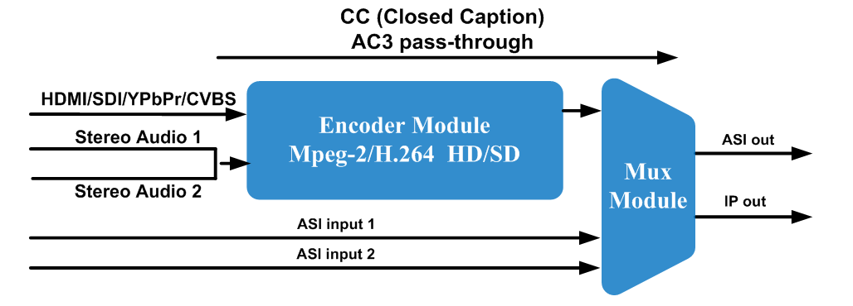

Specifications
Video | Interface | 1×HDMI, 1×HD-SDI, 1×YPbPr and 1×CVBS (only for CC)
Video | Resolution | Input | Output | Interface Applicable
Video | Resolution | 1920×1080p@60/59.94 | 1920×1080p@60, | SDI, HDMI
Video | Resolution | 1920×1080p@50 | 1920×1080p@50 | SDI, HDMI
Video | Resolution | 1920×1080i@60/59.94 | 1920×1080i @60 | SDI, HDMI, YpbPr
Video | Resolution | 1920×1080i @50 | 1920×1080i @50 | SDI, HDMI, YpbPr
Video | Resolution | 1280×720p@60/59.94 | 1280×720p@60 | SDI, HDMI, YpbPr
Video | Resolution | 1280×720p@50 | 1280×720p@50 | SDI, HDMI, YpbPr
Video | Resolution | 720×576i@50 | 720×576i @50 | SDI, HDMI
Video | Resolution | 720×480i@60 | 720×480i @60 | SDI, HDMI
Video | Encoding | MPEG-2 HD/SD,  MPEG-4 AVC/H.264 HD/SD
Video | Bitrate Range | 2.5 – 19.00 Mbps
Video | Rate Control | CBR/VBR
Video | GOP Structure | IP, IBBP, IBBBP
Video | Chroma | 4:2:0
Audio | Interface | 2×XLR, 2×AES, 2×BNC, 1×SDI (support maximum 2 stereos synchronous processing), 1×HDMI,
Audio | Encoding | MPEG-1 Layer II, HE-AAC (v1&v2), LC-AAC, DD AC3 (2.0)  DD AC3 pass-through (for SDI and HDMI in)
Audio | Sampling rate | 48KHz
Audio | Bit-rate | 32Kbps~384Kbps
Stream Input |  | 2 ASI Input for remux
Stream output |  | 2×ASI output ports, BNC interface
 |  | 2 IP (MPTS) over UDP / RTP /RTSP, 1000 Base-T Ethernet interface*2 with independent IP addresses (multicast/unicast)
System function |  | LCD/keyboard and web management
 |  | Language: English
 |  | Ethernet software upgrade
General |  | Dimensions | 482mm×405mm×44.5mm (W × D × H)
 |  | Temperature | 0~45℃(Operation), -20~80℃(Storage)
 |  | Power | AC110V±10%, 50/60Hz; AC 220V±10%,50/60Hz
 |  | Consumption | 16W

Technical Comparison
 | FU-4322B(V2) | FU-4322HS
Chipset | Vixs | Hisilicon
Video Encoding | MPEG-2 HD/SD;  MPEG-4 AVC/H.264 HD/SD | HEVC/H.265 HD/SD  MPEG-4 AVC/H.264 HD/SD
Bit Rate | 2.5Mbps~19.0Mbps | 1Mbps~15Mbps
HDMI Resolution | HD/SD | HD/SD
Audio Encode | MPEG-1 Layer II,  HE-AAC (v1&v2),  LC-AAC,  DD AC3 (2.0),  DD AC3 pass-through (for SDI and HDMI in) | MPEG-1 Layer II, HE-AAC (v1&v2), LC-AAC,  DD AC3 pass-through (for SDI and HDMI in)
Audio Channel | Up to 2 stereos | Up to 2 stereos
Rate Control | CBR/VBR | CBR/VBR
Aspect Ratio | 16:9, 4:3
Chroma | 4:2:0 | 4:2:0
Video Buffer | Yes | N/A
ASI In & Mux | 2 ASI input for remux | 2 ASI input for remux
IP out | 1 MPTS over UDP / RTP /RTSP | 1 MPTS over UDP / RTP /RTSP
Low Delay | 150ms - 650ms | N/A
Closed Caption | EIA 608 and EIA 708 | EIA 608

About Us
FMUSER is a company specializing in broadcasting and television transmission systems and integrating hotel IPTV systems. The company was established in 2009 and has served over 180 countries worldwide. More than 20,000 television stations, radio stations, and hotel clients from different.

Contact:Tomleequan Email：sales@fmuser.com whatsapp: +8613922702227

