FMUSER FUQ-4335X-N Network Encoder 4-8-12 HDMI Inputs HDCP 1.4 HEVC-H.265 H.264 Encoding IP Output SRT-RTP-RTSP-RTMP-HTTP-HLS for CATV Satellite Terrestrial
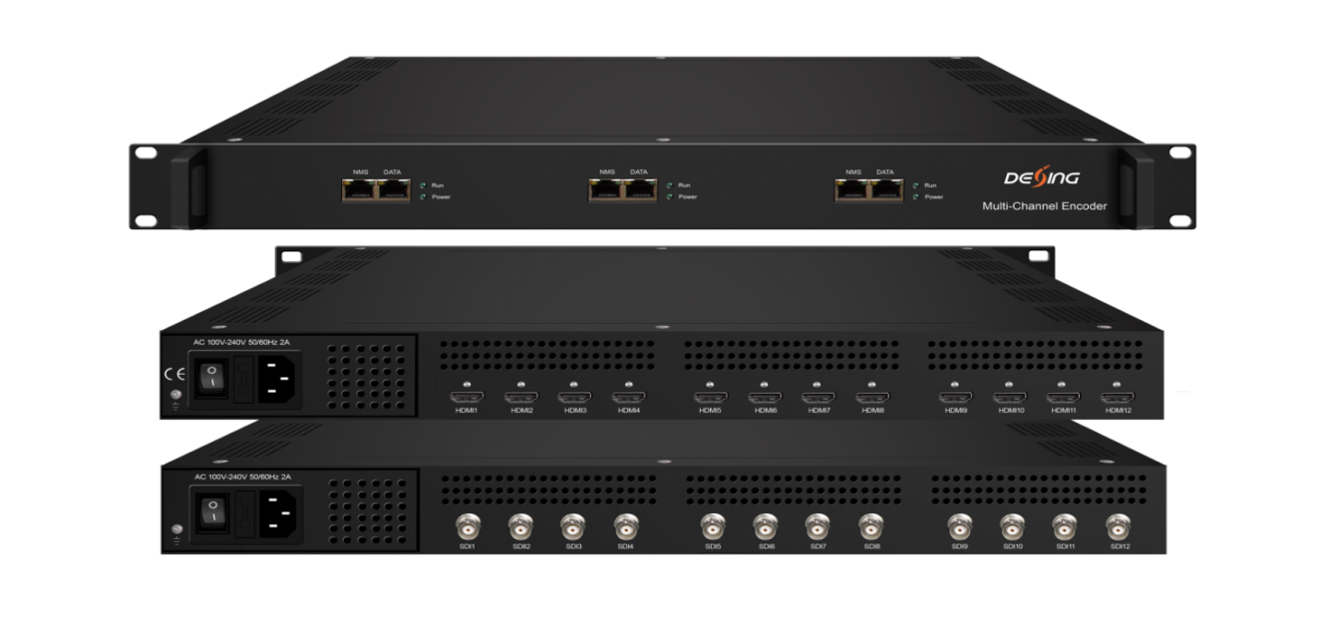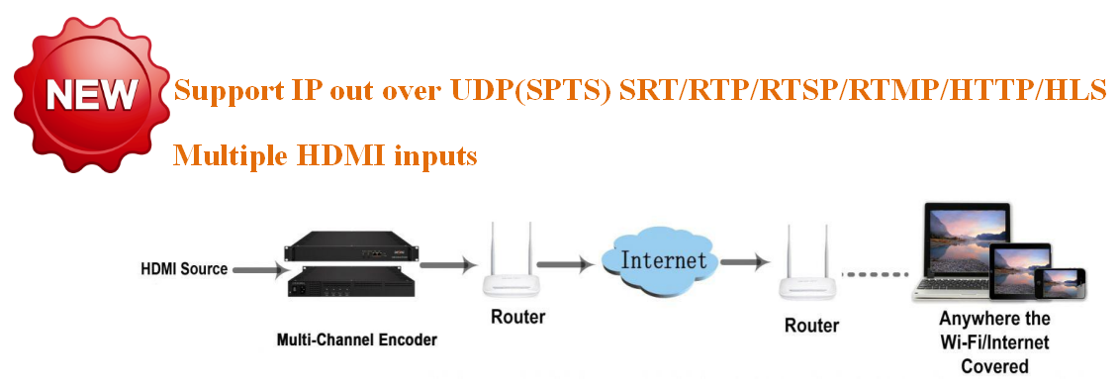
Product Overview
The FMUSER FUQ-4335X-N is a multi-channel network encoder with configurable 4, 8, or 12 HDMI inputs supporting HDCP 1.4. It encodes video using HEVC/H.265 and H.264 formats at resolutions up to 1080P/720P 50/60Hz, including de-interlacing pretreatment. Output delivers IP streams via SRT, RTP, RTSP, RTMP, HTTP, and HLS over Ethernet, with web-based management. This device is ideal for CATV headends, satellite broadcasting, and terrestrial TV systems.
Key feature
Supports configurable 4/8/12 HDMI inputs with HDCP 1.4 compliance.
Features HEVC/H.265 and H.264 encoding with B-frame (IBBP) GOP for high compression.
Provides flexible IP streaming via SRT, RTP, RTSP, RTMP, HTTP, and HLS.
Ensures stable transport stream output with Fujitsu chip technology.
Offers advanced system management via web-based control.

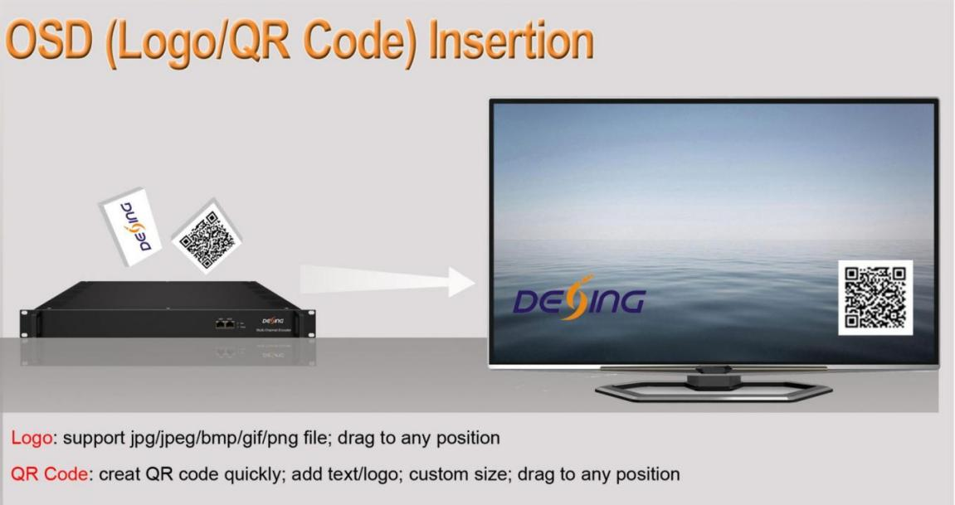
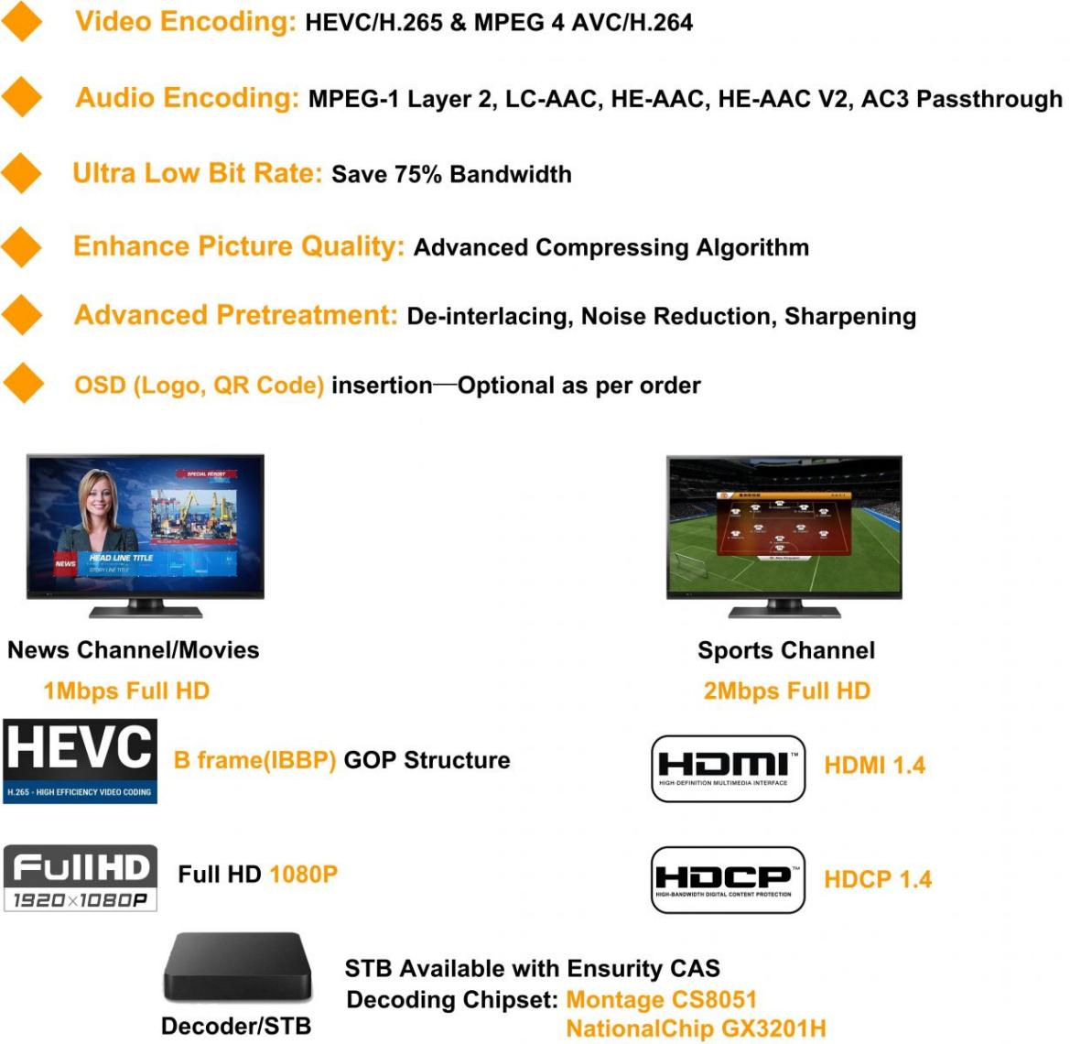

Principle Chart of Per Module
(The number of encoding channels depeFU on encoding format and resolution)
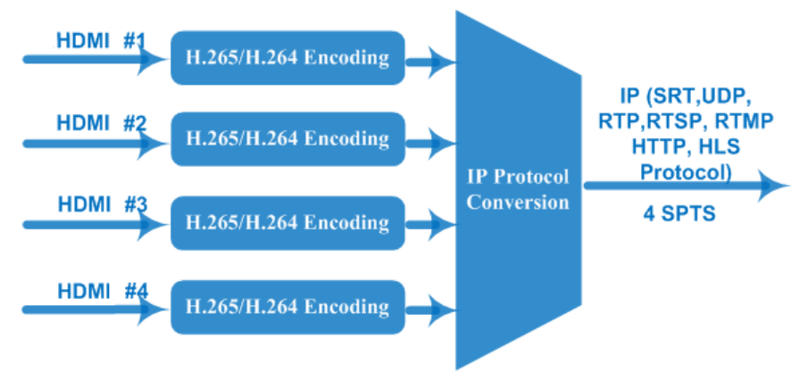
Technical Specification

Input | 4/8/12 HDMI inputs for option, HDCP 1.4
Video  Encoding | Encoding Format | HEVC/ H.265 , MPEG 4 AVC/H.264
Video  Encoding | Resolution | Input |  | Output
Video  Encoding | Resolution |  |  | HEVC/H.265 | MPEG-4 AVC/H.264
Video  Encoding | Resolution | 4*1080P-50 |  | 4*1080P-50 | 2*1080P-50
Video  Encoding | Resolution | 4*1080P-60 |  | 4*1080P-60, | 2*1080P-60
Video  Encoding | Resolution | 4*1080I-50 |  | 4*1080P-50 | 4*1080I-50  2*1080P-50
Video  Encoding | Resolution | 4*1080I-60 |  | 4*1080P-60 | 4*1080I-60  2*1080P-60
Video  Encoding | Resolution | 4*720P-50 |  | 4*720P-50 | 4*720P-50
Video  Encoding | Resolution | 4*720P-60 |  | 4*720P-60 | 4*720P-60
Video  Encoding | Chroma | 4:2:0
Video  Encoding | Bitrate | 0.5Mbps~20Mbps(each channel)
Video  Encoding | Rate Control | CBR/VBR
Video  Encoding | GOP Structure | IBBP, IPPP
Video  Encoding | Advanced Pretreatment | De-interlacing, Noise Reduction, Sharpening
Audio Encoding | Encoding Format | MPEG-1 Layer 2, LC-AAC, HE-AAC, HE-AAC V2, AC3 Pass-through
Audio Encoding | Sampling rate | 48KHz
Audio Encoding | Bit-rate (each channel) | 48Kbps~384Kbps (MPEG-1 Layer 2& LC-AAC)  24 Kbps~128 Kbps (HE-AAC)  18 Kbps~56 Kbps (HE-AAC V2)
Audio Encoding | Audio Gain | 0~255
Stream output | IP (4 SPTS) output over SRT, RTP, RTSP, RTMP, HTTP, HLS per module, 1000M/100M Base-T Ethernet interface (unicast/multicast); IPv4, IPv6 output  IP null packet filter
System | Web based management
System | Chinese-English control interface
System | Ethernet software upgrade
Miscellaneous | Dimension (W× L× H) |  | 482mm×328mm×44mm
Miscellaneous | Approx weight |  | 5kg
Miscellaneous | Temperature |  | 0~45℃(work), -20~80℃（Storage）
Miscellaneous | Power |  | AC 100V-220V±10%, 50/60Hz

FMUSER HEVC/H.265 encoder’s advantages
1. Providing smooth TS for modulators
FMUSER HEVC/H.265 encoder adopts Fujitsu chip which offers stable bitrate with lower fluctuation compared with other encoding chips, so it provides smooth TS for modulators. Itis widely used in variety of digital distribution systems such as CATV digital head-end, satellite and terrestrial digital TV, etc.

2. Encoding with highest compression format—B frame (IBBP)
What is B Frame?
Thereare 3 major picture types used in the different video algorithms, they are I, P and B.
They are different in the following characteristics:
I-frames are the least compressible but don't require other video frames to decode.
P-frames can use data from previous frames to decompress and are more compressible than I-frames.
B-frames can use both previous and forward frames for data reference to get the highest amount of data compression.

Frame Type | Byte of data/KB | Compression Ratio
I | 18 | 7:1
P | 6 | 20:1
B | 2.5 | 50:1

In one word, B frame is the highest compression format which makes it possible to process HD video at low bitrate. HEVC/H.265 encoder is not able to save bandwidth unless it is with B frame.In encoder parameters, B frame is often describedin GOP (Group of Pictures) structure, like “IBBP”.

About Us
FMUSER is a company specializing in broadcasting and television transmission systems and integrating hotel IPTV systems. The company was established in 2009 and has served over 180 countries worldwide. More than 20,000 television stations, radio stations, and hotel clients from different.

Contact:Tomleequan Email：sales@fmuser.com whatsapp: +8613922702227

