FMUSER FUQ-4335X Encoder 4-8-12 Input HD-SDI-HDMI HEVC-H.265 H.264 IP Output UDP-RTP-RTSP for Broadcast Systems
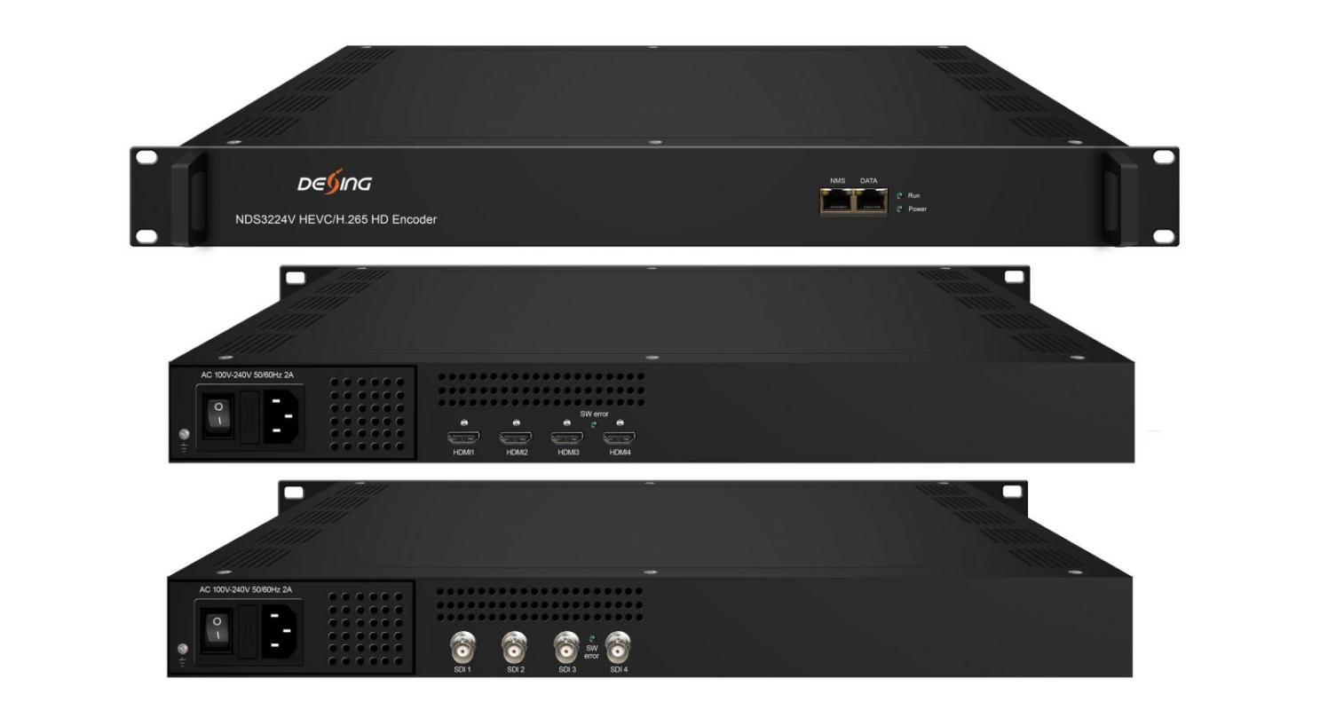
HEVC/H.265 Encoding1.5/2/2.5/3Mbps Bit Rate TS Download

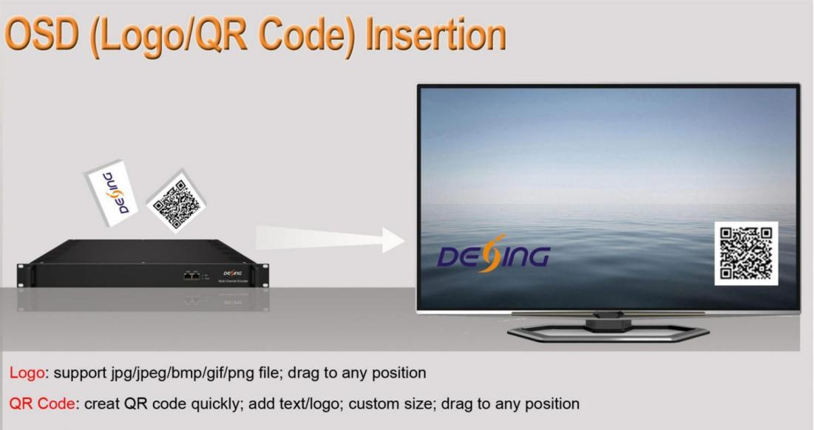
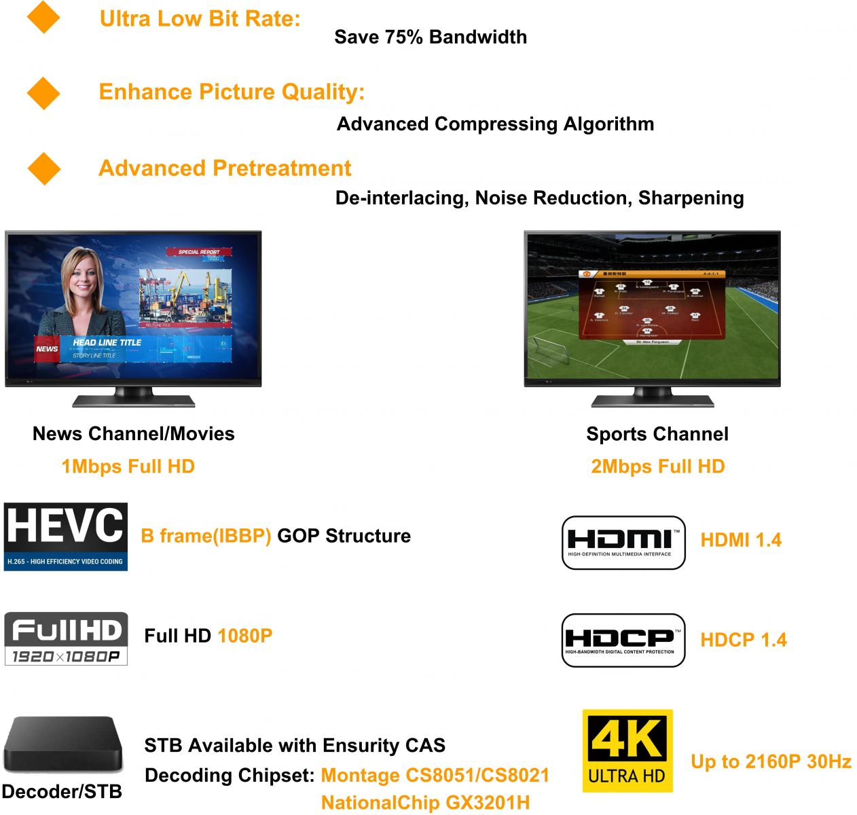

Principle Chart of Per Module (the number of encoding channels depend on encoding format and resolution)
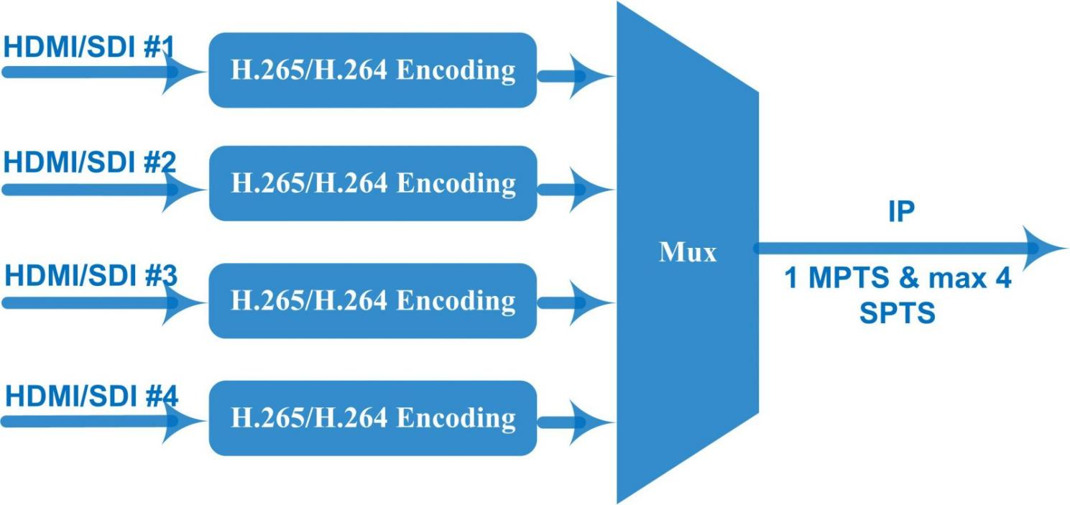

Product overview
The FMUSER FUQ-4335X encoder supports HEVC/H.265 and H.264 encoding with inputs including 4/8/12×HD-SDI or HDMI and IP output via UDP/RTP/RTSP. It processes high-definition signals efficiently for transmission. Featuring compact dimensions (482mm×328mm×44mm), lightweight design (5kg), and a wide operating temperature range (0~45℃), it is ideal for broadcast systems and digital headends.
Key feature
Offers robust design: compact dimensions (482mm×328mm×44mm), lightweight (5kg), and wide temperature range (0~45℃ work, -20~80℃ storage).
Technical specification
Input | 4/8/12×HD-SDI or HDMI (1.4) inputs for option, HDCP 1.4
Video  Encoding | Encoding Format | HEVC/ H.265 , MPEG 4 AVC/H.264
Video  Encoding | Resolution (HDMI V1, and SDI) | Input |  | Output
Video  Encoding | Resolution (HDMI V1, and SDI) |  |  | HEVC/H.265 | MPEG-4 AVC/H.264
Video  Encoding | Resolution (HDMI V1, and SDI) | 4*1080P-50 |  | 4*1080P-50 | 2*1080P-50
Video  Encoding | Resolution (HDMI V1, and SDI) | 4*1080P-60 |  | 4*1080P-60 | 2*1080P-60
Video  Encoding | Resolution (HDMI V1, and SDI) | 4*1080I-50 |  | 4*1080P-50 | 4*1080I-50  2*1080P-50
Video  Encoding | Resolution (HDMI V1, and SDI) | 4*1080I-60 |  | 4*1080P-60 | 4*1080I-60  2*1080P-60
Video  Encoding | Resolution (HDMI V1, and SDI) | 4*720P-50 |  | 4*720P-50 | 4*720P-50
Video  Encoding | Resolution (HDMI V1, and SDI) | 4*720P-60 |  | 4*720P-60 | 4*720P-60
Video  Encoding | Resolution (HDMI V2) | 3840×2160_30P, 3840×2160_29.97P  (Encoding 2 CHs per module for H.265, and encoding 1 CH for H.264 )  1920×1080_60P,1920×1080_59.94P,1920×1080_50P,  (Encoding 4 CHs per module for H.265, and encoding 2 CHs for H.264)  1280×720_60P, 1280×720_59.94P, 1280×720_50P  (Encoding 4 CHs per module for H.264 and H.265)
Video  Encoding | Chroma | 4:2:0
Video  Encoding | Bitrate | 0.5Mbps~20Mbps (each channel)
Video  Encoding | Rate Control | CBR/VBR
Video  Encoding | GOP Structure | IBBP, IPPP
Video  Encoding | Advanced Pretreatment | De-interlacing, Noise Reduction, Sharpening
Audio Encoding | Encoding Format | MPEG-1 Layer 2, LC-AAC, HE-AAC, HE-AAC V2, AC3 Passthrough
Audio Encoding | Sampling rate | 48KHz
Audio Encoding | Bit-rate (each channel) | 48Kbps~384Kbps (MPEG-1 Layer 2 & LC-AAC)  24 Kbps~128 Kbps (HE-AAC)  18 Kbps~56 Kbps (HE-AAC V2)
Audio Encoding | Audio Gain | 0~255
Stream output | IP (1 MPTS and maximum 4 SPTS) output over UDP/RTP/RTSP per module, 1000M/100M Base-T Ethernet interface (unicast/ multicast); IPv4, IPv6 output  IP null packet filter
System | Web based management
System | Chinese-English control interface
System | Ethernet software upgrade
Miscellaneous | Dimension (W× L× H) |  | 482mm×328mm×44mm
Miscellaneous | Approx weight |  | 5kg
Miscellaneous | Temperature |  | 0~45℃(work), -20~80℃（Storage）
Miscellaneous | Power |  | AC 100V-220V±10%, 50/60Hz

Order Guide
 | FU-4335V  HDMI V1 | FU-4335V  HDMI V2 | FU-4335V  SDI
Input | 4/8/12 HDMI | 4/8/12 HDMI | 4/8/12 SDI
Resolution | 1080p, 1080i, 720p | 4K-30p, 1080p, 720p | 1080p, 1080i, 720p
OSD (logo/QR code) Insertion Function | support | N/A | optional

FMUSER HEVC/H.265 encoder’s advantages
1. Providing smooth TS for modulators
FMUSER HEVC/H.265 encoder adopts Fujitsu chip which offers stable bitrate with lower fluctuation compared with other encoding chips, so it provides smooth TS for modulators. It is widely used in variety of digital distribution systems such as CATV digital head-end, satellite and terrestrial digital TV, etc.
2. Encoding with highest compression format—B frame (IBBP)
What is B Frame?
There are 3 major picture types used in the different video algorithms, they are I, P and B.
They are different in the following characteristics:
I-frames are the least compressible but don't require other video frames to decode.
P-frames can use data from previous frames to decompress and are more compressible than I-frames.
B-frames can use both previous and forward frames for data reference to get the highest amount of data compression.
Frame Type | Byte of data/KB | Compression Ratio
I | 18 | 7:1
P | 6 | 20:1
B | 2.5 | 50:1

In one word, B frame is the highest compression format which makes it possible to process HD video at low bit rate. HEVC/H.265 encoder is not able to save bandwidth unless it is with B frame. In encoder parameters, B frame is often described in GOP (Group of Pictures) structure, like “IBBP”.

How to check the GOP structure of the stream from an Encoder?
Please click the link below:
https://my.pcloud.com/publink/show?code=kZQNHW7ZnJBopqRQCchwqS1surdtnmd6cIjk

About Us
FMUSER is a company specializing in broadcasting and television transmission systems and integrating hotel IPTV systems. The company was established in 2009 and has served over 180 countries worldwide. More than 20,000 television stations, radio stations, and hotel clients from different.

Contact:Tomleequan Email：sales@fmuser.com whatsapp: +8613922702227

