FMUSER FUQ-4337SB SD Video Encoder 48× CVBS Input PAL-NTSC Input Formats IP-ASI Output MPEG4 AVC-H.264 Encoding for CATV Satellite Headend Systems
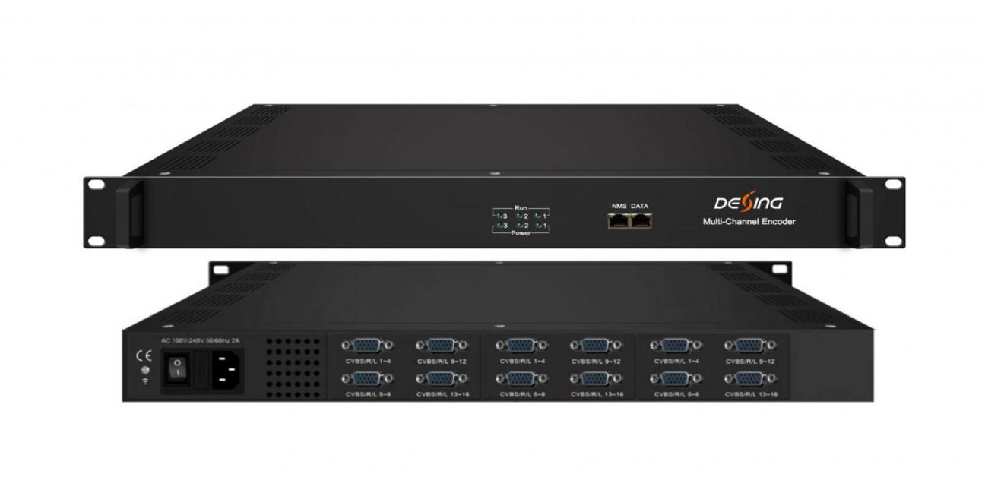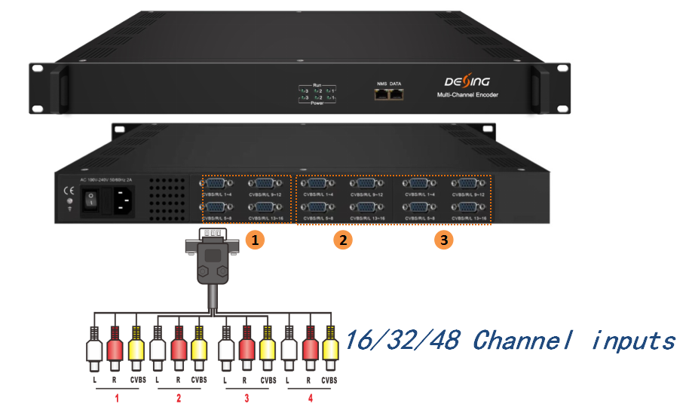
Product Overview
The FMUSER FUQ-4337SB is a multi-channel SD encoder supporting up to 48 CVBS inputs, with MPEG4 AVC/H.264 video encoding and outputs MPTS and SPTS via IP and ASI interfaces. It processes SD video signals for digital distribution, housed in a modular 1U chassis allowing up to three standalone modules with web-based management. Ideal for digital TV distribution systems like CATV and satellite headends.

Key feature
Supports 16/32/48× CVBS inputs with MPEG4 AVC/H.264 SD video encoding for PAL and NTSC formats.
Features MPEG-1 Layer II audio encoding with adjustable gain and multiple bit-rate options.
Provides MPTS output via ASI and SPTS output over IP with UDP/RTP support, including Null PKT Filter.
Supports logo, caption, and QR code insertion for customized content.
Modular 1U chassis design allows up to 3 standalone modules with web-based management for real-time monitoring and easy updates.

Principle Chart
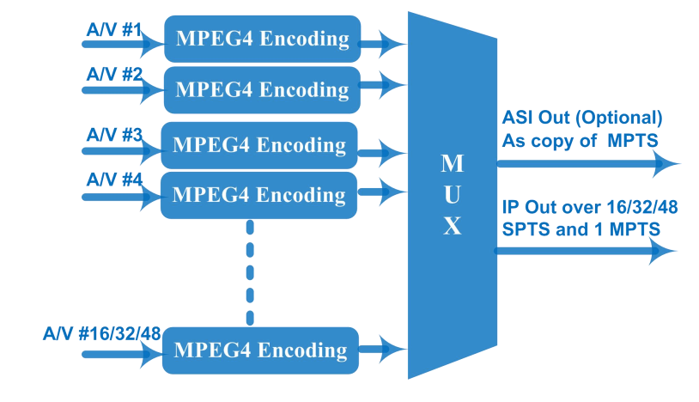
Technical specification
Input | 16/32/48 CVBS inputs , DB15-To-RCA interface
Video | Resolution | 720×576i (PAL-B,D,G,H,I), 720×480i (NTSC-M,J)
Video | Encoding | MPEG4 AVC/H.264(HP/MP/BP)
Video | Bit-rate | 1Mbps~66Mbps each channel
Video | Rate Control | CBR/VBR
Video | GOP Structure | IPP (P frame is adjustable)
Video | Aspect Ratio | 4:3; 16:9
Audio | Encoding | MPEG-1 Layer 2
Audio | Sampling rate | 48KHz
Audio | Resolution | 24-bit
Audio | Audio Gain | 0-255 adjustable
Audio | Bit-rate | 64/128/192/224/256/320/384Kbps each channel
Stream output | IP (1*MPTS and 16*SPTS for one module) output over UDP and RTP, 1000 Base-T Ethernet interface (Multicast and unicast)
Stream output | 1 MPTS output through 1 ASI output ports, BNC interface (Optional)
System function | Network management (WEB)
System function | English language
System function | Ethernet software upgrade
Miscellaneous | Dimension(W×L×H) | 482mm×328mm×44mm
Miscellaneous | Environment | 0~45℃(work)；-20~80℃（Storage）
Miscellaneous | Power requirements | AC 110V± 10%, 50/60Hz, AC 220 ± 10%, 50/60Hz

Order Information
 | Version I | Version II | Version III
16 CVBS Input | ○
32 CVBS Input |  | ○
48 CVBS Input |  |  | ○

About Us
FMUSER is a company specializing in broadcasting and television transmission systems and integrating hotel IPTV systems. The company was established in 2009 and has served over 180 countries worldwide. More than 20,000 television stations, radio stations, and hotel clients from different.

Contact:Tomleequan Email：sales@fmuser.com whatsapp: +8613922702227

