FMUSER FUQ-4339K-N V2 Network Encoder 48 HDMI Inputs IP Outputs HEVC-H.265 H.264 Encoding Multi-Protocol Streaming for IP Broadcasting
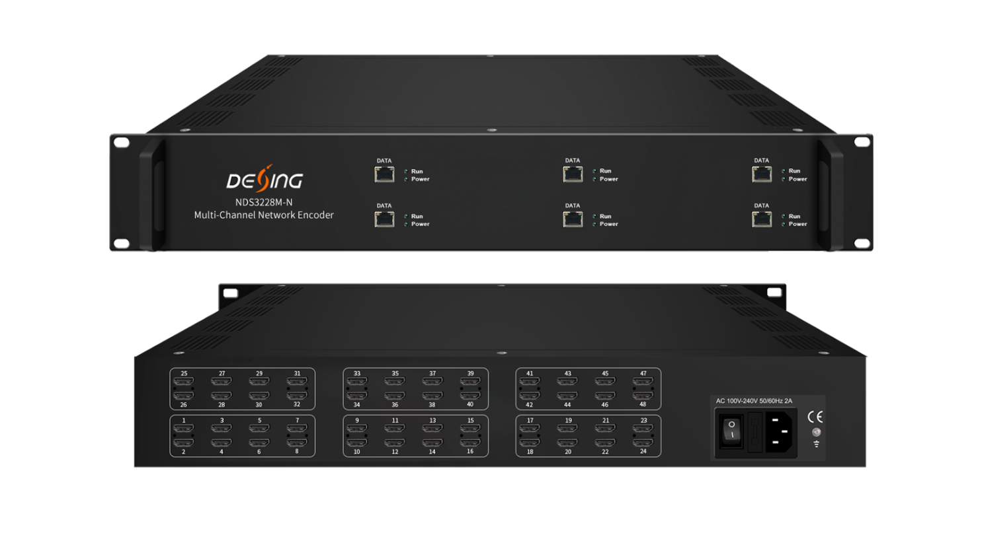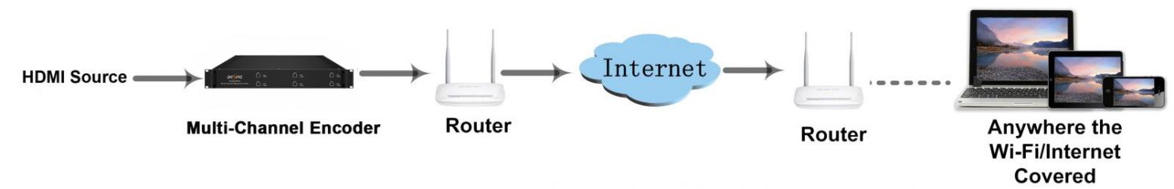
Product Overview
The FMUSER FUQ-4339K-N (V2) is a network encoder with 48 HDMI inputs and IP outputs. It encodes video in HEVC/H.265 and MPEG-4 AVC/H.264 formats, and audio in MPEG-1 Layer 2, LC-AAC, HE-AAC, with AC3 Pass Through. This 2-U rack-mountable device streams via UDP, SRT, RTSP, RTMP, HTTP, and HLS. Ideal for IP broadcasting in studios and streaming services.
Key feature
- Features 48 HDMI inputs configurable via six encoder modules for SPTS output.
- Supports HEVC/H.265 and MPEG-4 AVC/H.264 video encoding.
- Offers flexible audio options including MPEG-1 Layer 2, LC-AAC, HE-AAC, and AC3 Pass Through.
- Provides multi-protocol IP output via UDP, SRT, RTSP, RTMP, HTTP, and HLS.
- Enables enhanced features like QR code, LOGO, and caption insertion.
Inner Principle Chart (Per 8-HDMI Module)
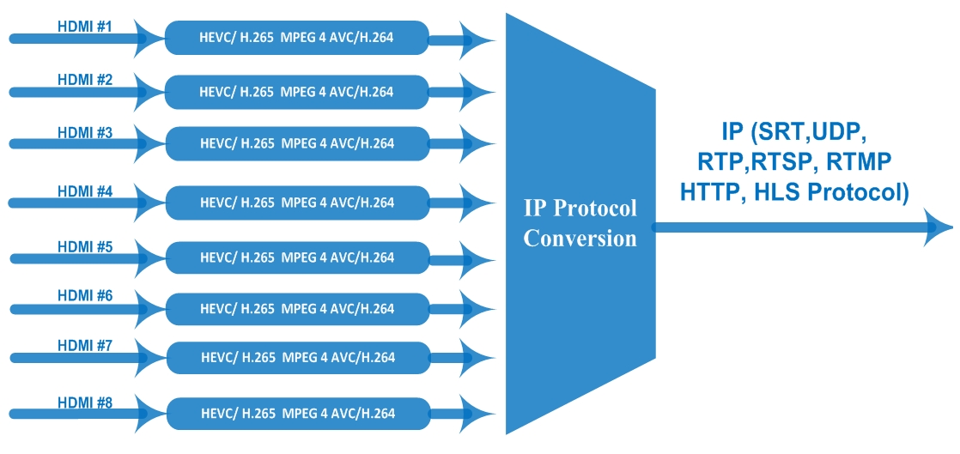
Specifications
Input | 48 HDMI inputs
Video | Resolution | input |  | 1920×1080_60P, 1920×1080_60i,  1920×1080_50P, 1920×1080_50i,  1280×720_60P, 1280×720_50P,  720 x 576_50i,720 x 480_60i
Video | Resolution | Output |  | 1920×1080_30P, 1920×1080_25P,  1280×720_30P, 1280×720_25P,  720 x 576_25P, 720 x 480_30P
Video | Encoding |  |  | HEVC/H.265 HD/SD; MPEG-4 AVC/H.264 HD/SD
Video | Bit-rate |  |  | 1~13Mbps each channel
Video | Rate Control |  |  | CBR/VBR
Video | GOP Structure |  |  | IP…P (P Frame adjustment, without B Frame )
Audio | Encoding |  |  | MPEG-1 Layer 2, LC-AAC, HE-AAC and AC3 Pass through
Audio | Sampling rate |  |  | 32KHz, 48KHz, 44.1KHz
Audio | Resolution |  |  | 24-bit
Audio | Audio Gain |  |  | 0-255 Adjustable
Audio | MPEG-1 Layer 2Bit-rate |  |  | 48/56/64/80/96/112/128/160/192/224/256/320/384 kbps
Audio | LC-AAC Bit-rate |  |  | 48/56/64/80/96/112/128/160/192/224/256/320/384 kbps
Audio | HE-AAC Bit-rate |  |  | 48/56/64/80/96/112/128 kbps
Stream output | IP out over UDP (Unicast/Multicast),SRT, RTP,RTSP, RTMP, HTTP, HLS (RJ45, 1000M ) (8 HDMI inputs with 8 SPTS for each encoder board)
System function | Network management(WEB)
System function | Chinese and English language
System function | Ethernet software upgrade
Miscellaneous | Dimension(W×L×H) |  | 482mm×328mm×88mm
Miscellaneous | Environment |  | 0~45℃(work)；-20~80℃（Storage）
Miscellaneous | Power requirements |  | AC 110V± 10%, 50/60Hz, AC 220 ± 10%, 50/60Hz

Major spec comparison
 | FU-4339S-N | FU-4339M-N v1 | FU-4339M-N v2
HDMI Channel | 8/16/24 | 2/4/8/16/24 | 48
Video Format | H.264 | H.264/H.265 | H.264/H.265
Resolution | HD/SD | HD | HD/SD
OSD | Yes | No | Yes
Chassis | 1-U | 1-U | 2-U

About Us
FMUSER is a company specializing in broadcasting and television transmission systems and integrating hotel IPTV systems. The company was established in 2009 and has served over 180 countries worldwide. More than 20,000 television stations, radio stations, and hotel clients from different.

Contact:Tomleequan Email：sales@fmuser.com whatsapp: +8613922702227

