FMUSER FUQ-4339R HDMI Encoder 8-16-24 HDMI Inputs 1 MPTS 8 SPTS Outputs MPEG4 AVC-H264 IP ASI Interfaces Cable TV Headend Broadcasting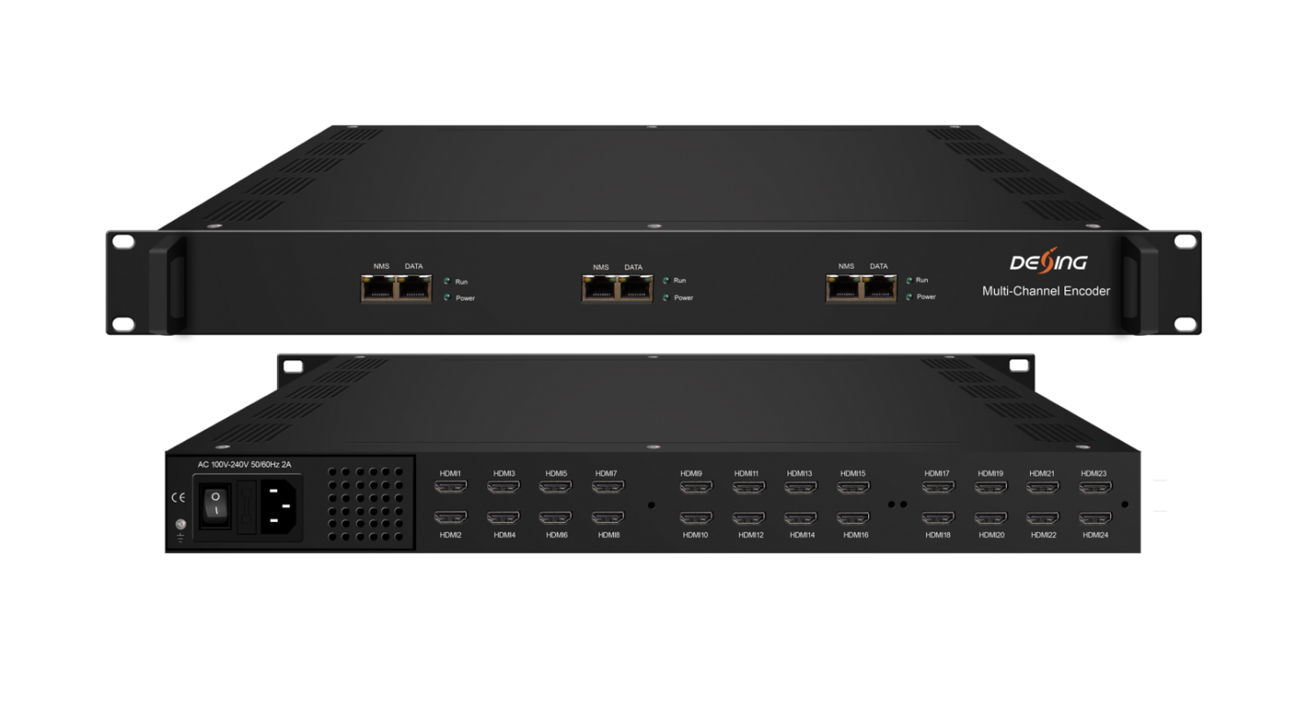Product Overview
The FUQ-4339R Encoder is a professional HD/SD audio and video encoding device with scalable 8/16/24 HDMI inputs and outputs including 1 MPTS and 8 SPTS per module. It processes signals using MPEG4 AVC/H.264 video encoding and MPEG1 Layer II, LC-AAC, HE-AAC audio formats. Controlled via web management, it supports features like QR code and caption insertion. Ideal for cable TV head-ends and broadcasting systems.
Key feature
Supports scalable 8/16/24 HDMI inputs with 1 MPTS and 8 SPTS outputs per module.
Features H.264 video encoding and MPEG audio formats including LC-AAC and HE-AAC.
Provides IP output over UDP/RTP/RTSP and optional ASI output.
Includes web management for control with QR code and caption insertion support.
Supports Null Packet Filter for stream optimization.

Principle Chart (Each Encoder Module)
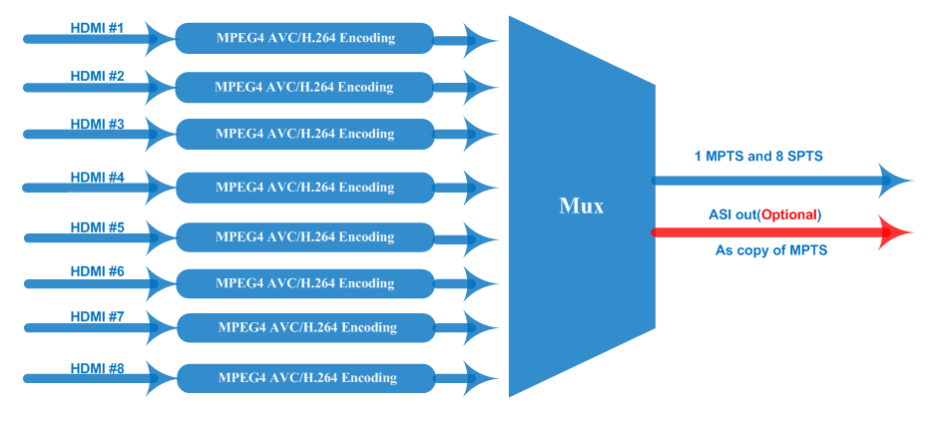
Technical specification
Input | 8/16/24 HDMI inputs
Video | Resolution | input |  | 1920×1080_60P, 1920×1080_60i,  1920×1080_50P, 1920×1080_50i,  1280×720_60P, 1280×720_50P,  720 x 576_50i,720 x 480_60i
Video | Resolution | Output |  | 1920×1080_30P, 1920×1080_25P,  1280×720_30P, 1280×720_25P,  720 x 576_25P, 720 x 480_30P
Video | Encoding |  |  | MPEG-4 AVC/H.264
Video | Bit-rate |  |  | 1~13Mbps each channel
Video | Rate Control |  |  | CBR/VBR
Video | GOP Structure |  |  | IP…P (P Frame adjustment, without B Frame )
Audio | Encoding |  |  | MPEG-1 Layer 2, LC-AAC, HE-AAC and AC3 Pass through
Audio | Sampling rate |  |  | 48KHz
Audio | Resolution |  |  | 24-bit
Audio | Audio Gain |  |  | 0-255 Adjustable
Audio | MPEG-1 Layer 2 Bit-rate |  |  | 48/56/64/80/96/112/128/160/192/224/256/320/384 kbps
 | LC-AAC Bit-rate |  |  | 48/56/64/80/96/112/128/160/192/224/256/320/384 kbps
 | HE-AAC Bit-rate |  |  | 48/56/64/80/96/112/128 kbps
Stream output | IP output through DATA (GE) over UDP and RTP/RTSP protocol  (8 HDMI inputs with 8 SPTS and 1MPTS output for each encoder board)  1 ASI out as mirror of MPTS (Optional as order)
System function | Network management(WEB)
System function | Chinese and English language
System function | Ethernet software upgrade
Miscellaneous | Dimension (W×L×H) |  | 482mm×328mm×44mm
Miscellaneous | Environment |  | 0~45℃(work)；-20~80℃（Storage）
Miscellaneous | Power requirements |  | AC 110V± 10%, 50/60Hz, AC 220 ± 10%, 50/60Hz

Order Information
 | FU-4339S-8 | FU-4339S-16 | FU-4339S-24
8 HDMI Inputs with 8 SPTS and 1 MPTS out (1 encoder board+1NMS port+1 DATA Port) | X
16 HDMI Inputs with 16 SPTS or 2 MPTS out (2 encoder boards+2 NMS ports+2 DATA Ports) |  | X
24 HDMI Inputs with 24 SPTS or 3 MPTS out((3 encoder boards+3 NMS ports+ 3 DATA Ports)) |  |  | X

About Us
FMUSER is a company specializing in broadcasting and television transmission systems and integrating hotel IPTV systems. The company was established in 2009 and has served over 180 countries worldwide. More than 20,000 television stations, radio stations, and hotel clients from different.

Contact:Tomleequan Email：sales@fmuser.com whatsapp: +8613922702227

