FMUSER FUQ-4339R-N IP Streaming Encoder 24 HDMI Inputs H.264 AAC Encoding UDP-SRT-RTMP-HLS IP Broadcasting Live Event Streaming
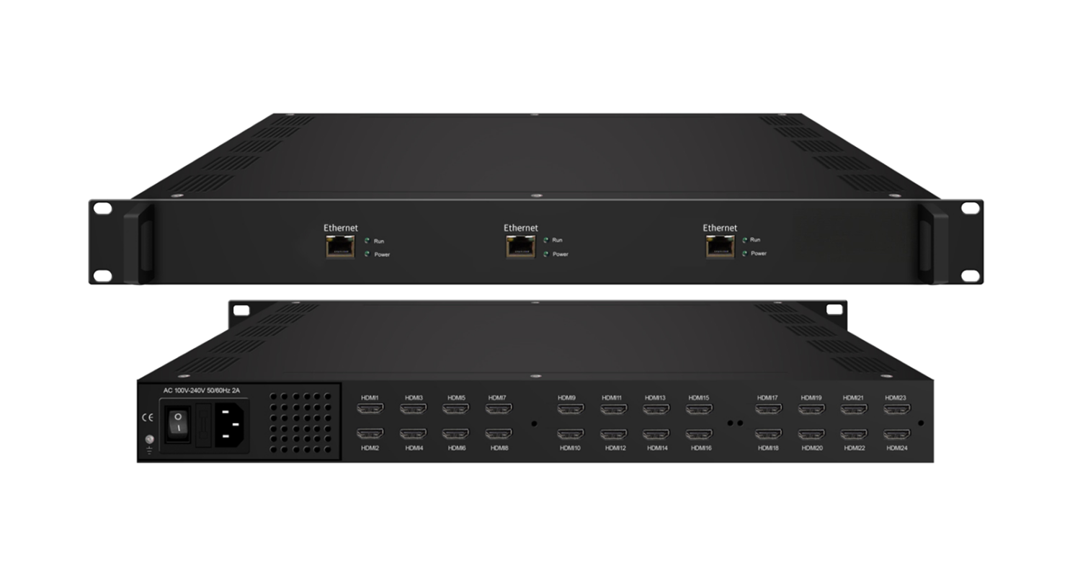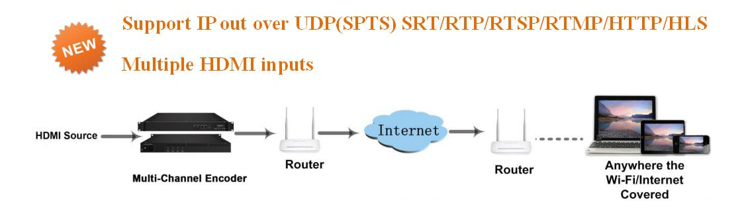
Product Overview
The FMUSER FUQ-4339R-N is a multi-channel network encoder with up to 24 HDMI inputs, supporting H.264 video and AAC audio encoding for IP broadcasting. It processes signals by encoding and streaming via protocols like UDP, SRT, RTMP, and HLS over internet/LAN. Featuring web-based management for control and updates. Ideal for applications in live event streaming to PCs, smartphones, and mobile devices.
Key feature

- Supports up to 24 HDMI inputs with individual SPTS output for flexible channel configuration.
- Features MPEG-4 AVC/H.264 video encoding and AAC audio encoding including LC-AAC, HE-AAC, and AC3 pass-through.
- Enables multiple IP output protocols: UDP (Unicast/Multicast), SRT, RTSP, RTMP, HTTP, and HLS for versatile streaming.
- Offers caption, logo, and QR code insertion with multi-language capabilities for content customization.
- Provides web-based management for easy control, updates, and network administration.
Inner Principle Chart (Per Module)
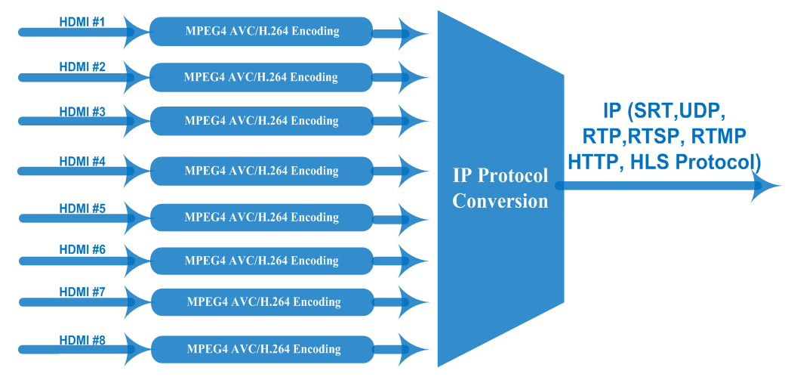

Specifications
Input | 8/16/24 HDMI inputs
Video | Resolution | input |  | 1920×1080_60P, 1920×1080_60i,  1920×1080_50P, 1920×1080_50i,  1280×720_60P, 1280×720_50P,  720 x 576_50i,720 x 480_60i
Video | Resolution | Output |  | 1920×1080_30P, 1920×1080_25P,  1280×720_30P, 1280×720_25P,  720 x 576_25P, 720 x 480_30P
Video | Encoding |  |  | MPEG-4 AVC/H.264
Video | Bit-rate |  |  | 1~13Mbps each channel
Video | Rate Control |  |  | CBR/VBR
Video | GOP Structure |  |  | IP…P (P Frame adjustment, without B Frame )
Audio | Encoding |  |  | MPEG-1 Layer 2, LC-AAC, HE-AAC and AC3 Pass through
Audio | Sampling rate |  |  | 48KHz
Audio | Resolution |  |  | 24-bit
Audio | Audio Gain |  |  | 0-255 Adjustable
Audio | MPEG-1 Layer 2 Bit-rate |  |  | 48/56/64/80/96/112/128/160/192/224/256/320/384 kbps
Audio | LC-AAC Bit-rate |  |  | 48/56/64/80/96/112/128/160/192/224/256/320/384 kbps
Audio | HE-AAC Bit-rate |  |  | 48/56/64/80/96/112/128 kbps
Stream output | IP out over UDP (Unicast/Multicast),SRT, RTP,RTSP, RTMP, HTTP, HLS (RJ45, 1000M ) (8 HDMI inputs with 8 SPTS for each encoder board)
System function | Network management(WEB)
System function | Chinese and English language
System function | Ethernet software upgrade
Miscellaneous | Dimension (W×L×H) |  | 482mm×328mm×44mm
Miscellaneous | Environment |  | 0~45℃(work)；-20~80℃（Storage）
Miscellaneous | Power requirements |  | AC 110V± 10%, 50/60Hz, AC 220 ± 10%, 50/60Hz

About Us
FMUSER is a company specializing in broadcasting and television transmission systems and integrating hotel IPTV systems. The company was established in 2009 and has served over 180 countries worldwide. More than 20,000 television stations, radio stations, and hotel clients from different.

Contact:Tomleequan Email：sales@fmuser.com whatsapp: +8613922702227

