FMUSER FUQ-4339X-Y Network Encoder 24 HDMI Inputs 1920x1080_60P H.265-H.264 Encoding Multi-Protocol Streaming UDP-SRT-RTMP-HLS Broadcast and Streaming
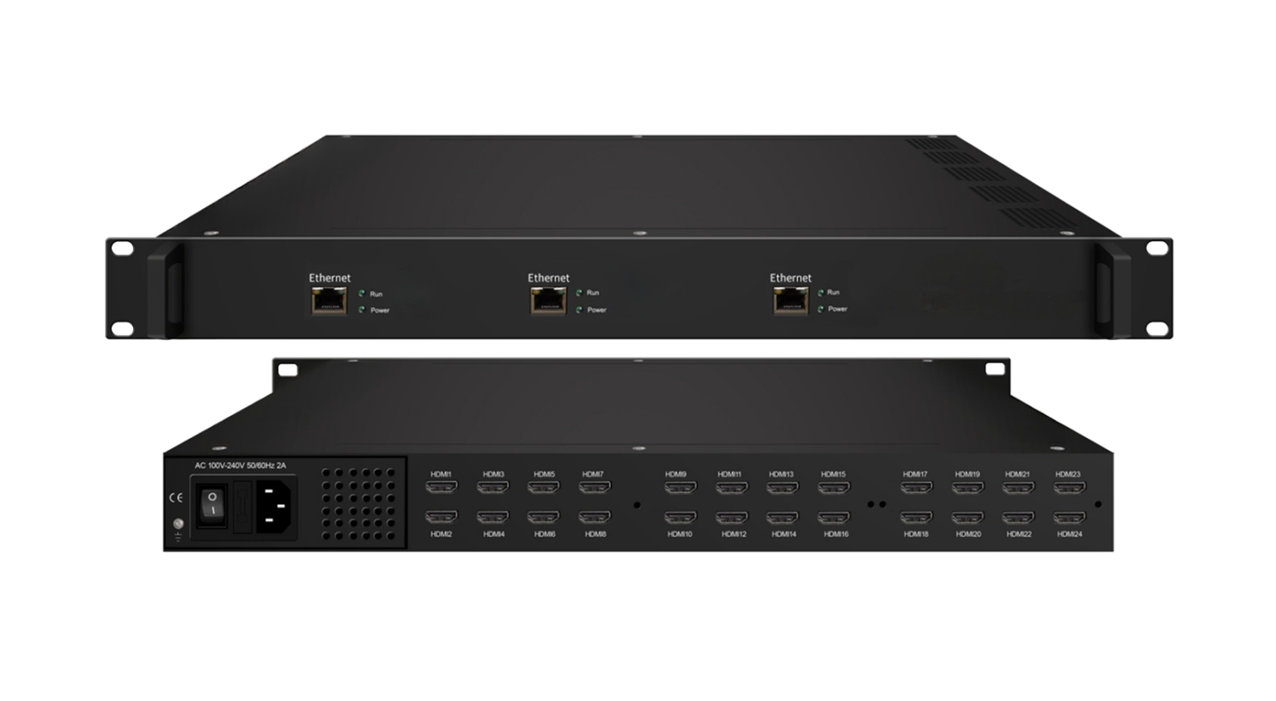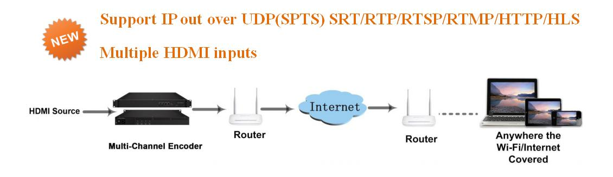
Product Overview
The FMUSER FUQ-433X-Y is a multi-channel network encoder with 24 HDMI inputs and IP streaming output via RJ45. It encodes video using H.265/HEVC or H.264/MPEG-4 AVC compression and streams via protocols like UDP, SRT, RTMP, and HLS. Managed through a web-based interface, it supports remote configuration and software upgrades. Ideal for IP broadcasting to PCs, smartphones, and mobile devices in live streaming and broadcast applications.
Key feature
Supports 24 HDMI inputs with individual SPTS output, handling resolutions up to 1920×1080 at 60P/50P.
Features H.265/HEVC and H.264/MPEG-4 AVC encoding with 1–7 Mbps bitrate, CBR/VBR control, and IP GOP structure.
Enables multi-protocol streaming via UDP (Unicast/Multicast), SRT, RTSP, RTMP, HTTP, and HLS over 1000M RJ45.
Provides flexible audio encoding with MPEG-1 Layer 2, LC-AAC, and HE-AAC, supporting 32–48 kHz sampling and adjustable gain.
Inner Principle Chart (Per Module)
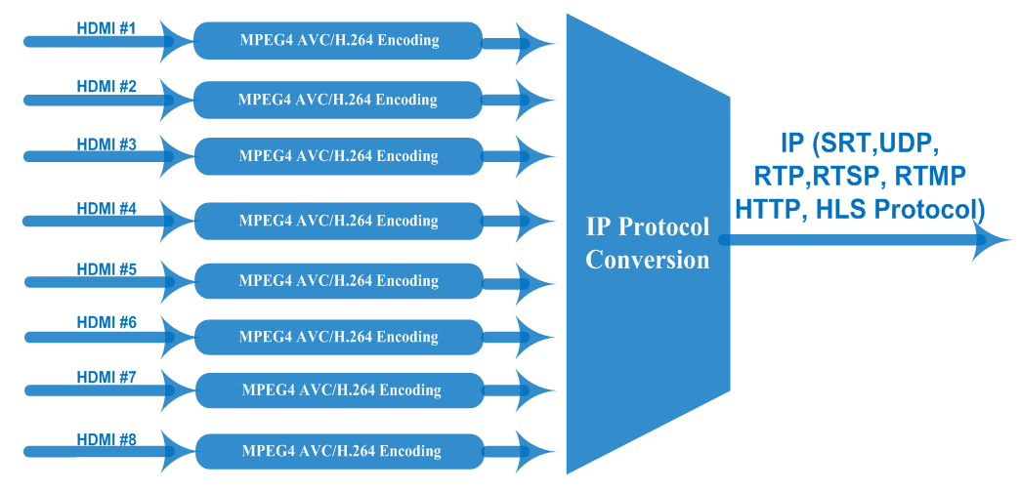

Specifications
Input | 2/4/8/16/24 HDMI inputs
Video | Resolution | 1920*1080_60P, 1920*1080_50P; 1920*1080_59.94P, 1280*720_60p,  1280*720_59.94, 1280*720_50P
Video | Encoding | H.264/H.265
Video | Bit-rate | 1~7Mbps each channel
Video | Rate Control | CBR/VBR
Video | GOP Structure | IP
Audio | Encoding | MPEG-1 Layer 2, LC-AAC, HE-AAC and AC3 Pass through
Audio | Sampling rate | 32KHz,44.1KHz,48KHz
Audio | Chroma | 4:2:0
Audio | Audio Gain | 0-255 Adjustable
Audio | MPEG-1 Layer 2Bit-rate | 48/56/64/80/96/112/128/160/192/224/256/320/384 kbps
Audio | LC-AAC Bit-rate | 48/56/64/80/96/112/128/160/192/224/256/320/384 kbps
Audio | HE-AAC Bit-rate | 48/56/64/80/96/112/128 kbps
Stream output | IP out over UDP (Unicast/Multicast), SRT, RTP,RTSP, RTMP, HTTP, HLS (RJ45, 1000M) (8 HDMI inputs with 8 SPTS for each encoder board)
System function | Network management(WEB)
System function | Chinese and English language
System function | Ethernet software upgrade
Miscellaneous | Dimension(W×L×H) | 482mm×328mm×44mm
Miscellaneous | Environment | 0~45℃(work)；-20~80℃（Storage）
Miscellaneous | Power requirements | AC 110V± 10%, 50/60Hz, AC 220 ± 10%, 50/60Hz

About Us
FMUSER is a company specializing in broadcasting and television transmission systems and integrating hotel IPTV systems. The company was established in 2009 and has served over 180 countries worldwide. More than 20,000 television stations, radio stations, and hotel clients from different.

Contact:Tomleequan Email：sales@fmuser.com whatsapp: +8613922702227

