FMUSER FUQ-4344 Audio Encoder Dual Unbalanced Stereo Inputs ASI BNC-IP Ethernet Output MPEG-1 Layer II Audio Gain Control Broadcast Applications
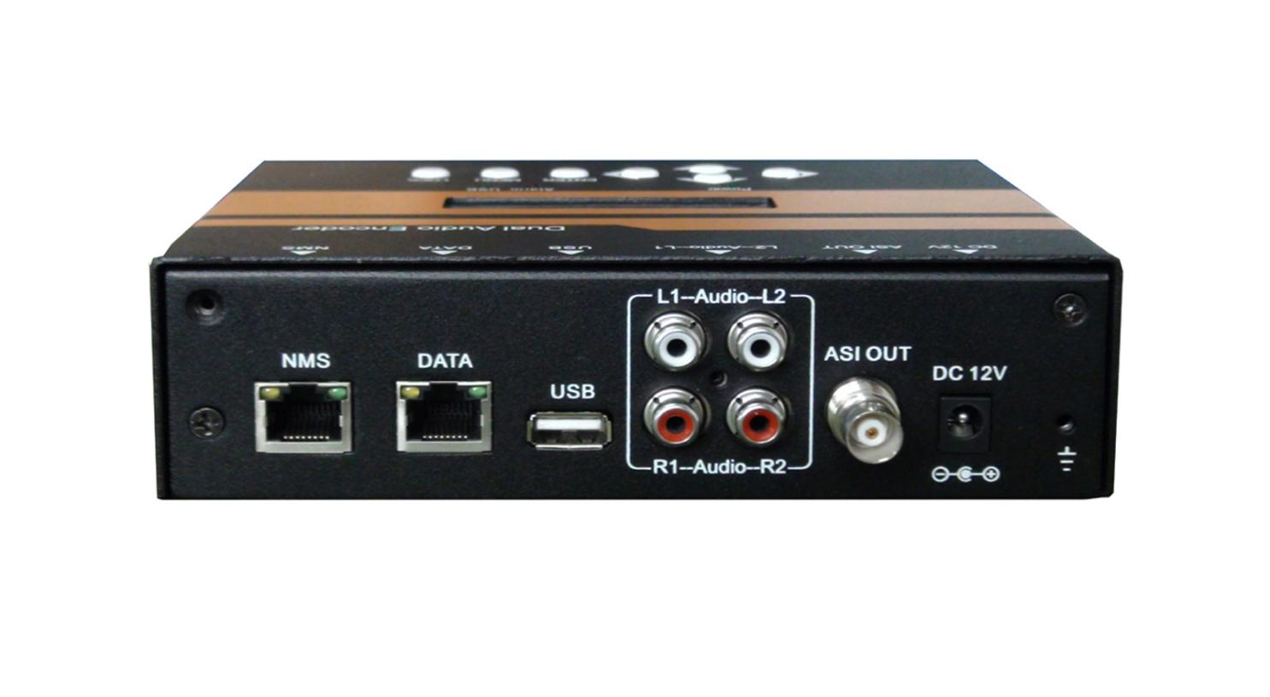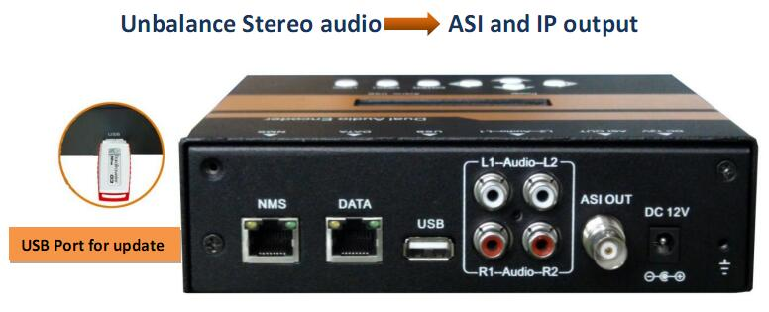
Product Overview
The FMUSER FUQ-4344 is a professional audio encoder with dual unbalanced stereo inputs for backup redundancy. It encodes audio using MPEG-1 Layer II compression and adjustable gain. Control is via web-based NMS and LCD/keyboard. Ideal for broadcast systems requiring reliable transmission through ASI and IP over UDP outputs.
Key feature
Supports dual unbalanced stereo inputs with backup for enhanced reliability.
Encodes audio using MPEG-1 Layer II with bit-rates from 32 to 384 Kb/s.
Features adjustable audio gain control from -20 to +6 dB.
Provides ASI and IP over UDP outputs for versatile transmission.
Enables management via web-based NMS and LCD/keyboard operation.
Principle Chart
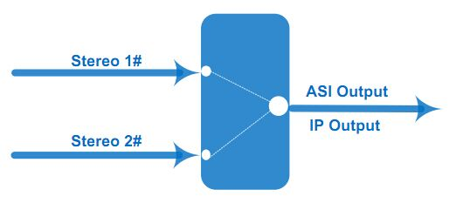
Specifications
Audio Encode | Interface | 2 pairs of unbalanced stereo inputs(one for backup), BNC interface
Audio Encode | Encoding Format | MPEG1 Layer 2
Audio Encode | Audio Gain | -20 ~ +6 dB
Audio Encode | Sampling Rate | 48KHz
Audio Encode | Bit-rate | 32/48/56/64/80/96/112/128/160/192/224/256/320/384Kb/s
Stream output | 1*ASI output, BNC interface
Stream output | IP output over UDP mirror ASI output, 100M Base-T Ethernet interface (unicast/multicast)
System | LCD/keyboard operating, web-based NMS manage
System | Language: LCD English  Web Chinese
System | Ethernet software & hardware upgrade
Miscellaneous | Dimension | 164mm×128mm×45mm (W× L× H)
Miscellaneous | Approx weight | ＜1kg
Miscellaneous | Temperature | 0~45℃ (work), -20~80℃（Storage）
Miscellaneous | Power supply | DC12V

About Us
FMUSER is a company specializing in broadcasting and television transmission systems and integrating hotel IPTV systems. The company was established in 2009 and has served over 180 countries worldwide. More than 20,000 television stations, radio stations, and hotel clients from different.

Contact:Tomleequan Email：sales@fmuser.com whatsapp: +8613922702227

