FMUSER FUQ-4347X/FUQ-4355X HDMI Encoder 16-24 HDMI Inputs 1 MPTS-8 SPTS Outputs MPEG4 AVC-H264 Encoding IP Streaming for Digital Headends Broadcasting
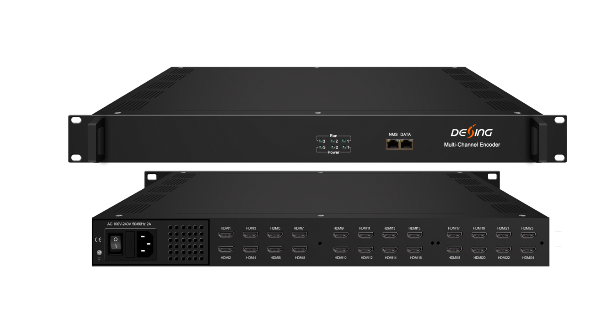Product Overview
The FMUSER FUQ-4347X/FUQ-4355X encoder provides high-density HDMI encoding with 16 or 24 HDMI inputs and outputs 1 MPTS plus 8 SPTS per module. It encodes video using MPEG4 AVC/H.264 and audio with MPEG1 Layer II, LC-AAC, or HE-AAC, supporting AC3 Pass Through. The device offers web-based management for control and customization, including QR code/LOGO/caption insertion and "Null PKT Filter" support. Ideal for digital headends, cable TV systems, and broadcasting applications.
Key feature
- - Supports 16 or 24 HDMI inputs with SPTS/MPTS output per module.
- - Encodes video in MPEG4 AVC/H.264 and audio in MPEG1 Layer II, LC-AAC, HE-AAC with AC3 Pass Through.
- - Streams via UDP/RTP/RTSP protocols over GE DATA port.
- - Features web management for updates, QR code/LOGO/caption insertion, and "Null PKT Filter" support.
- MPEG4 AVC/H.264 video encoding format
- MPEG1 Layer II, LC-AAC，HE-AAC audio encoding format and AC3 Pass Through, and audio gain adjustment
- IP output over UDP and RTP/RTSP protocol
- Support QR code, LOGO, caption insertion
- Support “Null PKT Filter” function
- Control via web management, and easy updates via web

Principle Chart (Each Encoder Module)
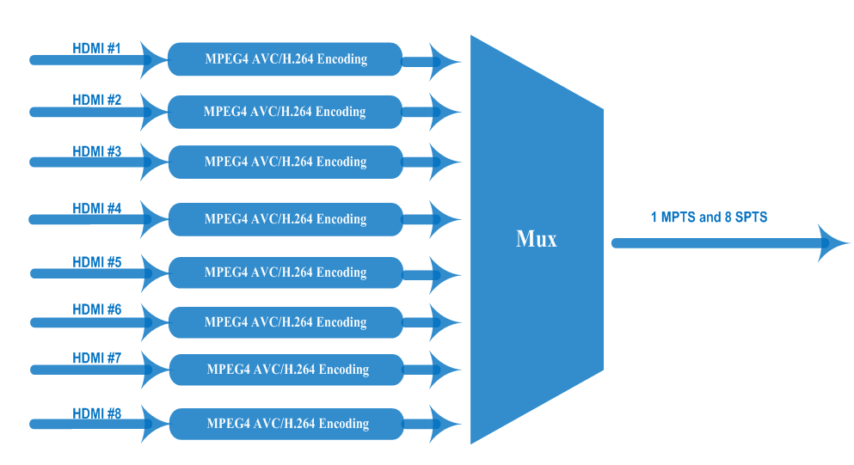

Technical specification
Input | 16 HDMI inputs (FU-4347S); 24 HDMI inputs (FU-4355S)
Video | Resolution | input |  | 1920×1080_60P, 1920×1080_60i,  1920×1080_50P, 1920×1080_50i,  1280×720_60P, 1280×720_50P,  720 x 576_50i,720 x 480_60i
Video | Resolution | Output |  | 1920×1080_30P, 1920×1080_25P,  1280×720_30P, 1280×720_25P,  720 x 576_25P, 720 x 480_30P
Video | Encoding |  |  | MPEG-4 AVC/H.264
Video | Bit-rate |  |  | 1~13Mbps each channel
Video | Rate Control |  |  | CBR/VBR
Video | GOP Structure |  |  | IP…P (P Frame adjustment, without B Frame )
Audio | Encoding |  |  | MPEG-1 Layer 2, LC-AAC, HE-AAC and AC3 Pass through
Audio | Sampling rate |  |  | 48KHz
Audio | Resolution |  |  | 24-bit
Audio | Audio Gain |  |  | 0-255 Adjustable
Audio | MPEG-1 Layer 2 Bit-rate |  |  | 48/56/64/80/96/112/128/160/192/224/256/320/384 kbps
Audio | LC-AAC Bit-rate |  |  | 48/56/64/80/96/112/128/160/192/224/256/320/384 kbps
Audio | HE-AAC Bit-rate |  |  | 48/56/64/80/96/112/128 kbps
Stream output | IP output through DATA (GE) over UDP and RTP/RTSP protocol  (8 HDMI inputs with 8 SPTS and 1MPTS output for each encoder module)
System function | Network management (WEB)
System function | English language
System function | Ethernet software upgrade
Miscellaneous | Dimension(W×L×H) |  | 440mm×324mm×44mm
Miscellaneous | Environment |  | 0~45℃(work)；-20~80℃（Storage）
Miscellaneous | Power requirements |  | AC 110V± 10%, 50/60Hz, AC 220 ± 10%, 50/60Hz

Order Guide
P/N | Config
FU-4347S | 16 HDMI inputs
FU-4355S | 24 HDMI inputs

About Us
FMUSER is a company specializing in broadcasting and television transmission systems and integrating hotel IPTV systems. The company was established in 2009 and has served over 180 countries worldwide. More than 20,000 television stations, radio stations, and hotel clients from different.

Contact:Tomleequan Email：sales@fmuser.com whatsapp: +8613922702227

