FMUSER FUQ-4349 8-Channel Audio Encoder 8 Unbalanced Stereo BNC Inputs ASI-IP Outputs MPEG1 Layer 2 Compression Adjustable Gain Control Professional Broadcasting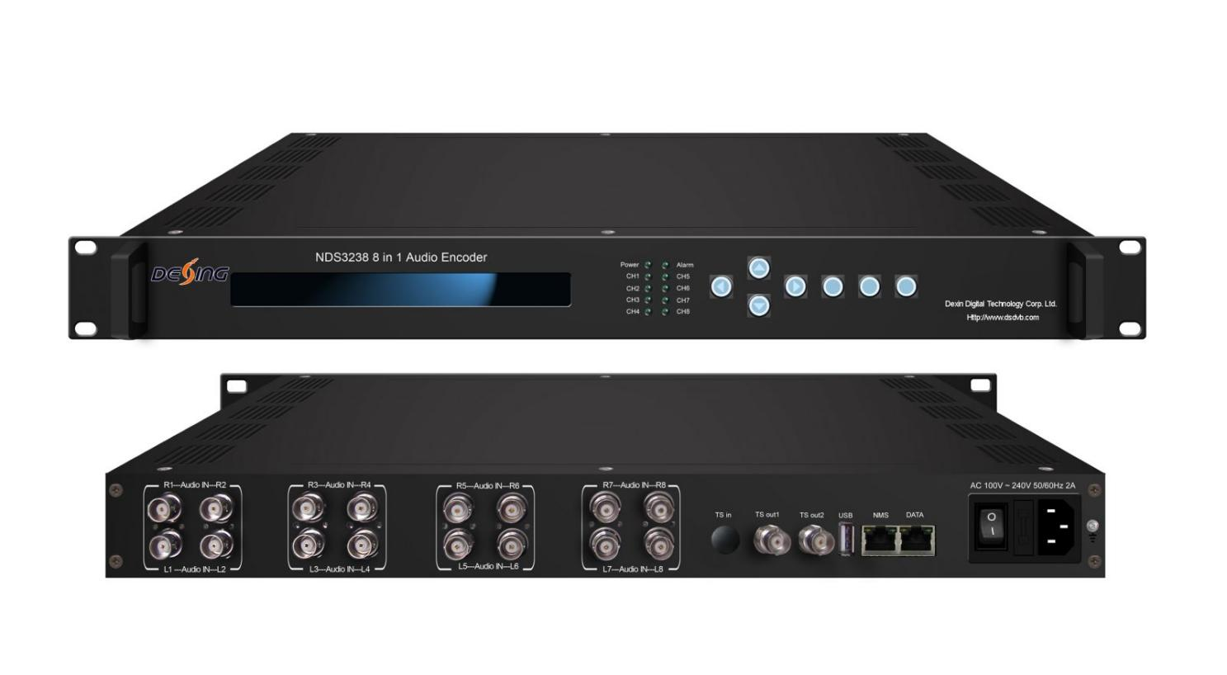Product Overview
The FMUSER FUQ-4349 is a professional 8-channel audio encoder featuring MPEG1 Layer 2 compression. It processes audio signals with adjustable gain control and outputs via ASI and IP ports. The device supports web-based operation for easy management. Ideal for broadcast studios and IP streaming systems.
Key feature
Features 8 unbalanced stereo audio inputs for flexible connectivity.
Supports MPEG1 Layer 2 encoding for high-quality compression.
Includes adjustable audio gain control for signal optimization.
Provides dual ASI mirrored outputs for redundancy.
Offers IP output with MPTS and 8 SPTS over UDP for versatile streaming.
Principle Chart
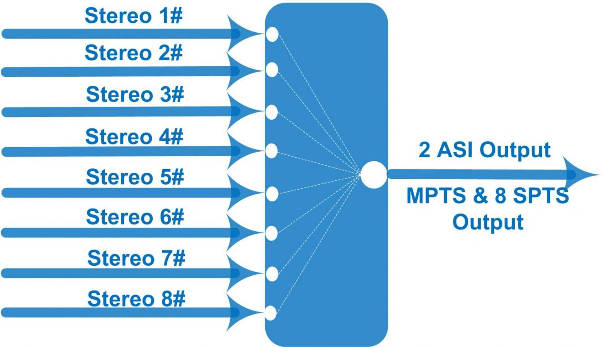

Specifications

Audio Encode | Interface | 8 pairs of unbalanced stereo audio inputs, BNC interface
Audio Encode | Encoding Format | MPEG1 Layer 2
Audio Encode | Audio Gain | 0~255
Audio Encode | Sampling Rate | 48KHz
Audio Encode | Bit-rate | 32/48/56/64/80/96/112/128/160/192/224/256/320/384Kb/s (each channel)---for stereo audio  32/48/56/64/80/96/112/128/160Kb/s (each channel)---for Left/Right audio
Stream output | 2*ASI mirrored output, BNC interface
Stream output | MPTS & 8 SPTS over UDP, 1000M Base-T Ethernet interface (unicast/multicast)
System | LCD/keyboard operating, web-based NMS manage
System | Ethernet software & hardware upgrade
Miscellaneous | Dimension | 482mm×455mm×44mm (W× L× H)
Miscellaneous | Approx weight | 4kg
Miscellaneous | Temperature | 0~45℃ (work), -20~80℃（Storage）
Miscellaneous | Power | AC 100V-220V±10%, 50/60Hz
Miscellaneous | Consumption | 25W

About Us
FMUSER is a company specializing in broadcasting and television transmission systems and integrating hotel IPTV systems. The company was established in 2009 and has served over 180 countries worldwide. More than 20,000 television stations, radio stations, and hotel clients from different.

Contact:Tomleequan Email：sales@fmuser.com whatsapp: +8613922702227

