FMUSER FUQ-4349S 8-Channel FM Receiver 8 FM Inputs MPEG1 Layer-2 Encoding ASI-IP Outputs Audio-to-Digital TS Conversion for HFC Terrestrial Systems
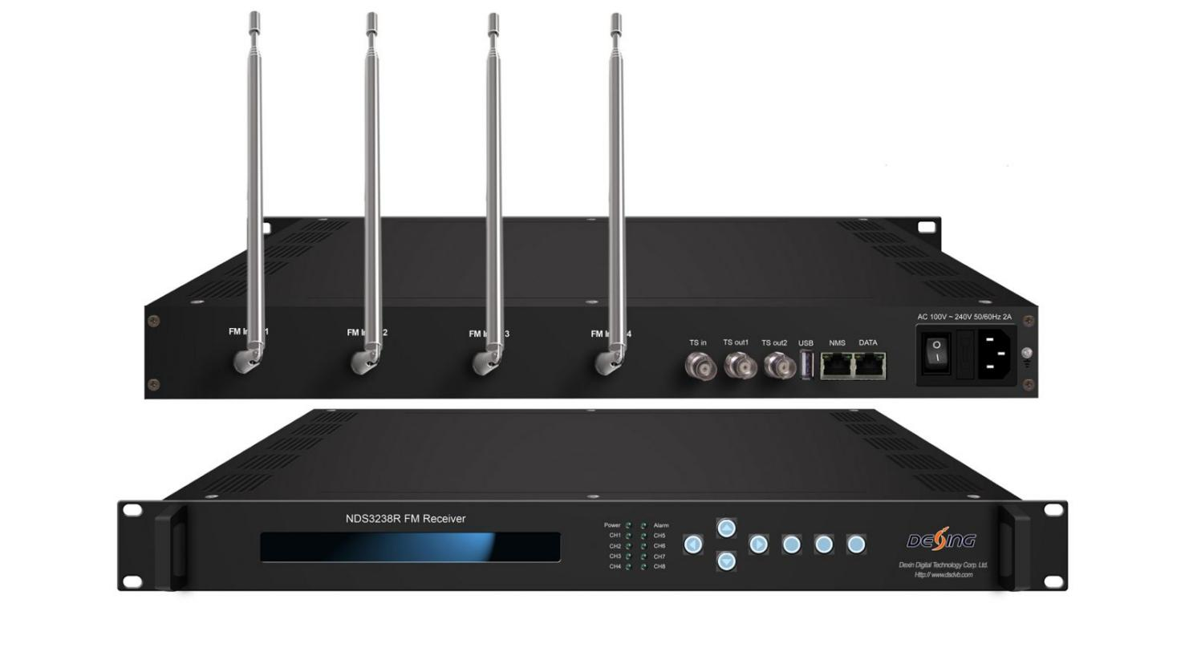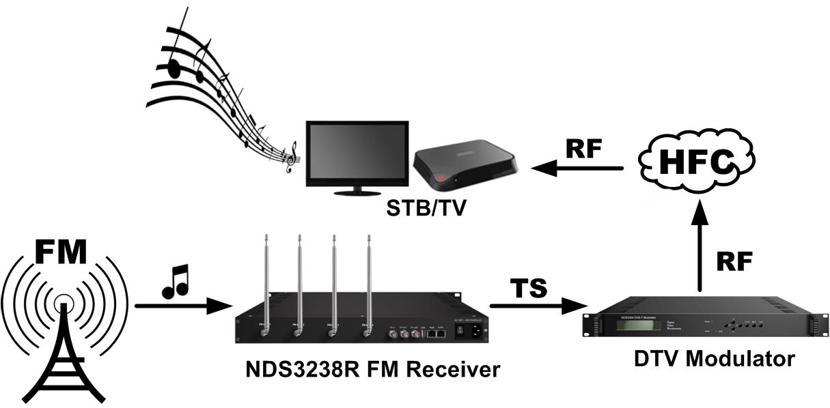
Product Overview
The FMUSER FUQ-4349S is an 8-in-1 FM receiver that captures FM audio and outputs via ASI and IP ports. It compresses audio into digital TS streams using MPEG1 Layer 2 encoding. Features LCD/keyboard control and web-based NMS for management. Ideal for professional audio distribution in HFC or terrestrial systems, integrating with STBs or TVs.Each antenna receives two audios and this unit can maximally process 8 audios. In addition, it is equipped with one ASI input port as well for Audio/Video re-mux. It is featured to operators with its high capacity and integration.

Key feature
Supports reception of 8 FM audio channels via 4 antennas for dual-audio capability.
Features ASI input for Audio/Video re-mux and remultiplexing.
Provides MPEG1 Layer 2 audio encoding with adjustable bit-rates and volume control.
Offers 2 ASI mirrored outputs and IP output over UDP/RTP for versatile distribution.
Enables control via LCD/keyboard and web-based NMS for monitoring and updates.
Inner Principle Chart
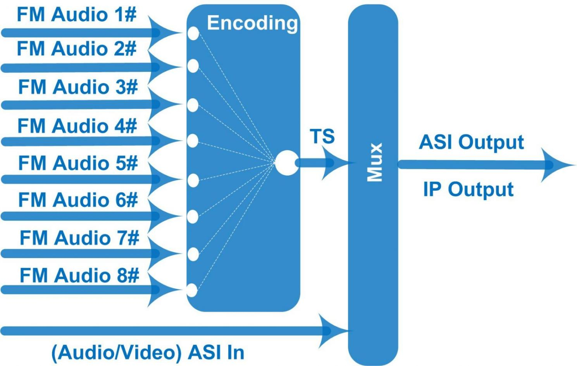
Specifications
FM Receiving | Antenna Frequency | 76-108 MHz
FM Receiving | Volume Control | 0%-100%
FM Receiving | FM lock status and signal quality display
Audio Encode | Encoding Format | MPEG1 Layer 2
Audio Encode | Audio Gain | 0-255
Audio Encode | Sampling Rate | 48KHz
Audio Encode | Bit-rate | 32/48/56/64/80/96/112/128/160/192/224/256/320/384Kb/s (each channel)
Stream In/Out | 1*ASI input, BNC interface
Stream In/Out | 2*ASI mirrored output, BNC interface
Stream In/Out | 8*SPTS+1*MPTS over UDP/RTP, 1000M Base-T Ethernet interface (unicast/multicast) (SPTS output is for the FM input audio)
System | LCD/keyboard operating, web-based NMS manage
System | Language: English/Chinese
System | Ethernet software & hardware upgrade
Miscellaneous | Dimension | 482mm×455mm×44mm (W× L× H)
Miscellaneous | Temperature | 0~45℃ (work), -20~80℃（Storage）
Miscellaneous | Power | AC 100V-220V±10%, 50/60Hz

About Us
FMUSER is a company specializing in broadcasting and television transmission systems and integrating hotel IPTV systems. The company was established in 2009 and has served over 180 countries worldwide. More than 20,000 television stations, radio stations, and hotel clients from different.

Contact:Tomleequan Email：sales@fmuser.com whatsapp: +8613922702227

