FMUSER FUQ-4353 Dual-Channel Encoder HDMI-SDI-YPbPr-CVBS Inputs ASI-IP Outputs MPEG-2 H.264 Encoding Web NMS Broadcast IPTV Solution
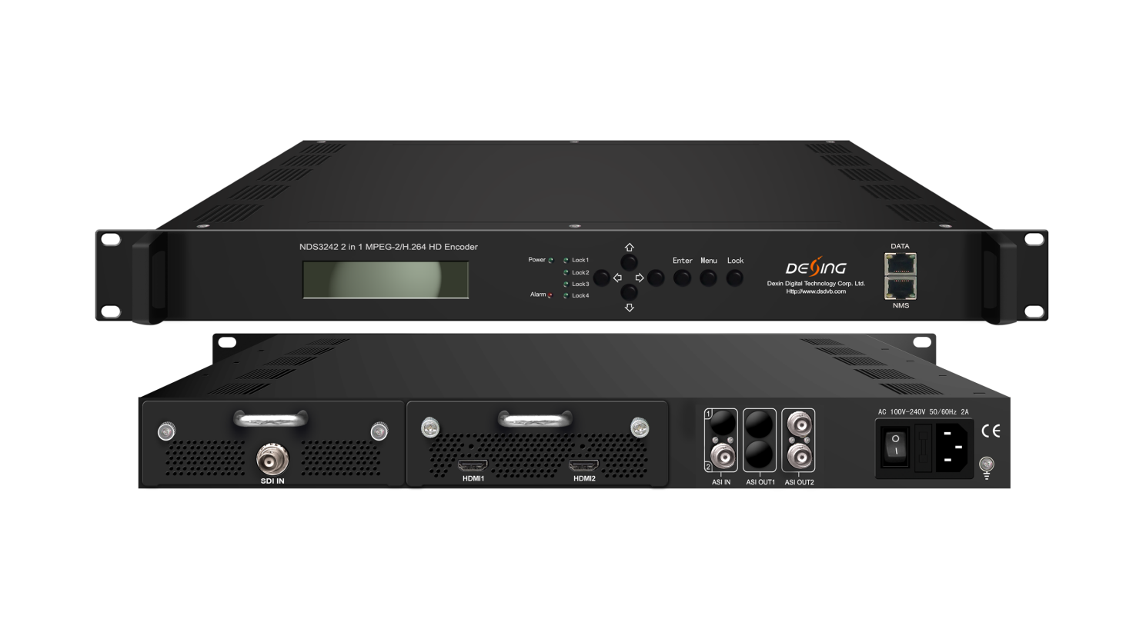Product Overview
The FMUSER FUQ-4353 is a dual-channel encoder supporting HD/SD MPEG-2 & H.264 video and MP2/AAC/AC3 audio. It accepts pluggable HDMI/3G-SDI/YPbPr+CVBS inputs and delivers ASI re-muxed outputs (MPTS/SPTS) or IP streams (UDP/RTP). The 1RU rack-mount unit features PSI/SI editing and web-based NMS for broadcast and IPTV workflows.
Key feature
Centralized Control: Web GUI and SNMP v2 for remote management via network
Technical Specifications
HDMI Input  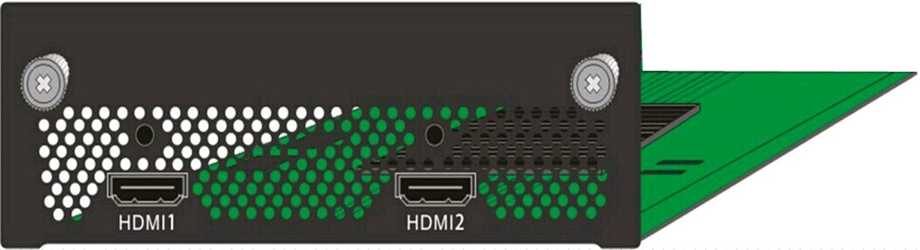 | Video | Input | HDMI*1 (with one for backup)
 | Video | Encoding | MPEG2; MPEG4 AVC/H.264
 | Video | Bitrate | 1-19.5Mbps
 | Video | Resolution | 1920*1080_60P, 1920*1080_50P,  (-for MPEG4 AVC/H.264 only)  1920*1080_60i, 1920*1080_50i,  1280*720_60p, 1280*720_50P  720*480_60i, 720*576_50i
 | Video | Low Delay | Normal, Mode 1, Mode 2
 | Video | Chroma | 4:2:0
 | Video | Aspect Ratio | 16:9,4:3
 | Audio | Encoding | MPEG1 Layer II;MPEG 2-AAC; MPEG 4-AAC and Dolby Digital AC3 2.0
 | Audio | Sample rate | 48KHz
 | Audio | Bitrate | 64/96/128/ 192/256/320kbps
HDMI/YPbPr/CVBS 3-in-1 Input  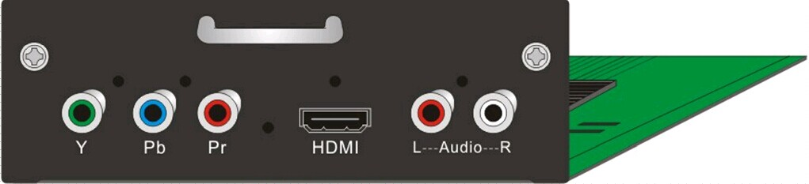  (under developing) | Video  (HDMI) | Encoding | MPEG2; MPEG4 AVC/H.264
 | Video  (HDMI) | Input | HDMI*1
 | Video  (HDMI) | Bitrate | 1-19.5Mbps
 | Video  (HDMI) | Resolution | 1920*1080_60P, 1920*1080_50P,  -for MPEG4 AVC/H.264 only)  1920*1080_60i, 1920*1080_50i,  1280*720_60p, 1280*720_50P  720*480_60i, 720*576_50i
 | Video  (HDMI) | Low Delay | Normal, Mode 1, Mode 2
 | Video  (HDMI) | Chroma | 4:2:0
 | Video  (HDMI) | Aspect Ratio | 16:9,4:3
 | Audio  (HDMI) | Encoding | MPEG1 Layer II ,MPEG2-AAC, MPEG4-AAC  and Dolby Digital AC3 2.0
 | Audio  (HDMI) | Input | HDMI*1
 | Audio  (HDMI) | Sample rate | 48KHz
 | Audio  (HDMI) | Bitrate | 64/96/128/ 192/256/320kbps
 | Video  (YpbPr/ CVBS) | Encoding | MPEG2; MPEG4 AVC/H.264
 | Video  (YpbPr/ CVBS) | Input | YpbPr*1 / CVBS *1
 | Video  (YpbPr/ CVBS) | Bitrate | 1-19.5Mbps
 | Video  (YpbPr/ CVBS) | Resolution | CVBS: 720x576_50i (PAL); 720x480_60i (NTSC)  YpbPr: 1920*1080_60i, 1920*1080_50i;  1280*720_60p, 1280*720_50P
 | Video  (YpbPr/ CVBS) | Low Delay | Normal, Mode 1, Mode 2
 | Video  (YpbPr/ CVBS) | Chroma | 4:2:0
 | Video  (YpbPr/ CVBS) | Aspect Ratio | 16:9, 4:3
 | Audio  (YpbPr/ CVBS) | Encoding | MPEG1 Layer II; MPEG2-AAC; MPEG4-AAC  and Dolby Digital AC3 2.0
 | Audio  (YpbPr/ CVBS) | Interface | 1*Stereo/2*mono
 | Audio  (YpbPr/ CVBS) | Sample rate | 48KHz
 | Audio  (YpbPr/ CVBS) | Bit rate | 64/96/128/ 192/256/320kbps
SDI Input   | Video | Encoding | MPEG2; MPEG4 AVC/H.264
 | Video | Input | SDI*1
 | Video | Bitrate | 1-19.5Mbps
 | Video | Resolution | 1920*1080_60P, 1920*1080_50P, (-for MPEG4 AVC/H.264 only)  1920*1080_60i, 1920*1080_50i,  1280*720_60p, 1280*720_50P  720*480_60i, 720*576_50i
 | Video | Low Delay | Normal, Mode 1, Mode 2
 | Video | Chroma | 4:2:0
 | Video | Aspect Ratio | 16:9,4:3
 | Audio | Encoding | MPEG1 Layer II ,MPEG2-AAC, MPEG4-AAC  and Dolby Digital AC3 2.0
 | Audio | Sample rate | 48KHz
 | Audio | Bitrate | 64/96/128/ 192/256/320kbps

General | System | Local interface | LCD + control buttons
General | System | Remote management | Web NMS
General | System | Stream In | 1 ASI in for re-multiplexing
General | System | Stream Out | 2 ASI out (BNC type, same one TS, mirror as MPTS or SPTS)
General | System | Stream Out | IP (1 MPTS & 2 SPTS) over UDP, RTP/RTSP (RJ45, 1000M)
General | System | DATA Port | 1000M
General | System | NMS interface | RJ45, 100M
General | System | Language | English
General | Physical Specification | Power supply | 100~240VAC, 50/60Hz
General | Physical Specification | Dimensions | 482*300*44mm
General | Physical Specification | Operation temp | 0~45℃

About Us
FMUSER is a company specializing in broadcasting and television transmission systems and integrating hotel IPTV systems. The company was established in 2009 and has served over 180 countries worldwide. More than 20,000 television stations, radio stations, and hotel clients from different.

Contact:Tomleequan Email：sales@fmuser.com whatsapp: +8613922702227

