FMUSER FUQ-4353B HD-SD Encoder 4 Input Channels SDI-HDMI-ASI-IP Interfaces MPEG-2 H.264 Encoding ASI Re-multiplexing Broadcast Headend System
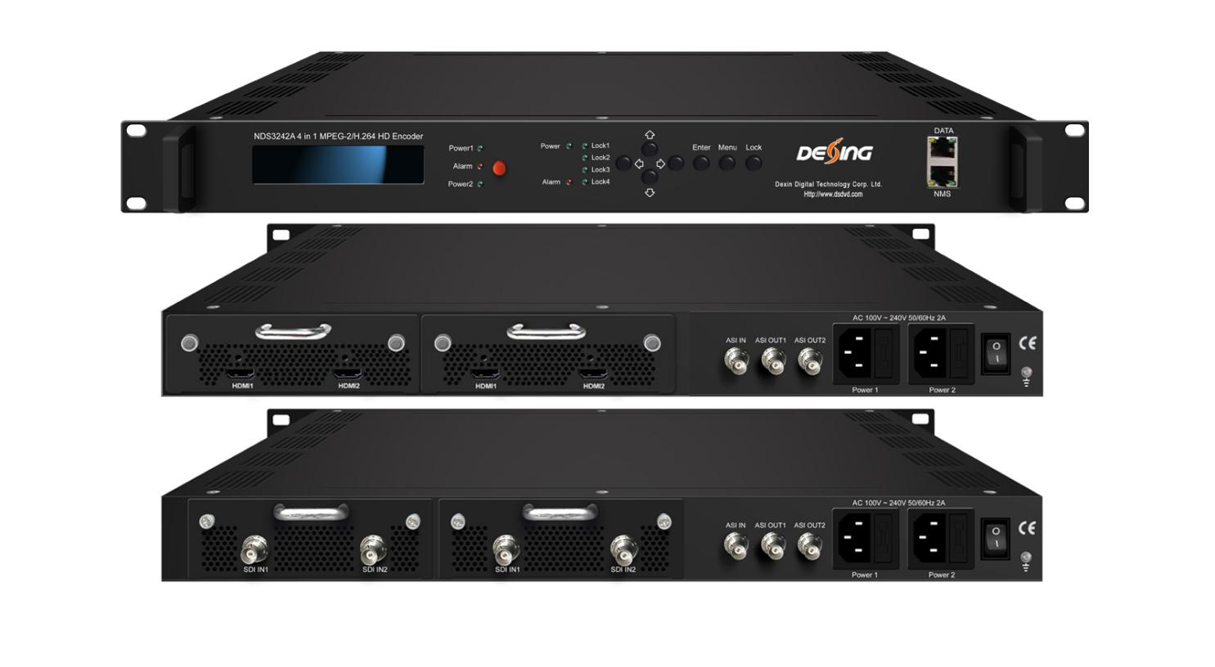Product Overview
The FMUSER FUQ-4353B is a professional HD/SD encoder supporting MPEG-2 and H.264 video encoding with four SDI or HDMI inputs. It processes signals by encoding and re-multiplexing into MPTS or SPTS, outputting via ASI and IP. Featuring a modular drawer design, it is ideal for broadcast, cable TV, and streaming applications.HDMI inputs supporting MPEG‐2 and MPEG‐4 AVC/H.264 video encoding and
MPEG 2, MPEG 2‐AAC, MPEG 4‐AAC and DD AC3 audio encoding. The 4 encoded programs will output through ASI and IP ports in MPTS or SPTS, and there is also one ASI in port for re-multiplexing.
It adopts inner drawer‐type structural design which greatly facilitates the change of encoding modules if needed.

Key feature
Supports MPEG2 HD/SD and MPEG4 AVC/H.264 video encoding with resolution downscale conversion
Multiple audio encoding options: MPEG2, AAC, and AC3, including dialog normalization
Flexible input configurations: 4x SDI, 4x HDMI, or mixed inputs
Advanced features: low delay, closed caption support, and web-based NMS management

Principle Chart

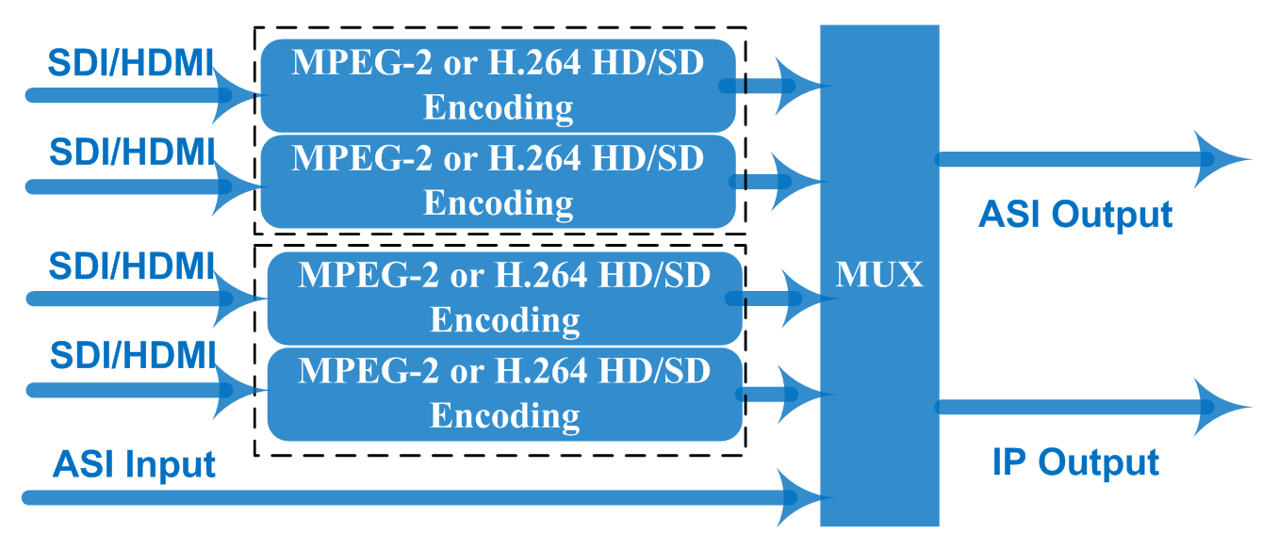

Technical Specifications
Encoding Section
Video
Encoding | MPEG2 & MPEG4 AVC/H.264
Input | SDI*4 or HDMI*4 + 1 ASI in
Resolution | 1920*1080_60P, 1920*1080_50P, (-for MPEG4 AVC/H.264 only)  1920*1080_60i, 1920*1080_50i,  1280*720_60p, 1280*720_50P  720*480_60i, 720*576_50i
Support object resolution  (for downscale conversion) | 1920*1080_60P, 1920*1080_50P, (-for MPEG4 AVC/H.264 only)  1440*1080_60i, 1440*1080_50i,  1280*720_60p, 1280*720_50P  720*480_60i, 720*576_50i
Bit Rate | 1~19.5Mbps
Chroma Sample | 4:2:0
Aspect Ratio | 16:9, 4:3
Audio
encoding | MPEG 2, MPEG2-AAC, MPEG4-AAC, Dolby Digital AC3 (2.0)
Dialog Normalization  Applicable for DD AC3 encoding only) | -31 ~ -1 dB
Sample rate | 48KHz
Bit rate | 64kbps, 96kbps,128kbps, 192kbps, 256kbps, 320kbps

System
Local interface | LCD + control buttons
Remote management | Web NMS
Low Delay Mode | Normal, mode 1, mode 2, Manual
output | 2*ASI out (BNC type, mirror ports/the same one TS);  IP (1 MPTS & 4 SPTS) over UDP, RTP/RTSP (RJ45, 1000M)
NMS interface | RJ45, 100M
Language | English

General
Power | AC 100V~240V
Dimensions | 482*400*44mm
Operation temperature | 0~45℃

Technical Comparision
 | The Former Version | The Current Version（V2）
ASI in | No | Yes
Bit rate Mode | CBR/VBR option | CBR
Audio Group/Pair option-SDI | No | Yes
Video Bit Rate | 0.5~19.5Mbps for H.264 encoding  1~19.5Mbps for MPEG-2 encoding | 1~19.5Mbps
Low Delay | Normal/Mode 1/Mode 2 | Normal/Mode 1/Mode 2/Manual
Character Encoding option | No | Yes
Output Protocol | UDP, RTP | UDP, RTP/RTSP
DATA Port | 100M port | 1000M port

About Us
FMUSER is a company specializing in broadcasting and television transmission systems and integrating hotel IPTV systems. The company was established in 2009 and has served over 180 countries worldwide. More than 20,000 television stations, radio stations, and hotel clients from different.

Contact:Tomleequan Email：sales@fmuser.com whatsapp: +8613922702227

