FMUSER FUQ-4353C 4-Channel Encoder 4x HDMI-YPbPr-CVBS Input 2x ASI-IP Output MPEG2 MPEG4 H.264 Dual-Output EIA608 Closed Captioning Digital TV Headend IPTV System
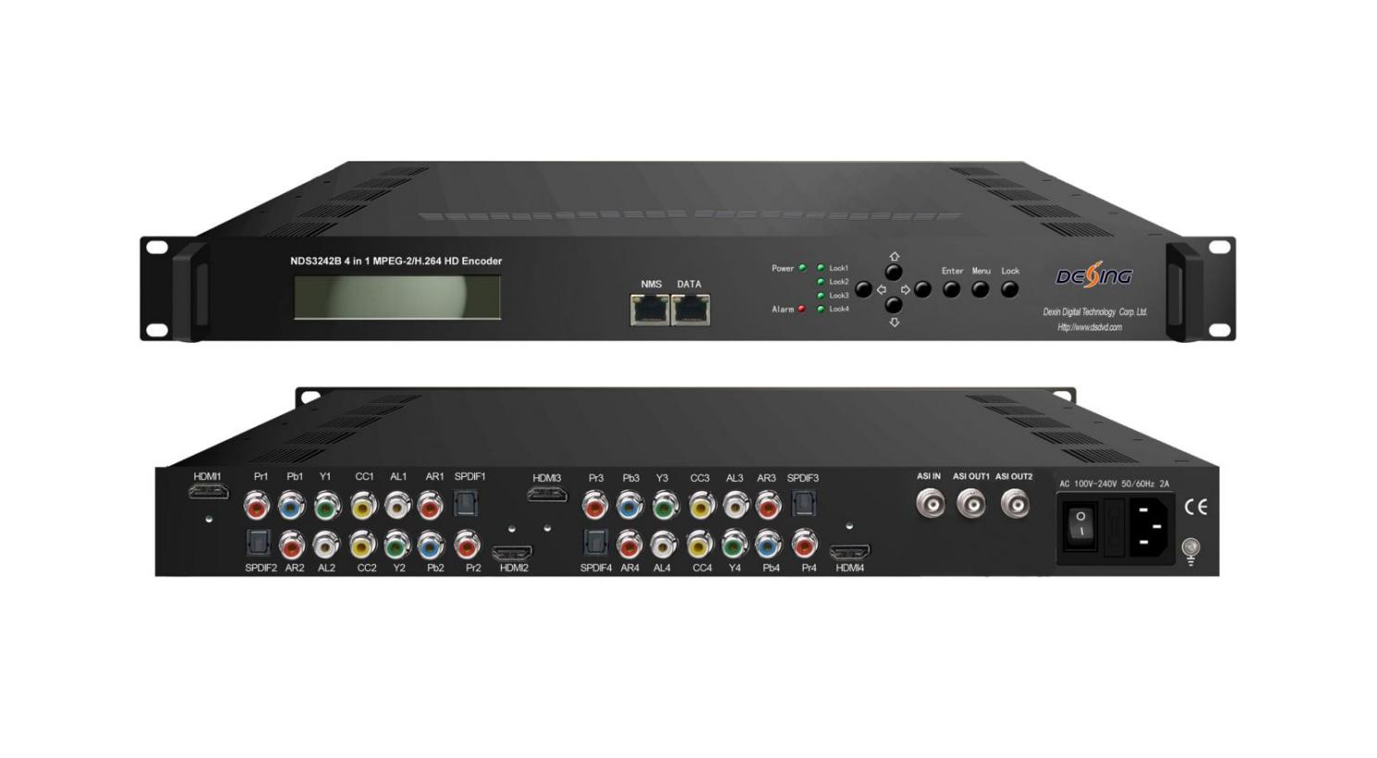Product Overview
The FMUSER FUQ-4353C is a professional 4-in-1 HD encoder featuring 4x HDMI/YPbPr/CVBS inputs and dual-output via ASI (2x) + IP (UDP/RTP/RTSP). It performs real-time MPEG2/MPEG4 H.264 encoding with AC3 passthrough and EIA608 Closed Captioning support. The 1RU rack-mount unit offers web-based NMS control and firmware upgrades. Ideal for digital TV headends, IPTV systems, and satellite uplink applications.
Key feature
1. Multi-standard encoding: Supports MPEG2 & H.264 with HD-to-SD downscaling (1080i/720p/576i)
2. Flexible audio handling: AC3 2.0/5.1/7.1 passthrough + MPEG4-AAC/MP2 encoding
3. Dual-output architecture: 2x ASI outputs (SPTS/MPTS) + IP streaming (UDP/RTP/RTSP)
4. Broadcast features: EIA608 Closed Captioning, LCN support, low-latency mode
5. Remote management: Web GUI + SNMP v2/v3 for NMS integration
Principle Chart
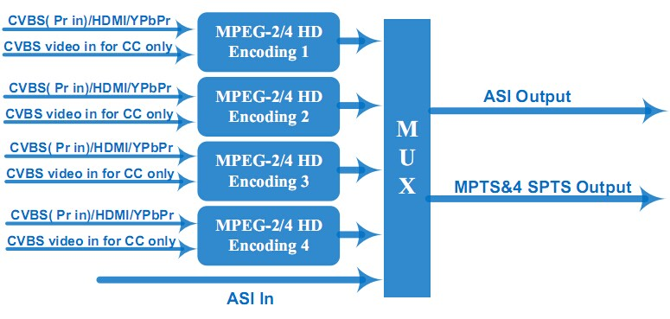

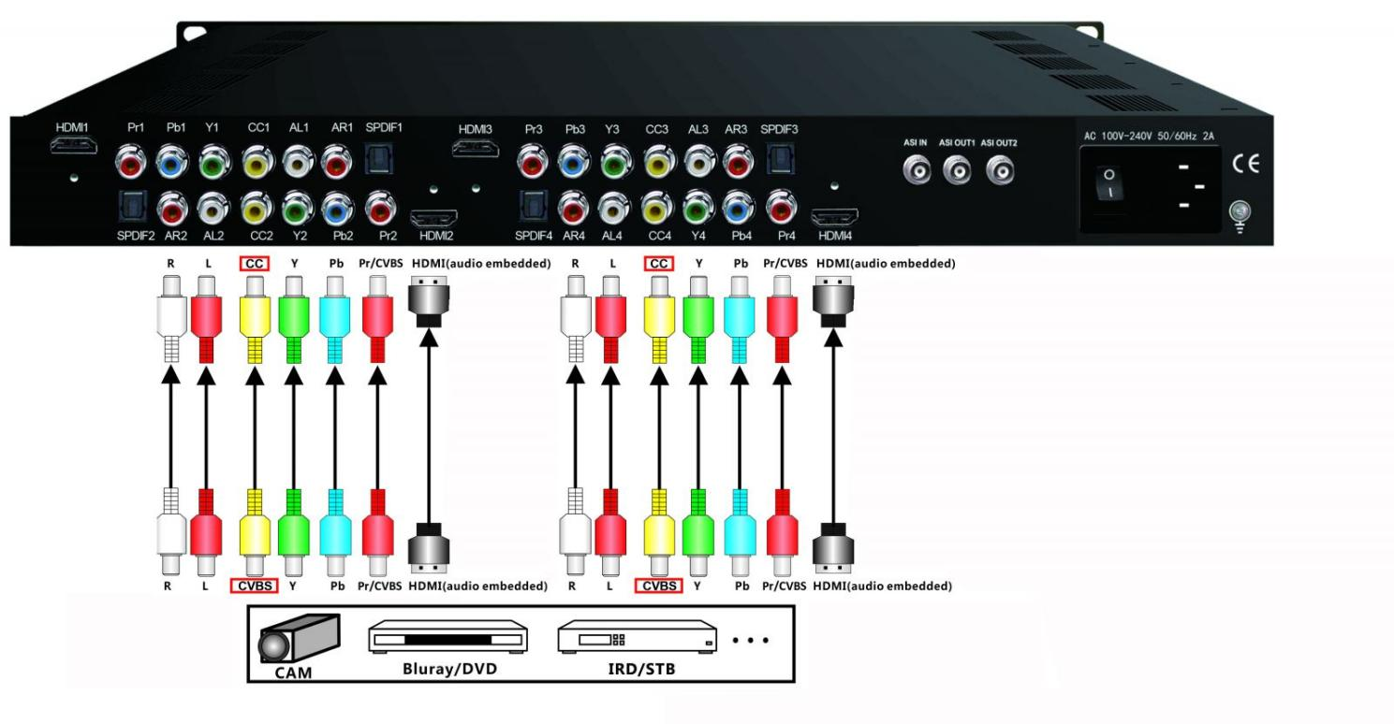

Specifications
Encoding Section
Video (HDMI)
Encoding | MPEG2; MPEG4 AVC/H.264
Interface | HDMI*4
Resolution | Input | Output
Resolution | 1920*1080_60P, 1920*1080_50P  (For MPEG 4 AVC/H.264 only),  1920*1080_60i, 1920*1080_50i,  1280*720_60p, 1280*720_50P | 1920*1080_60i, 1920*1080_50i,  1440*1080_60i, 1440*1080_50i  1280*720_60p, 1280*720_50P,  720*480_60i, 720*576_50i
Low Delay | Normal, Mode 1, Mode 2
Audio (HDMI)
Encoding | MPEG1 Layer II; MPEG2-AAC; MPEG4-AAC;  DD AC3 (2.0) Optional;  DD AC3 (2.0/5.1/7.1) passthrough
Interface | HDMI*4 /SPDIF*4
Sample rate | 48KHz
Bit rate | 64/96/128/ 192/256/320kbps
Video (CVBS/YPbPr)
Encoding | MPEG2; MPEG4 AVC/H.264
Interface | CVBS/YPbPr*4 (RCA)
Resolution | CVBS: 720*576_50i, 720*480_60i
Resolution | YPbPr Input | YPbPr Output
Resolution | 1920*1080_60i, 1920*1080_50i;  1280*720_60p, 1280*720_50P | 1920*1080_60i, 1920*1080_50i,  1440*1080_60i, 1440*1080_50i  1280*720_60p, 1280*720_50P,  720*480_60i, 720*576_50i
Low Delay | Normal, Mode 1, Mode 2
Audio (L/R)
Encoding | MPEG1 Layer II; MPEG2-AAC; MPEG4-AAC;  DD AC3 (2.0) Optional
Interface | 4*Stereo/8*mono/4*SPDIF
Sample rate | 48KHz
Bit rate | 64/96/128/ 192/256/320kbps

System
Local interface | LCD + control buttons
Remote management | Web NMS
Stream Out | 2 ASI mirrored out (BNC type, 100M);  IP (MPTS&4 SPTS) over UDP, RTP/RTSP out (RJ45, 100M)
NMS interface | RJ45, 100M
Aspect Ratio | 4:3; 16:9
Language | English
General
Power supply |  | AC 100V~240V
Dimensions |  | 482*400*44mm
Weight |  | 4.5 kg
Operation temperature |  | 0~45℃

About Us
FMUSER is a company specializing in broadcasting and television transmission systems and integrating hotel IPTV systems. The company was established in 2009 and has served over 180 countries worldwide. More than 20,000 television stations, radio stations, and hotel clients from different.

Contact:Tomleequan Email：sales@fmuser.com whatsapp: +8613922702227

