FMUSER FUQ-4354 Decoder Transcoder 32 IP 2 Tuner 1 ASI Input DVB-C-T-S2-ATSC Output IP ASI CVBS YPbPr HDMI SDI Interfaces AVS+-H.264-MPEG-2 Standards Broadcast IPTV Systems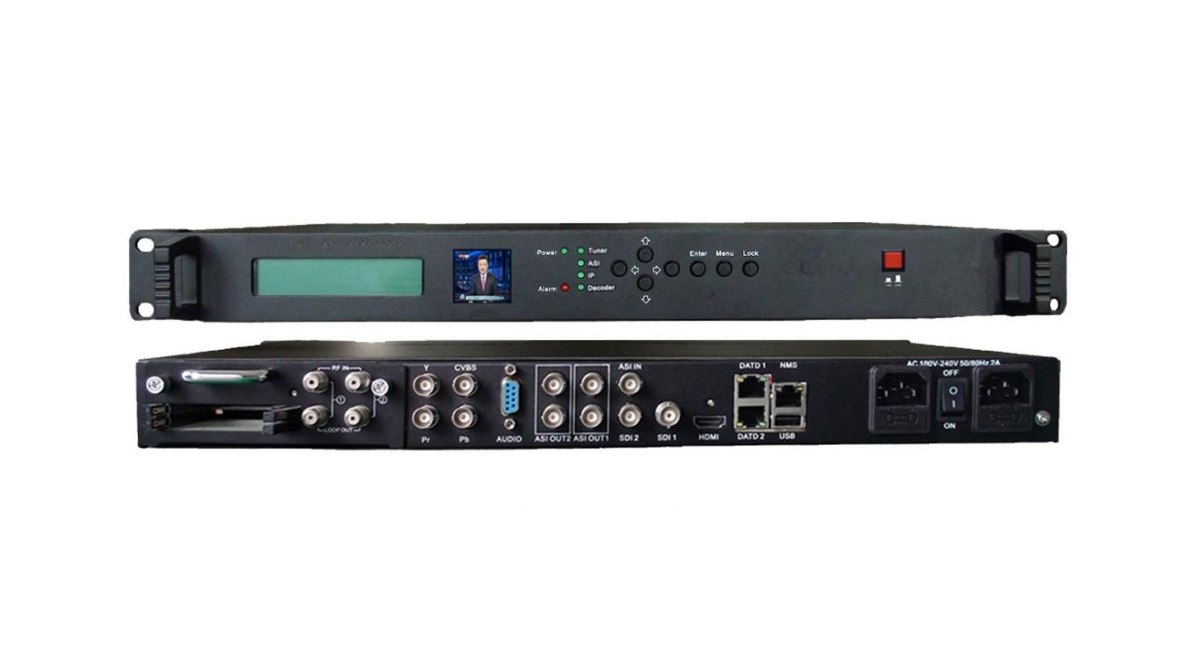Product overview
The FUQ-4354 integrates demodulation, descrambling, decoding, and transcoding, supporting inputs like 32× IP, 2× tuner, and 1× ASI, with outputs including IP, ASI, CVBS, YPbPr, HDMI, and SDI. It processes signals by converting AVS+ to H.264/MPEG-2, transcoding video and audio, and downscaling HD to SD. Managed via web-based NMS, it is designed for broadcast systems, enabling efficient video handling for operators.It can be easily managed through web NMS system, and has become an ideal solution for operator to provide high quality video trans-coding.

KeyFeature
- Supports multi-format inputs: 32× IP (UDP/RTP), 2× tuner with CAM/CI slots, and 1× ASI.
- Enables flexible transcoding: AVS+/MPEG-2/H.264 SD/HD video conversion; MPEG-2/AAC/AC3 audio with CBR/VBR control.
- Provides diverse outputs: IP/ASI streams, CVBS, YPbPr, HDMI, and SDI.
- Features advanced control: BISS descrambling, web-based NMS, and local LCD/keyboard management.

Principle Chart
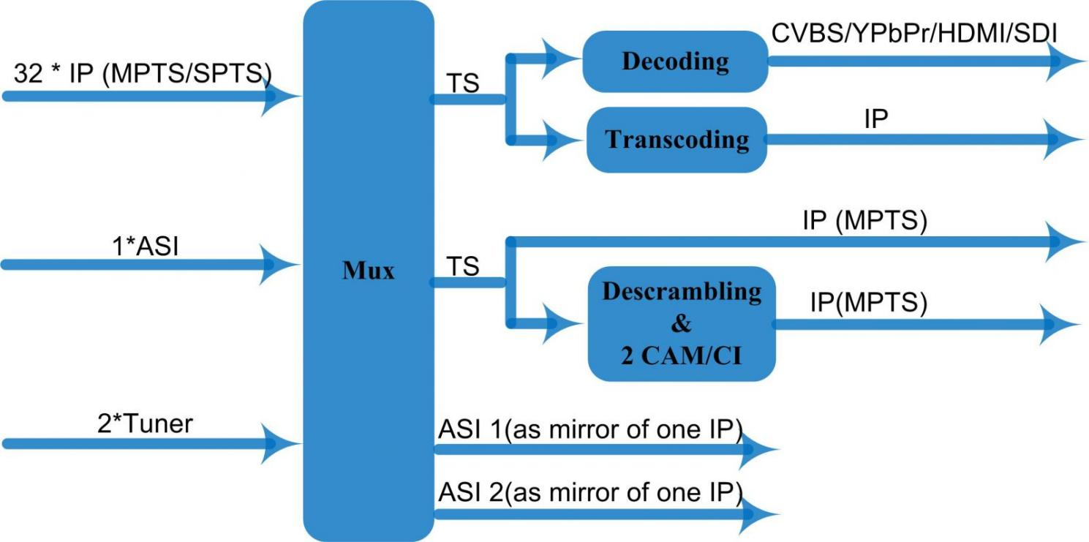
Pri
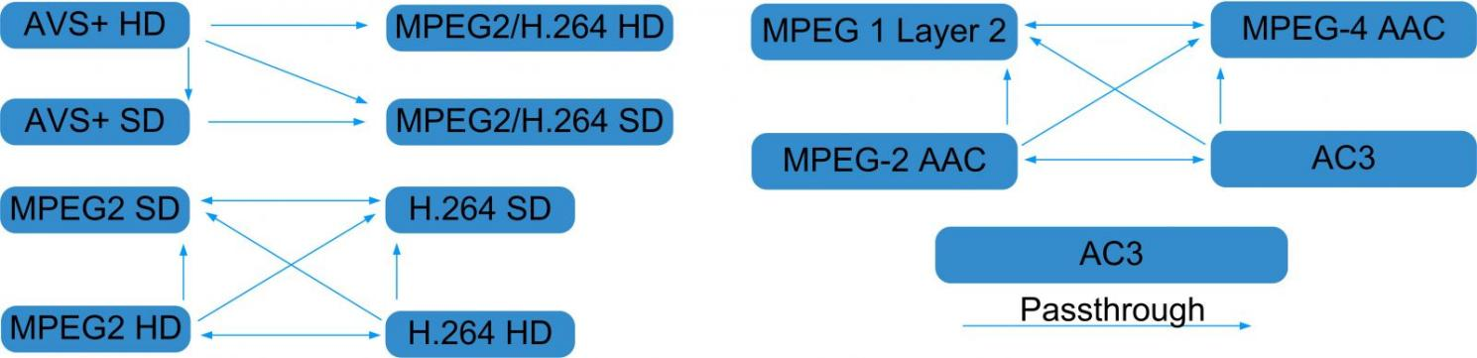

Specifications

Stream In | 32 IP over UDP/RTP, 2*100/1000M Base-T Ethernet Interface
Stream In | 2 * DVB-C/T/S2/ATSC Tuners
Stream In | 1 ASI input
BISS Descramble | 1 program
BISS Descramble | Mode 0, Mode1, Mode E
Transcoding | Video | AVS+ HD → MPEG2/H.264 HD  AVS+ HD → MPEG2/H.264 SD  AVS+ SD → MPEG2/H.264 SD
Transcoding | Video | MPEG2 HD → MPEG2/H.264 HD ;  MPEG2 HD → MPEG2/H.264 SD ;  MPEG2 SD → MPEG2/H.264 SD
Transcoding | Video | H.264 HD → MPEG2/H.264 HD ;  H.264 HD → MPEG2/H.264 SD ;  H.264 SD → MPEG2/H.264 SD
Transcoding | Audio | MPEG-2, MPEG-2 AAC, MPEG-4 AAC and AC3 any to any; AC3 pass through
Decoding | Video Output | 1×CVBS; 1×YPbPr ; 1×HDMI; 2×HD-SDI
Decoding | Resolution | 480i，480p，576i，576p，720p@50，720p@60，1080i@50，1080i@60, 1080p@50, 1080p@60
Decoding | Rate Control | CBR/VBR
Decoding | Audio Output | 1*Stereo /2*mono, HDMI，SDI
Decoding | Audio Sampling | 48KHz
Decoding | Audio Bit Rate | 64Kbps-384Kbps
Stream Out | 3*IP over UDP protocol, 2*100M/1000M Base-T Ethernet Interface, one for backup
Stream Out | 2 groups separate ASI outputs (each group has 2 channels, as a copy of one of IP) output, BNC interface
System Function | LCD & Key board control; web-based NMS management
System Function | Ethernet software upgrade
General | Dimensions |  | 430mm×405mm×45mm (WxDxH)
General | Approx weight |  | 4.8 Kg
General | Temperature range |  | 0~45℃(Operation), -20~80℃(Storage)
General | Power requirements |  | AC 200V-240V, 50/60Hz, 2A

About Us
FMUSER is a company specializing in broadcasting and television transmission systems and integrating hotel IPTV systems. The company was established in 2009 and has served over 180 countries worldwide. More than 20,000 television stations, radio stations, and hotel clients from different.

Contact:Tomleequan Email：sales@fmuser.com whatsapp: +8613922702227

