FMUSER FUQ-4354 Transcoder Single Channel 32 IP Streams 2 Tuners ASI Input DVB-C-T-S2-ATSC Demodulation Decoding Transcoding for Broadcast Operators
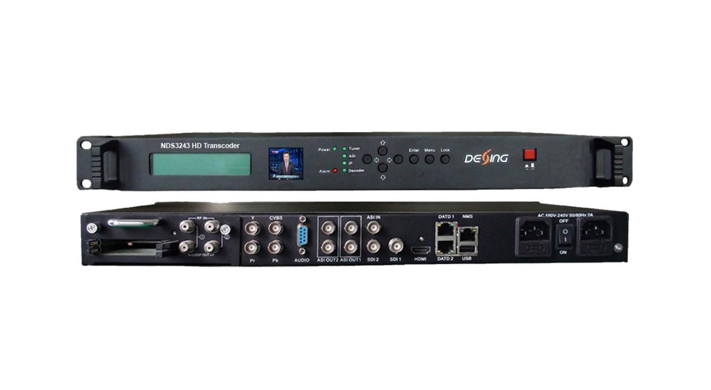Product overview
The FMUSER FUQ-4354 is a single-channel transcoder integrating demodulation (optional DVB-C/T/S2/ATSC), descrambling, decoding, and transcoding. It processes signals by accepting inputs via 2 tuners with CAM/CI slots, ASI, and 32 IP streams (UDP/RTP), supporting any-to-any conversion between AVS+ and H.264/MPEG-2 with HD-to-SD downscaling. Controlled via web NMS, this unit is ideal for broadcast transmission and cable distribution systems.
KeyFeature
Supports flexible inputs: 32 IP streams (UDP/RTP), 2 tuners with CAM/CI slots, and ASI.
Enables multi-format video transcoding: any-to-any conversion between AVS+, MPEG-2, and H.264 in SD/HD, including HD-to-SD downscaling.
Features advanced audio handling: any-to-any transcoding of MPEG-2, AAC, and AC3 with AC3 pass-through.
Provides robust outputs: 3 IP (UDP), 2 ASI groups, and decoded video/audio (CVBS/YPbPr/HDMI/SDI).
Offers secure management: BISS descrambling, CBR/VBR control, and web NMS for remote monitoring.
Principle Chart
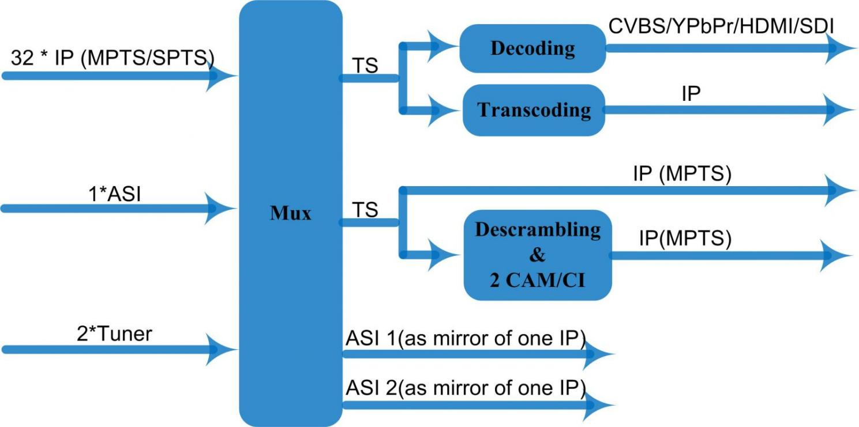
Pri
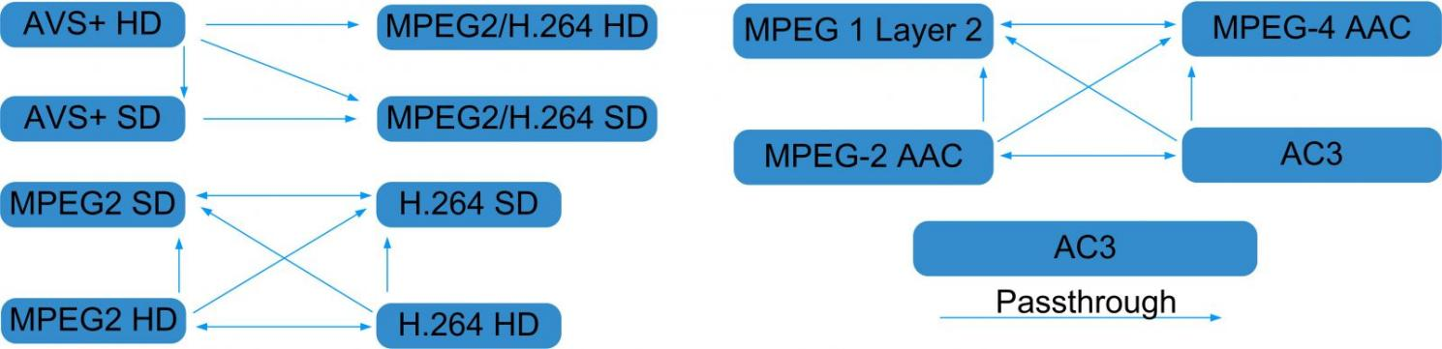

Specifications

Stream In | 32 IP over UDP/RTP, 2*100/1000M Base-T Ethernet Interface
Stream In | 2 * DVB-C/T/S2/ATSC Tuners
Stream In | 1 ASI input
BISS Descramble | 1 program
BISS Descramble | Mode 0, Mode1, Mode E
Transcoding | Video | AVS+ HD → MPEG2/H.264 HD  AVS+ HD → MPEG2/H.264 SD  AVS+ SD → MPEG2/H.264 SD
Transcoding | Video | MPEG2 HD → MPEG2/H.264 HD ;  MPEG2 HD → MPEG2/H.264 SD ;  MPEG2 SD → MPEG2/H.264 SD
Transcoding | Video | H.264 HD → MPEG2/H.264 HD ;  H.264 HD → MPEG2/H.264 SD ;  H.264 SD → MPEG2/H.264 SD
Transcoding | Audio | MPEG-2, MPEG-2 AAC, MPEG-4 AAC and AC3 any to any; AC3 pass through
Decoding | Video Output | 1×CVBS; 1×YPbPr ; 1×HDMI; 2×HD-SDI
Decoding | Resolution | 480i，480p，576i，576p，720p@50，720p@60，1080i@50，1080i@60, 1080p@50, 1080p@60
Decoding | Rate Control | CBR/VBR
Decoding | Audio Output | 1*Stereo /2*mono, HDMI，SDI
Decoding | Audio Sampling | 48KHz
Decoding | Audio Bit Rate | 64Kbps-384Kbps
Stream Out | 3*IP over UDP protocol, 2*100M/1000M Base-T Ethernet Interface, one for backup
Stream Out | 2 groups separate ASI outputs (each group has 2 channels, as a copy of one of IP) output, BNC interface
System Function | LCD & Key board control; web-based NMS management
System Function | Ethernet software upgrade
General | Dimensions |  | 430mm×405mm×45mm (WxDxH)
General | Approx weight |  | 4.8 Kg
General | Temperature range |  | 0~45℃(Operation), -20~80℃(Storage)
General | Power requirements |  | AC 200V-240V, 50/60Hz, 2A

About Us
FMUSER is a company specializing in broadcasting and television transmission systems and integrating hotel IPTV systems. The company was established in 2009 and has served over 180 countries worldwide. More than 20,000 television stations, radio stations, and hotel clients from different.

Contact:Tomleequan Email：sales@fmuser.com whatsapp: +8613922702227

