FMUSER FUQ-4359 Bidirectional Transcoder 8 IP + 6 Tuner-ASI Inputs MPTS-SPTS Outputs UDP-RTP-RTSP MPEG-2 H.264 HD-SD BISS Descramble Broadcast Operators
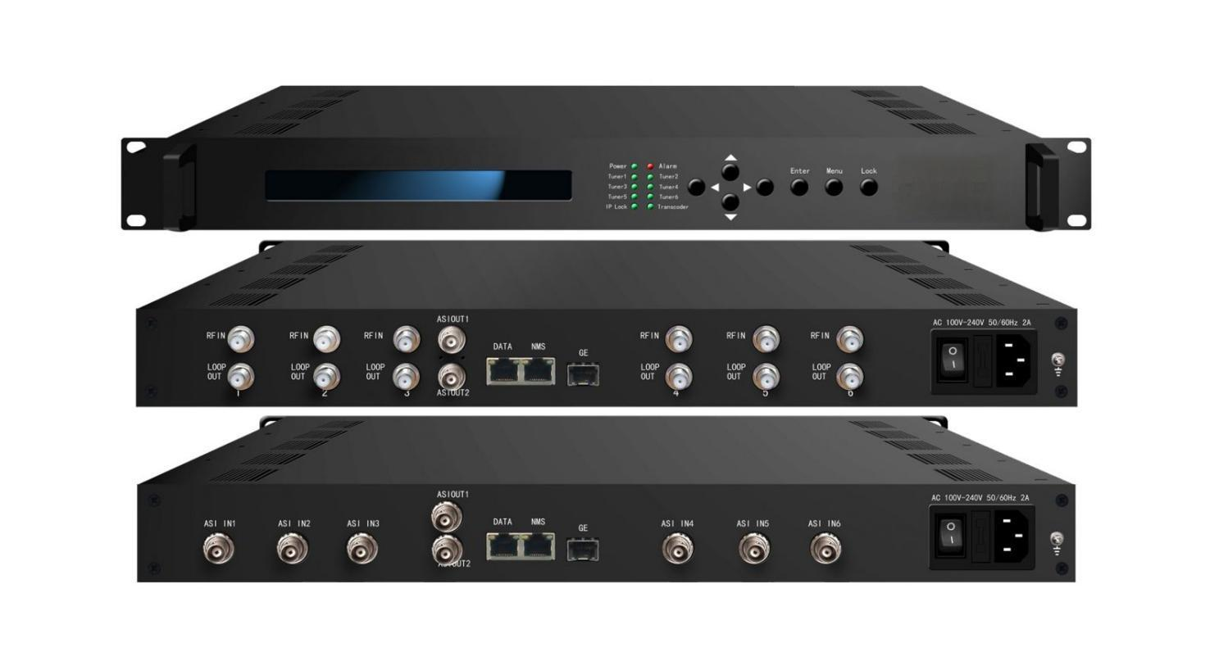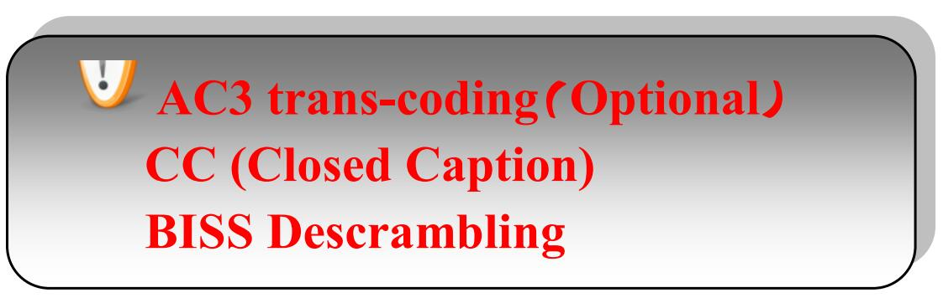
Product overview
The FMUSER FUQ-4359 is a bidirectional transcoder supporting H.264/MPEG-2 and HD/SD conversion, with 6 tuner inputs and ASI/IP inputs for reception, and outputs MPTS/SPTS via IP or ASI. It performs any-to-any transcoding with CBR/VBR rate control. Features include BISS descrambling, CC support, and web NMS management with LCD/keyboard interface. Ideal for satellite TV operators and broadcast content distribution.
Key feature
Supports versatile inputs: 8×IP (SPTS/MPTS) plus 6×tuners or 6×ASI.
Delivers flexible outputs: 8×SPTS & 1×MPTS via UDP/RTP/RTSP, plus ASI output.
Enables advanced transcoding: Any-to-any MPEG-2/H.264 conversion in HD/SD with CBR/VBR control.
Features integrated security: BISS descrambling and CC support.
Provides centralized control: Web NMS management with LCD/keyboard interface.
Principle Chart (FU-4359)

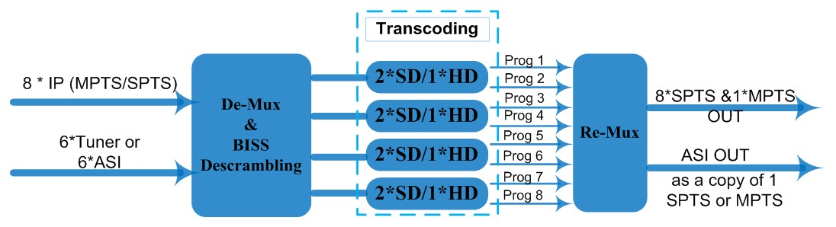

Transcoding Mode Example
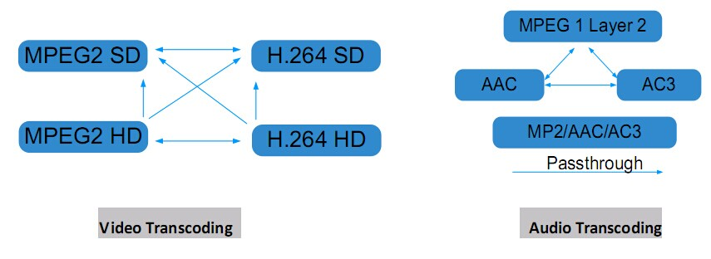

Technical Specifications
Stream In | MPTS/SPTS over UDP/RTP, 1000M Base-T Ethernet Interface/ SFP interface
Stream In | 6 * (DVB-S/S2/C/T/ISDB-T/ATSC) Tuners; 6 * ASI (optional)
BISS Descramble | Maximum 8 programs
Video | Resolution | 1920x1080P,1920x1080i,1280x720P, 720x576i, 720x480i  480x576, 544x576, 640x576, 704x576
Video | Trans-coding | 4*MPEG2 HD → 4*MPEG2/H.264 HD ;  4*MPEG2 HD → 4*MPEG2/H.264 SD ;  8 *MPEG2 SD → 8 *MPEG2/H.264 SD
Video | Trans-coding | 4* H.264 HD → 4*MPEG2/H.264 HD ;  4* H.264 HD → 4*MPEG2/H.264 SD ;  8* H.264 SD → 8 *MPEG2/H.264 SD
Video | Rate Control | CBR/VBR
Audio | Trans-coding | MPEG-1 Layer 2, AAC and AC3(Optional) any-to-any or pass through
Audio | Sampling rate | 48KHz
Audio | Bit Rate | 64Kbps-384Kbps
Stream Out | 8*SPTS & 1*MPTS over UDP/RTP/RTSP, 1000M Base-T Ethernet Interface (UDP/RTP uni-cast / multicast) /SFP interface
Stream Out | 1*ASI (as a copy of one of the 8 SPTS or the MPTS) output, BNC interface
System Function | LCD & Key board control; web NMS management
System Function | Ethernet software upgrade
General | Dimensions |  | 430mm×405mm×45mm(WxDxH)
General | Approx weight |  | 4.8 Kg
General | Temperature range |  | 0~45℃(Operation), -20~80℃(Storage)
General | Power requirements |  | AC 110V±10%, 50/60Hz or AC 220V±10%,50/60Hz
General | Power consumption |  | 20W

About Us
FMUSER is a company specializing in broadcasting and television transmission systems and integrating hotel IPTV systems. The company was established in 2009 and has served over 180 countries worldwide. More than 20,000 television stations, radio stations, and hotel clients from different.

Contact:Tomleequan Email：sales@fmuser.com whatsapp: +8613922702227

