FUQ-4359 Transcoder 6 Tuner-ASI Inputs 8 IP Inputs DVB-S-S2-C-T-ISDB-T-ATSC to IP-ASI Outputs Bidirectional H.264-MPEG2 Transcoding BISS CC Support for Broadcast Operators
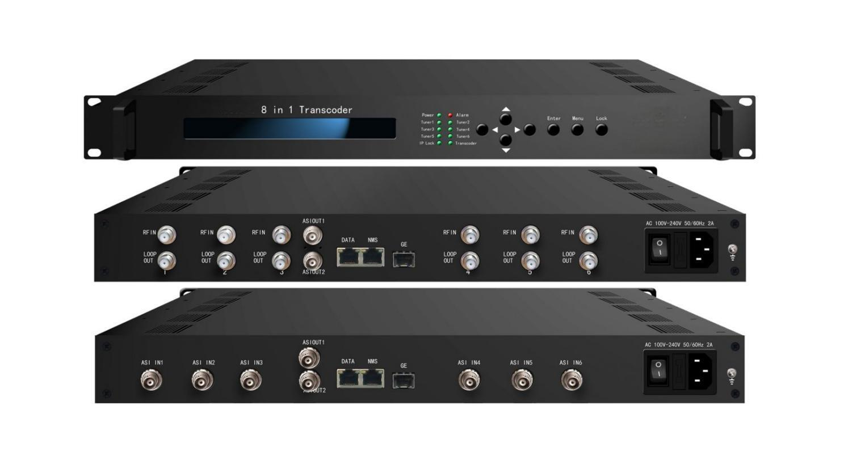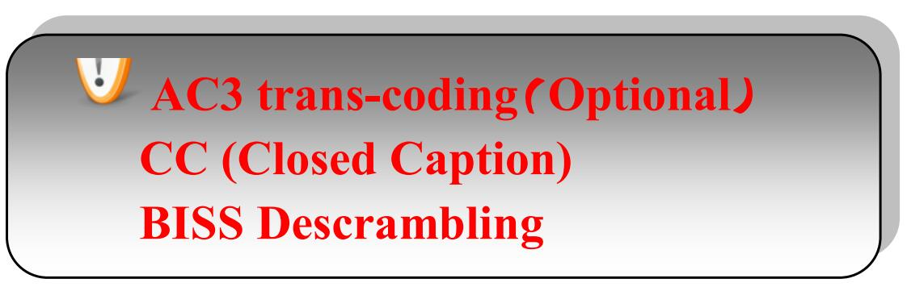
Product overview
The FUQ-4359 transcoder performs bidirectional conversion between H.264 and MPEG-2 formats, supporting HD/SD video. It includes 6 tuner or ASI inputs and 8 IP inputs, with outputs via IP or ASI. Managed via web-based NMS, it handles signal transcoding efficiently. Ideal for broadcast operators in television and media distribution.
Key feature
Supports bidirectional transcoding between H.264 and MPEG-2 for SD/HD programs.
Features flexible I/O with 6 tuner/ASI inputs, 8 IP inputs, 8 SPTS and 1 MPTS over IP/ASI outputs.
Includes BISS descrambling and closed captioning support.
Enables remote control and monitoring via web-based NMS.
Principle Chart (FU-4359)

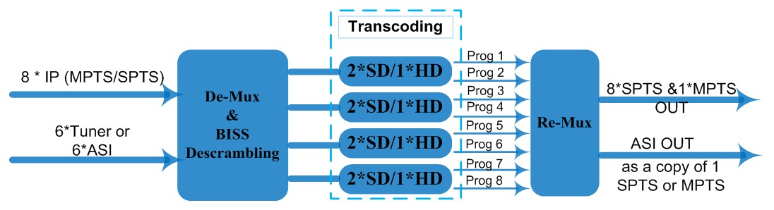

Transcoding Mode Example
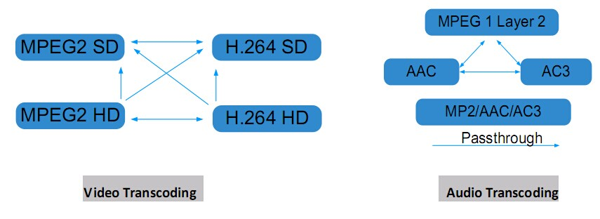

Technical Specifications
Stream In | MPTS/SPTS over UDP/RTP, 1000M Base-T Ethernet Interface/ SFP interface
Stream In | 6 * (DVB-S/S2/C/T/ISDB-T/ATSC) Tuners; 6 * ASI (optional)
BISS Descramble | Maximum 8 programs
Video | Resolution | 1920x1080P,1920x1080i,1280x720P, 720x576i, 720x480i  480x576, 544x576, 640x576, 704x576
Video | Trans-coding | 4*MPEG2 HD → 4*MPEG2/H.264 HD ;  4*MPEG2 HD → 4*MPEG2/H.264 SD ;  8 *MPEG2 SD → 8 *MPEG2/H.264 SD
Video | Trans-coding | 4* H.264 HD → 4*MPEG2/H.264 HD ;  4* H.264 HD → 4*MPEG2/H.264 SD ;  8* H.264 SD → 8 *MPEG2/H.264 SD
Video | Rate Control | CBR/VBR
Audio | Trans-coding | MPEG-1 Layer 2, AAC and AC3(Optional) any-to-any or pass through
Audio | Sampling rate | 48KHz
Audio | Bit Rate | 64Kbps-384Kbps
Stream Out | 8*SPTS & 1*MPTS over UDP/RTP/RTSP, 1000M Base-T Ethernet Interface (UDP/RTP uni-cast / multicast) /SFP interface
Stream Out | 1*ASI (as a copy of one of the 8 SPTS or the MPTS) output, BNC interface
System Function | LCD & Key board control; web NMS management
System Function | Ethernet software upgrade
General | Dimensions |  | 430mm×405mm×45mm(WxDxH)
General | Approx weight |  | 4.8 Kg
General | Temperature range |  | 0~45℃(Operation), -20~80℃(Storage)
General | Power requirements |  | AC 110V±10%, 50/60Hz or AC 220V±10%,50/60Hz
General | Power consumption |  | 20W

About Us
FMUSER is a company specializing in broadcasting and television transmission systems and integrating hotel IPTV systems. The company was established in 2009 and has served over 180 countries worldwide. More than 20,000 television stations, radio stations, and hotel clients from different.

Contact:Tomleequan Email：sales@fmuser.com whatsapp: +8613922702227

