FMUSER FUQ-4359B Transcoder 4 Tuner + 8 IP Inputs MPEG-2 H.264 MPEG-2 HD SD Bidirectional Transcoding ASI UDP-RTP Streaming BISS Descrambling Cable Satellite Broadcast
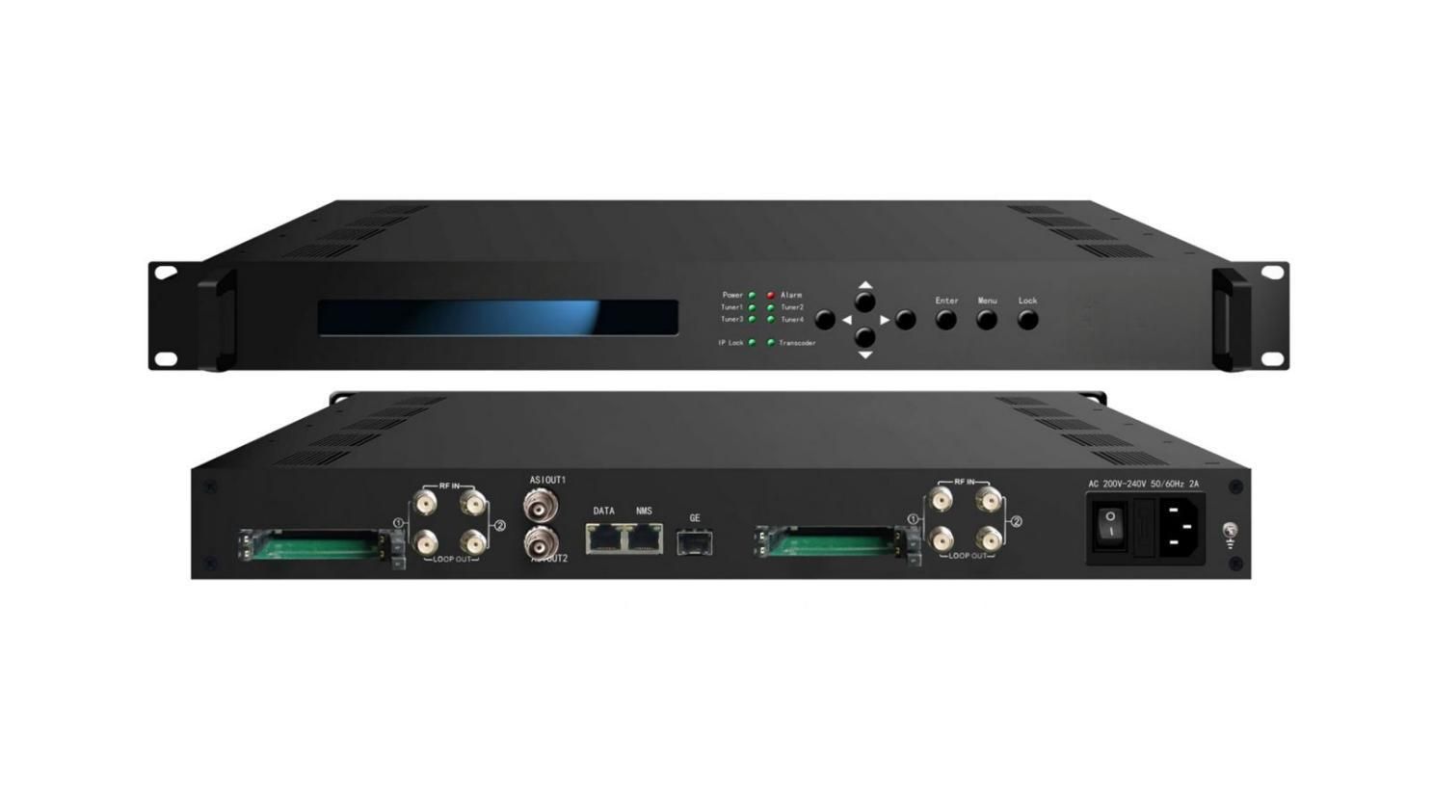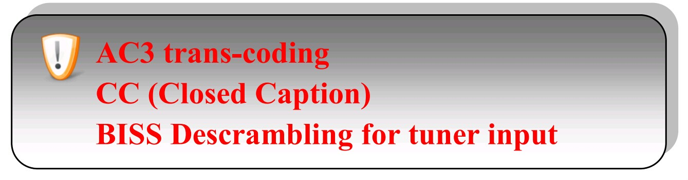
Remarks: All H.264 mentioned in this sheet refers to MPEG-4 AVC/H.264.
Product overview
The FMUSER FUQ-4359B transcoder enables bidirectional conversion between H.264 and MPEG-2, HD and SD. It processes signals with inputs including 4 tuners featuring CAM/CI slots and IP inputs, and outputs MPTS/SPTS via ASI or DATA ports. Managed via web-based NMS, it suits broadcast operators in cable TV and satellite systems for efficient signal handling.
Key feature
Supports bidirectional video transcoding between MPEG-2 and H.264 for up to 8 SD or 4 HD programs.
Includes flexible I/O with 4 tuners having CAM/CI slots, 8 IP inputs, and outputs via ASI or UDP/RTP/RTSP for 8 SPTS & 1 MPTS.
Handles audio transcoding for LC-AAC, MP2, and AC3 formats with any-to-any conversion.
Offers advanced functions like BISS descrambling, CC, and web-based NMS control.
Principle Chart

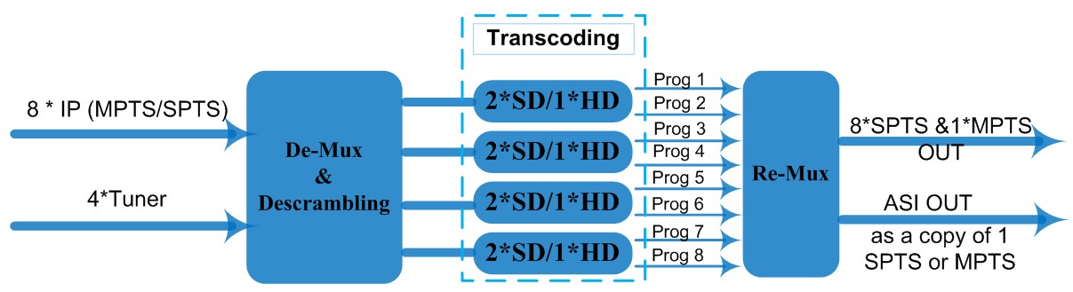

Transcoding Mode Example

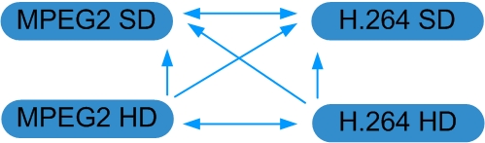

Technical Specifications
Stream In | MPTS/SPTS over UDP/RTP, 1000M Base-T Ethernet Interface/SFP interface
Stream In | 4 * (DVB-S/S2/C/T/ISDB-T/ATSC Optional) Tuners
BISS Descramble | 8 programs
Video | Resolution | 1920x1080P,1920x1080i,1280x720P, 720x576i, 720x480i  480x576, 544x576, 640x576, 704x576
Video | Trans-coding | 4*MPEG2 HD → 4*MPEG2/H.264 HD ;  4*MPEG2 HD → 4*MPEG2/H.264 SD ;  8 *MPEG2 SD → 8 *MPEG2/H.264 SD
Video | Trans-coding | 4* H.264 HD → 4*MPEG2/H.264 HD ;  4* H.264 HD → 4*MPEG2/H.264 SD ;  8* H.264 SD → 8 *MPEG2/H.264 SD
Video | Rate Control | CBR/VBR
Audio | Trans-coding | MPEG-1 Layer 2, LC-AAC and AC3 any-to-any or pass through
Audio | Sampling rate | 48KHz
Audio | Bit Rate | 64Kbps-384Kbps
Stream Out | 8*SPTS & 1*MPTS over UDP/RTP/RTSP, 1000M Base-T Ethernet Interface (UDP/RTP uni-cast / multicast) /SFP interface
Stream Out | 1*ASI (as a copy of one of the 8 SPTS or the MPTS) output, BNC interface
System Function | LCD & Key board control; web-based NMS management
System Function | Ethernet software upgrade
General | Dimensions |  | 430mm×405mm×45mm (WxDxH)
General | Approx weight |  | 4.8 Kg
General | Temperature range |  | 0~45℃(Operation), -20~80℃(Storage)
General | Power requirements |  | AC 200V-240V, 50/60Hz, 2A
General | Power consumption |  | 20W

Order Information
Version | 4* ASI or Tuner Input | 6* ASI or Tuner Input | 4* Tuner input | IP Input | CAM/CI
Simple Version (FU-4359B) | *
Advanced Version (FU-4359) |  | * |  | *
FU-4359A |  |  | * | * | *

About Us
FMUSER is a company specializing in broadcasting and television transmission systems and integrating hotel IPTV systems. The company was established in 2009 and has served over 180 countries worldwide. More than 20,000 television stations, radio stations, and hotel clients from different.

Contact:Tomleequan Email：sales@fmuser.com whatsapp: +8613922702227

