FMUSER FUQ-4359B Bidirectional Video Transcoder 4 Tuner & 8 IP Inputs 8 SPTS-1 MPTS Outputs DVB-S-S2-C-T ISDB-T ATSC H.264-MPEG2 MPEG-2 AVC AVC Broadcast Operators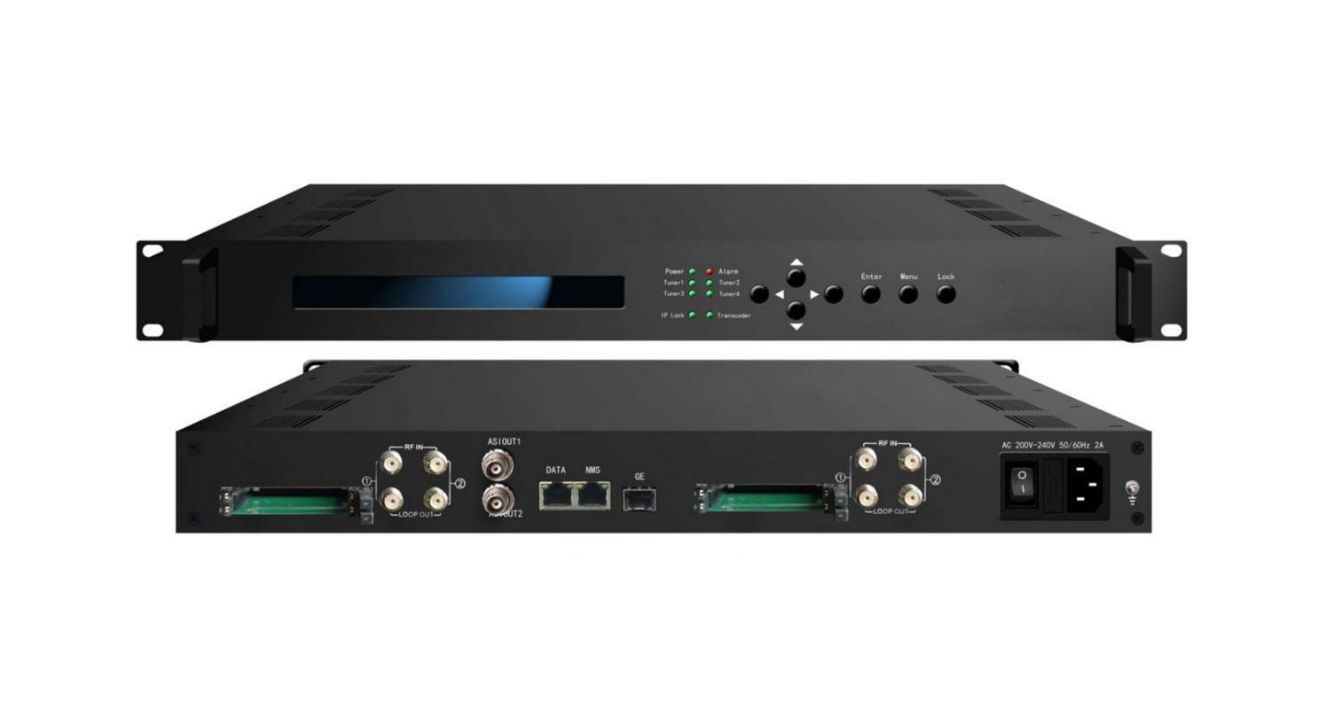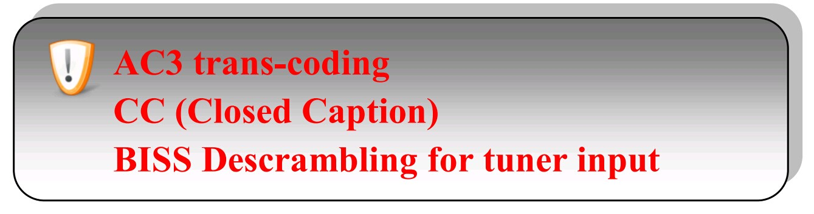
Remarks: All H.264 mentioned in this sheet refers to MPEG-4 AVC/H.264.
Product overview
The FMUSER FUQ-4359B is a bidirectional transcoder converting video between H.264 and MPEG-2 formats, including HD to SD. It supports 4 tuner inputs with CAM/CI slots and IP input, outputting MPTS and SPTS via IP or ASI. Features BISS descrambling, CC, and web-based NMS management for broadcast systems requiring flexible format conversion.
Key feature
- Bidirectional Video Transcoding: Converts between H.264 and MPEG-2 for HD/SD resolutions.
- Flexible I/O Configuration: Supports 8 IP inputs, 4 tuner inputs with CAM/CI, outputs 8 SPTS and 1 MPTS via IP/ASI.
- Audio Processing: Handles LC-AAC, MP2, and AC3 with any-to-any conversion.
- Advanced Control: Features CBR/VBR rate control, BISS descrambling, and CC.
- Management System: Web-based NMS for monitoring and control.
Principle Chart

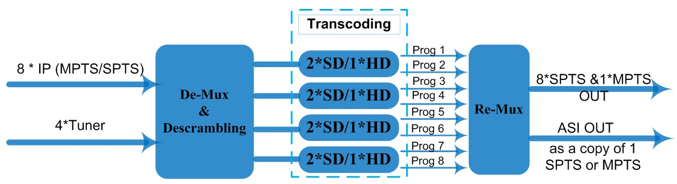

Transcoding Mode Example

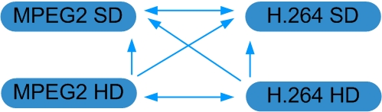

Technical Specifications
Stream In | MPTS/SPTS over UDP/RTP, 1000M Base-T Ethernet Interface/SFP interface
Stream In | 4 * (DVB-S/S2/C/T/ISDB-T/ATSC Optional) Tuners
BISS Descramble | 8 programs
Video | Resolution | 1920x1080P,1920x1080i,1280x720P, 720x576i, 720x480i  480x576, 544x576, 640x576, 704x576
Video | Trans-coding | 4*MPEG2 HD → 4*MPEG2/H.264 HD ;  4*MPEG2 HD → 4*MPEG2/H.264 SD ;  8 *MPEG2 SD → 8 *MPEG2/H.264 SD
Video | Trans-coding | 4* H.264 HD → 4*MPEG2/H.264 HD ;  4* H.264 HD → 4*MPEG2/H.264 SD ;  8* H.264 SD → 8 *MPEG2/H.264 SD
Video | Rate Control | CBR/VBR
Audio | Trans-coding | MPEG-1 Layer 2, LC-AAC and AC3 any-to-any or pass through
Audio | Sampling rate | 48KHz
Audio | Bit Rate | 64Kbps-384Kbps
Stream Out | 8*SPTS & 1*MPTS over UDP/RTP/RTSP, 1000M Base-T Ethernet Interface (UDP/RTP uni-cast / multicast) /SFP interface
Stream Out | 1*ASI (as a copy of one of the 8 SPTS or the MPTS) output, BNC interface
System Function | LCD & Key board control; web-based NMS management
System Function | Ethernet software upgrade
General | Dimensions |  | 430mm×405mm×45mm (WxDxH)
General | Approx weight |  | 4.8 Kg
General | Temperature range |  | 0~45℃(Operation), -20~80℃(Storage)
General | Power requirements |  | AC 200V-240V, 50/60Hz, 2A
General | Power consumption |  | 20W

Order Information
Version | 4* ASI or Tuner Input | 6* ASI or Tuner Input | 4* Tuner input | IP Input | CAM/CI
Simple Version (FU-4359B) | *
Advanced Version (FU-4359) |  | * |  | *
FU-4359A |  |  | * | * | *

About Us
FMUSER is a company specializing in broadcasting and television transmission systems and integrating hotel IPTV systems. The company was established in 2009 and has served over 180 countries worldwide. More than 20,000 television stations, radio stations, and hotel clients from different.

Contact:Tomleequan Email：sales@fmuser.com whatsapp: +8613922702227

