FMUSER FUQ-44105B 16-Channel DVB-C QAM Modulator with 16 DVB-C Tuners 512 IP Inputs 16 RF Outputs ETR289 Scrambling Multiplexing for CATV IPTV Headend 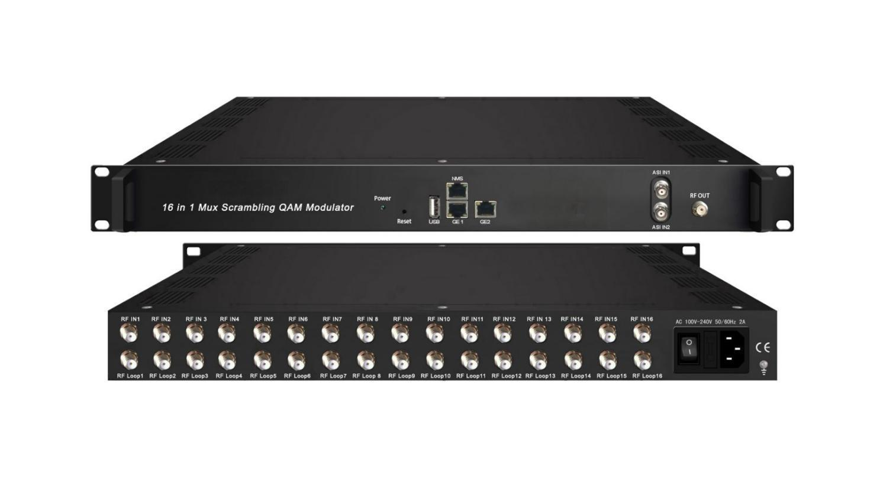
Product overview
The FMUSER FUQ-44105B is a high-density QAM modulator supporting 16x DVB-C tuner inputs, 2x ASI (BNC), and 512x IP streams via GE1 (UDP/RTP). It performs multiplexing, ETR289-compliant scrambling, and 16-256QAM modulation, delivering 16x RF outputs (50-960MHz) and 1x MPTS IP mirror (UDP/RTP/RTSP). The 1U rack-mount unit features MER ≥40dB and web-based control. Ideal for CATV digitization, IPTV redistribution, and multi-standard headend deployments.FU-44105C is also characterized with high integrated level, high performance and low cost. It supports dual power supply (optional). This is very adaptable to newly generation CATV broadcasting system.

Key feature
Broad Compliance: Supports DVB-C/T/S/S2/S2X, ATSC, ISDB-T, and J.83A/B/C standards

Working Principle
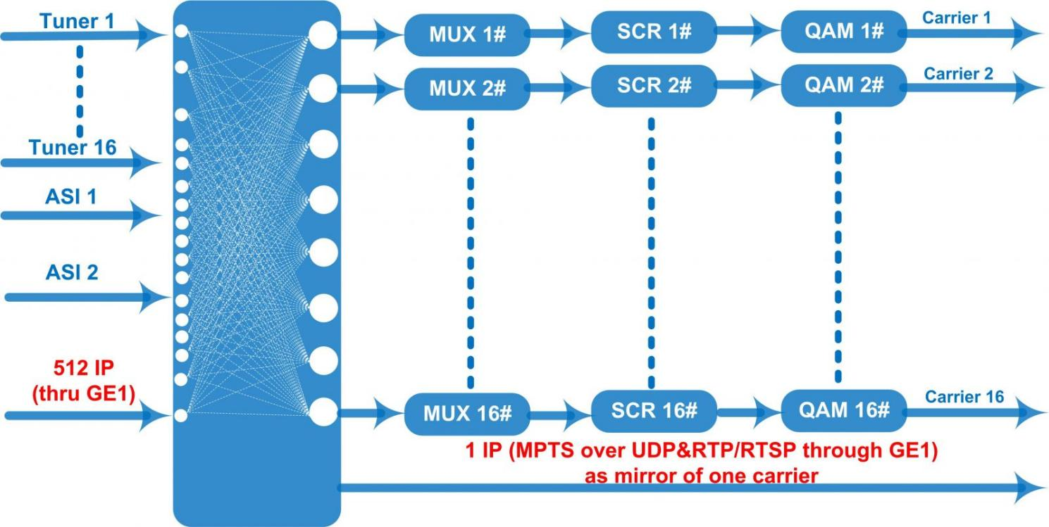

Specifications
Input | 16 DVB-C (DVB-T/-(T)/-S/-S2/-S2X, ATSC, ISDB-T Optional) FTA Tuner
Input | 512 IP input through GE1 over UDP and RTP protocol
Input | 2 ASI input, BNC interface
Tuner Section | Multi-mode tuners switchable  (New) | DVB-C | Standard |  | J.83A(DVB-C), J.83B, J.83C
Tuner Section | Multi-mode tuners switchable  (New) | DVB-C | Frequency In |  | 60~890MHz
Tuner Section | Multi-mode tuners switchable  (New) | DVB-C | Constellation |  | 16/32/64/128/256 QAM
Tuner Section | Multi-mode tuners switchable  (New) | DVB-T/(T) | Frequency In |  | 60~890MHz
Tuner Section | Multi-mode tuners switchable  (New) | DVB-T/(T) | Bandwidth |  | 6/7/8 M bandwidth
Tuner Section | Multi-mode tuners switchable  (New) | ISDB-T | Frequency In |  | 60~890MHz
Tuner Section | Version 1 | DVB-S/S2 | Frequency In |  | 950~2150MHz
Tuner Section | Version 1 | DVB-S/S2 | Symbol rate |  | QPSK 1~45Mbauds  8PSK 1~45Mbauds
Tuner Section | Version 1 | DVB-S/S2 | Code rate |  | 1/2, 3/5, 2/3, 3/4, 4/5, 5/6, 8/9, 9/10
Tuner Section | Version 1 | DVB-S/S2 | Constellation |  | QPSK, 8PSK
Tuner Section | Version 2  (New) | DVB-S | Frequency In |  | 950~2150MHz
Tuner Section | Version 2  (New) | DVB-S | Symbol rate |  | 0.5~45Msps
Tuner Section | Version 2  (New) | DVB-S | Signal Strength |  | - 65~-25dBm
Tuner Section | Version 2  (New) | DVB-S | FEC |  | 1/2, 2/3, 3/4, 5/6, 7/8
Tuner Section | Version 2  (New) | DVB-S | Constellation |  | QPSK
Tuner Section | Version 2  (New) | DVB-S | Max input bitrate |  | ≤129 Mbps
Tuner Section | Version 2  (New) | DVB-S2 | Frequency In |  | 950~2150MHz
Tuner Section | Version 2  (New) | DVB-S2 | Symbol rate |  | QPSK/8PSK /16APSK: 0.5~45 Msps  32APSK: 0.5~40Msps;
Tuner Section | Version 2  (New) | DVB-S2 | FEC |  | QPSK: 1/2, 3/5, 2/3, 3/4, 4/5, 5/6, 8/9, 9/10  8PSK: 3/5, 2/3, 3/4, 5/6, 8/9, 9/10  16APSK: 2/3, 3/4, 4/5, 5/6, 8/9, 9/10  32APSK: 3/4, 4/5, 5/6, 8/9, 9/10
Tuner Section | Version 2  (New) | DVB-S2 | Constellation |  | QPSK, 8PSK, 16APSK, 32APSK
Tuner Section | Version 2  (New) | DVB-S2 | Max input bitrate |  | ≤129 Mbps
Tuner Section | Version 2  (New) | DVB-S2X | Frequency In |  | 950-2150MHz
Tuner Section | Version 2  (New) | DVB-S2X | Symbol rate |  | QPSK/8PSK /16APSK: 0.5~45 Msps  8APSK/32APSK: 0.5~40Msps
Tuner Section | Version 2  (New) | DVB-S2X | FEC |  | QPSK: 1/2, 3/5, 2/3, 3/4, 4/5, 5/6, 8/9, 9/10, 13/45, 9/20, 11/20  8PSK: 3/5, 2/3, 3/4, 5/6, 8/9, 9/10  8APSK: 5/9-L, 26/45-L  16APSK: 2/3, 3/4, 4/5, 5/6, 8/9, 9/10, 1/2-L, 8/15-L, 5/9-L, 26/45, 3/5, 3/5-L, 28/45, 23/36 , 2/3-L, 25/36, 13/18, 7/9, 77/90  32APSK: 3/4, 4/5, 5/6, 8/9, 9/10, 2/3-L, 32/45, 11/15, 7/9
Tuner Section | Version 2  (New) | DVB-S2X | Constellation |  | QPSK, 8PSK, 8APSK, 16APSK, 32APSK
Tuner Section | Version 2  (New) | DVB-S2X | Max input bitrate |  | ≤129 Mbps
Tuner Section |  | ATSC | Frequency In |  | 30~1000MHz
Tuner Section |  | ATSC | Bandwidth |  | 6M
Tuner Section |  | ATSC | Constellation |  | 8VSB
Multiplexing | Maximum PID Remapping |  | 360 output per channel
Multiplexing | Function |  | PID remapping (automatically or manually)
Multiplexing |  |  | Accurate PCR adjusting
Multiplexing |  |  | Generate PSI/SI table automatically
Scrambling  Parameters | Max simulscrypt CA |  | 4
Scrambling  Parameters | Scramble Standard |  | ETR289, ETSI 101 197, ETSI 103 197
Scrambling  Parameters | Connection |  | Local/remote connection
Modulation | QAM Channel |  | 16 non-adjacent carriers output
Modulation | Standard |  | EN300 429/ITU-T J.83A/B
Modulation | MER |  | ≥40db
Modulation | RF frequency |  | 50~960MHz, 1KHz step
Modulation | RF output level |  | -20~+10dbm(87~107 dbµV),0.1db step
Modulation | Symbol Rate |  | 5.0Msps~7.0Msps, 1ksps stepping
Modulation |  |  | J.83A |  |  | J.83B
Modulation | Constellation |  | 16/32/64/128/256QAM |  |  | 64/256 QAM
Modulation | Bandwidth |  | 8M |  |  | 6M
Stream out | 16 RF output (F type interface)
Stream out | 1 IP (MPTS) output over UDP and RTP/RTSP (GE1 only), as mirror of one carrier
System | Network management (WEB)
System | Chinese and English language
System | Ethernet software upgrade
General | Dimension(W*D*H) |  |  | 482mm×300mm×44.5mm
General | Temperature |  |  | 0~45℃(Operation) ; -20~80℃(Storage)
General | Power |  |  | AC 100V±1050/60Hz;  AC 220V±10%, 50/60HZ

About Us
FMUSER is a company specializing in broadcasting and television transmission systems and integrating hotel IPTV systems. The company was established in 2009 and has served over 180 countries worldwide. More than 20,000 television stations, radio stations, and hotel clients from different.

Contact:Tomleequan Email：sales@fmuser.com whatsapp: +8613922702227

