FMUSER FUQ-44105B QAM Modulator 16-24 DVB-S2 Tuner 128 IP 1 ASI Input 16 RF 16 IP Output DVB-S2 IP ASI QAM Multiplexing Scrambling EN300 429 ITU-T J.83A-B For CATV Broadcasting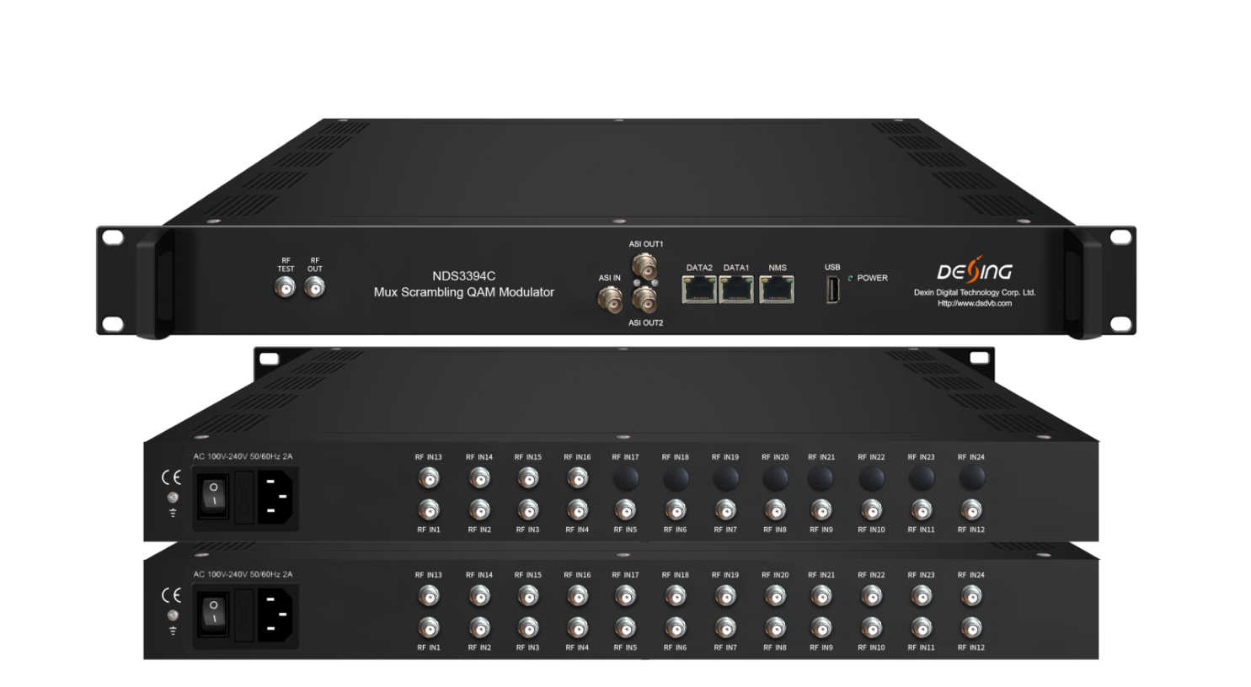Product overview
The FMUSER FUQ-44105B is a QAM modulator with integrated multiplexing and scrambling. It accepts inputs from up to 24 DVB-S2 tuners, 128 IP sources via GE1, and ASI, and outputs 16 RF carriers and 16 IP (MPTS) streams via GE2. The device processes signals through multiplexing, scrambling to ETR289/ETSI standards, and QAM modulation. Managed via web interface, it is ideal for modern CATV broadcasting systems.FU-44105C is also characterized with high integrated level, high performance and low cost. It supports dual power supply (optional). This is very adaptable to newly generation CATV broadcasting system.

Key feature
Supports up to 24 DVB-S2 tuners, 128 IP inputs over UDP/RTP, and ASI, with TS file playback via USB.
Delivers 16 non-adjacent RF outputs and 16 IP (MPTS) outputs for versatile distribution.
Integrates multiplexing, scrambling to ETR289/ETSI standards, and QAM modulation with MER≥40dB.
Enables PSI/SI editing, PCR adjusting, and web management for configuration.
Offers optional redundant power supply for enhanced reliability.
Working Principle
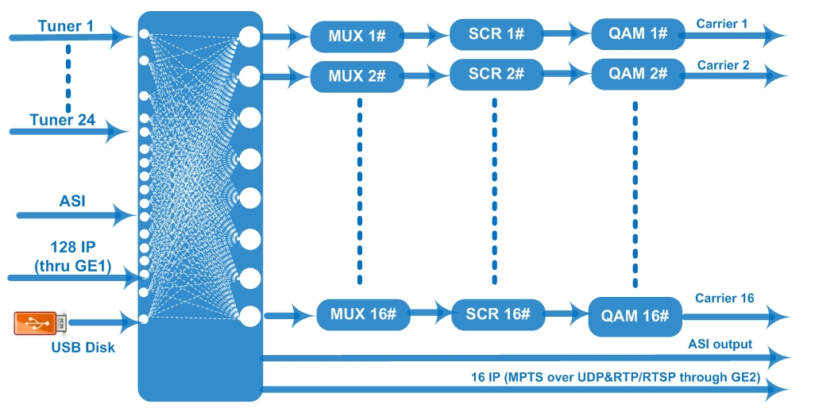

Specifications
Input | 24 or 16 DVB-S/S2/S2X FTA Tuner input as per order
Input | 128 IP input through GE1 over UDP and RTP protocol
Input | 1 ASI input, BNC interface
Input | TS files input and playing via the USB disk (FAT 32)
Input | Tuner | DVB-S | Frequency In |  | 950~2150MHz
Input | Tuner | DVB-S | Symbol rate |  | 0.5~45Msps
Input | Tuner | DVB-S | Signal Strength |  | - 65~-25dBm
Input | Tuner | DVB-S | FEC |  | 1/2, 2/3, 3/4, 5/6, 7/8
Input | Tuner | DVB-S | Constellation |  | QPSK
Input | Tuner | DVB-S | Max input bitrate |  | ≤129 Mbps
Input | Tuner | DVB-S2 | Frequency In |  | 950~2150MHz
Input | Tuner | DVB-S2 | Symbol rate |  | QPSK/8PSK /16APSK: 0.5~45 Msps  32APSK: 0.5~40Msps;
Input | Tuner | DVB-S2 | FEC |  | QPSK: 1/2, 3/5, 2/3, 3/4, 4/5, 5/6, 8/9, 9/10  8PSK: 3/5, 2/3, 3/4, 5/6, 8/9, 9/10  16APSK: 2/3, 3/4, 4/5, 5/6, 8/9, 9/10  32APSK: 3/4, 4/5, 5/6, 8/9, 9/10
Input | Tuner | DVB-S2 | Constellation |  | QPSK, 8PSK, 16APSK, 32APSK
Input | Tuner | DVB-S2 | Max input bitrate |  | ≤129 Mbps
Input | Tuner | DVB-S2X | Frequency In |  | 950-2150MHz
Input | Tuner | DVB-S2X | Symbol rate |  | QPSK/8PSK /16APSK: 0.5~45 Msps  8APSK/32APSK: 0.5~40Msps
Input | Tuner | DVB-S2X | FEC |  | QPSK: 1/2, 3/5, 2/3, 3/4, 4/5, 5/6, 8/9, 9/10, 13/45, 9/20, 11/20  8PSK: 3/5, 2/3, 3/4, 5/6, 8/9, 9/10  8APSK: 5/9-L, 26/45-L  16APSK: 2/3, 3/4, 4/5, 5/6, 8/9, 9/10, 1/2-L, 8/15-L, 5/9-L, 26/45, 3/5, 3/5-L, 28/45, 23/36 , 2/3-L, 25/36, 13/18, 7/9, 77/90  32APSK: 3/4, 4/5, 5/6, 8/9, 9/10, 2/3-L, 32/45, 11/15, 7/9
Input | Tuner | DVB-S2X | Constellation |  | QPSK, 8PSK, 8APSK, 16APSK, 32APSK
Input | Tuner | DVB-S2X | Max input bitrate |  | ≤129 Mbps
Multiplexing | Max PID Remapping |  | 360 output per channel
Multiplexing | Function |  | PID remapping (automatically or manually)
Multiplexing |  |  | Accurate PCR adjusting
Multiplexing |  |  | Generate PSI/SI table automatically
Scrambling  Parameters | Max simulscrypt CA |  | 4
Scrambling  Parameters | Scramble Standard |  | ETR289, ETSI 101 197, ETSI 103 197
Scrambling  Parameters | Connection |  | Local/remote connection
Modulation | QAM Channel |  | 16 non-adjacent carriers output
Modulation | Standard |  | EN300 429/ITU-T J.83A/B
Modulation | MER |  | ≥40db
Modulation | RF frequency |  | 50~960MHz, 1KHz step
Modulation | RF output level |  | -20~+10dbm(87~107 dbµV),0.1db step
Modulation | Symbol Rate |  | 5.0Msps~7.0Msps, 1ksps stepping
Modulation |  |  | J.83A |  | J.83B
Modulation | Constellation |  | 16/32/64/128/256QAM |  | 64/256 QAM
Modulation | Bandwidth |  | 8M |  | 6M
Stream out | 16 RF output (F type interface)
Stream out | 16 IP (MPTS) output over UDP and RTP/RTSP (thru GE2), 2 ASI output(one as mirror)
System | Network management (WEB)
System | Chinese and English language
System | Ethernet software upgrade
General | Dimension (W*D*H) |  |  | 482mm×230mm×44mm
General | Temperature |  |  | 0~45℃(Operation) ; -20~80℃(Storage)
General | Power |  |  | AC 100V±1050/60Hz; AC 220V±10%, 50/60HZ

About Us
FMUSER is a company specializing in broadcasting and television transmission systems and integrating hotel IPTV systems. The company was established in 2009 and has served over 180 countries worldwide. More than 20,000 television stations, radio stations, and hotel clients from different.

Contact:Tomleequan Email：sales@fmuser.com whatsapp: +8613922702227

