FMUSER FUQ-44105B V3 QAM Modulator 24-16 Tuner 128 IP 2 ASI Input DVB-S-S2-S2X-C-T-T2-ISDB-T Input 16 DVB-C 16 IP 2 ASI Output BISS ETSI Scrambling CATV Broadcasting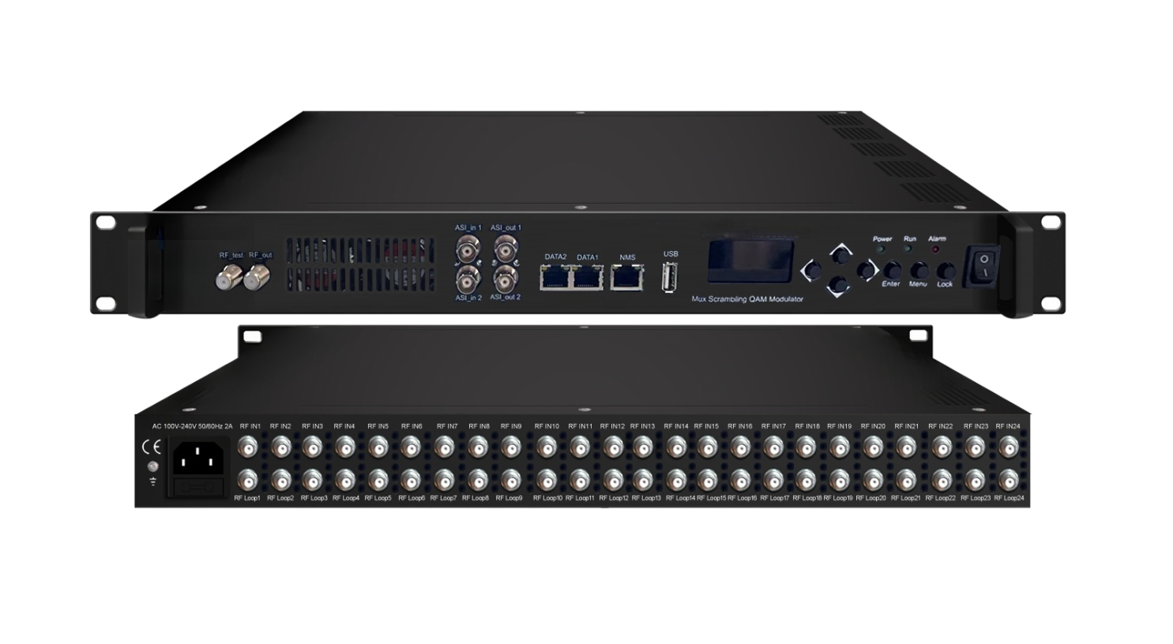Product overview
The FMUSER FUQ-44105D v3 is a QAM modulator supporting 24/16 tuner inputs, 128 IP inputs via DATA1, and 2 ASI inputs, with outputs of 16 DVB-C carriers and 16 IP (MPTS) streams. It processes signals by modulating into QAM format with optional BISS scrambling. Featuring web-based management for remote control, it is ideal for CATV broadcasting systems, ensuring reliable transmission.FU-44105C v3 is also characterized with high integrated level, high performance and low cost. This is very adaptable to a new generation CATV broadcasting system.

Key feature
Supports 24/16 FTA multi-mode tuner inputs for DVB-S/S2/S2X, DVB-C/T/T2, or ISDB-T with loop-out.
Features 128 IP inputs, 2 ASI inputs, and USB TS file playback for flexible source integration.
Outputs 8 non-adjacent DVB-T carriers and 8 IP (MPTS) outputs, plus 2 TS outputs via ASI.
Ensures MER ≥40dB with multiplexing, PCR adjusting, and PSI/SI editing via web control.
Working Principle
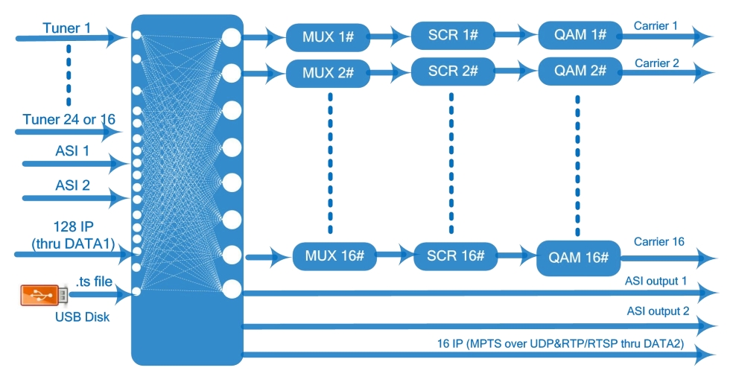

Specifications
Input | 24 or 16 FTA DVB-S/S2/S2X or DVB-C/T/T2/ISDB-T multi-mode switchable tuner inputs as per order
Input | 128 IP inputs through DATA1 over UDP and RTP protocol
Input | 2 ASI inputs, BNC interface
Input | TS files input by playing via the USB disk (FAT 32, USB 2.0)
Input | Tuner option 1 | DVB-S | Frequency In |  | 950~2150MHz
Input | Tuner option 1 | DVB-S | Symbol rate |  | 0.5~45Msps
Input | Tuner option 1 | DVB-S | Signal Strength |  | - 65~-25dBm
Input | Tuner option 1 | DVB-S | FEC |  | 1/2, 2/3, 3/4, 5/6, 7/8
Input | Tuner option 1 | DVB-S | Constellation |  | QPSK
Input | Tuner option 1 | DVB-S | Max input bitrate |  | ≤129 Mbps
Input | Tuner option 1 | DVB-S2 | Frequency In |  | 950~2150MHz
Input | Tuner option 1 | DVB-S2 | Symbol rate |  | QPSK/8PSK /16APSK: 0.5~45 Msps  32APSK: 0.5~40Msps;
Input | Tuner option 1 | DVB-S2 | FEC |  | QPSK: 1/2, 3/5, 2/3, 3/4, 4/5, 5/6, 8/9, 9/10  8PSK: 3/5, 2/3, 3/4, 5/6, 8/9, 9/10  16APSK: 2/3, 3/4, 4/5, 5/6, 8/9, 9/10  32APSK: 3/4, 4/5, 5/6, 8/9, 9/10
Input | Tuner option 1 | DVB-S2 | Constellation |  | QPSK, 8PSK, 16APSK, 32APSK
Input | Tuner option 1 | DVB-S2 | Max input bitrate |  | ≤129 Mbps
Input | Tuner option 1 | DVB-S2X | Frequency In |  | 950-2150MHz
Input | Tuner option 1 | DVB-S2X | Symbol rate |  | QPSK/8PSK /16APSK: 0.5~45 Msps  8APSK/32APSK: 0.5~40Msps
Input | Tuner option 1 | DVB-S2X | FEC |  | QPSK: 1/2, 3/5, 2/3, 3/4, 4/5, 5/6, 8/9, 9/10, 13/45, 9/20, 11/20  8PSK: 3/5, 2/3, 3/4, 5/6, 8/9, 9/10  8APSK: 5/9-L, 26/45-L  16APSK: 2/3, 3/4, 4/5, 5/6, 8/9, 9/10, 1/2-L, 8/15-L, 5/9-L, 26/45, 3/5, 3/5-L, 28/45, 23/36 , 2/3-L, 25/36, 13/18, 7/9, 77/90  32APSK: 3/4, 4/5, 5/6, 8/9, 9/10, 2/3-L, 32/45, 11/15, 7/9
Input | Tuner option 1 | DVB-S2X | Constellation |  | QPSK, 8PSK, 8APSK, 16APSK, 32APSK
Input | Tuner option 1 | DVB-S2X | Max input bitrate |  | ≤129 Mbps
Input | Tuner option 2 | DVB-C | Standard |  | J.83A(DVB-C), J.83B, J.83C
Input | Tuner option 2 | DVB-C | Frequency In |  | 50~960MHz
Input | Tuner option 2 | DVB-C | Constellation |  | 16/32/64/128/256 QAM
Input | Tuner option 2 | DVB-T/T2 | Frequency In |  | 50~960MHz
Input | Tuner option 2 | DVB-T/T2 | Bandwidth |  | 6/7/8 M bandwidth
Input | Tuner option 2 | ISDB-T | Frequency In |  | 50~960MHz
Multiplexing | Max PID Remapping |  | 256 outputs per channel
Multiplexing | Function |  | PID remapping (automatically or manually)/CA Filter
Multiplexing |  |  | A/V PID Filter
Multiplexing |  |  | Accurate PCR adjusting
Multiplexing |  |  | Generate PSI/SI table automatically
Scrambling  Parameters (optional) | Max simulscrypt CA |  | 4
Scrambling  Parameters (optional) | Scramble Standard |  | ETR289, ETSI 101 197, ETSI 103 197
Scrambling  Parameters (optional) | Connection |  | Local/remote connection
Modulation | QAM Channel |  | 16 non-adjacent carriers output, within 192MHz bandwidth
Modulation | Standard |  | EN300 429/ITU-T J.83A/B
Modulation | MER |  | ≥40db
Modulation | RF frequency |  | 50~960MHz, 1KHz step
Modulation | RF output level |  | -20~+3dbm(87~110 dbµV),0.1db step
Modulation | Symbol Rate |  | 3600ksps~6952ksps, 1ksps stepping
Modulation |  |  | J.83A |  | J.83B
Modulation | Constellation |  | 16/32/64/128/256QAM |  | 64/256 QAM
Modulation | Bandwidth |  | 8M |  | 6M
Stream out | 16 carriers output (F type interface)
Stream out | 16 IP (MPTS) output over UDP and RTP/RTSP (thru DATA 2),  2 ASI outputs(2 TS as mirror)
System | Network management (WEB)
System | Chinese and English language
System | Ethernet software upgrade
General | Dimension (W*D*H) |  |  | 482mm×270mm×44mm
General | Temperature |  |  | 0~45℃(Operation) ; -20~80℃(Storage)
General | Power |  |  | AC 100V±1050/60Hz; AC 220V±10%, 50/60HZ

Major Technical Comparison
FU-44105C | v1 | v2 | v3
LCD/KEY Feature | NO | NO | Yes
ASI inputs | 2 | 1 | 2
ASI outputs | NO | 2 for one TS | 2 for two TS
Tuner inputs | 16 | 16 or 24 | 16 or 24 (FTA DVB-S/S2/S2X  or DVB-C/T/T2/ISDB-T multi-mode  switchable Tuner inputs with loop out)
RF loop out | Yes | No | Yes
IP outputs | 1 MPTS output | 16 MPTS output | 16 MPTS output
USB | N/A | Playing TS | Playing TS
DATA Ports | IP inputs/outputs via GE1 | IP inputs via DATA 1  IP outputs via DATA 2 | IP inputs via DATA 1  IP outputs via DATA2
Reboot in Web after  firmware upgrading | N/A | N/A | Yes

About Us
FMUSER is a company specializing in broadcasting and television transmission systems and integrating hotel IPTV systems. The company was established in 2009 and has served over 180 countries worldwide. More than 20,000 television stations, radio stations, and hotel clients from different.

Contact:Tomleequan Email：sales@fmuser.com whatsapp: +8613922702227

