FMUSER FUQ-44105R DVB-T Modulator 24-16 Tuner 256 IP 1 ASI Input 8 RF 8 IP Output EN300 744 QPSK-16QAM-64QAM BISS Descrambling For Digital Broadcasting Headend
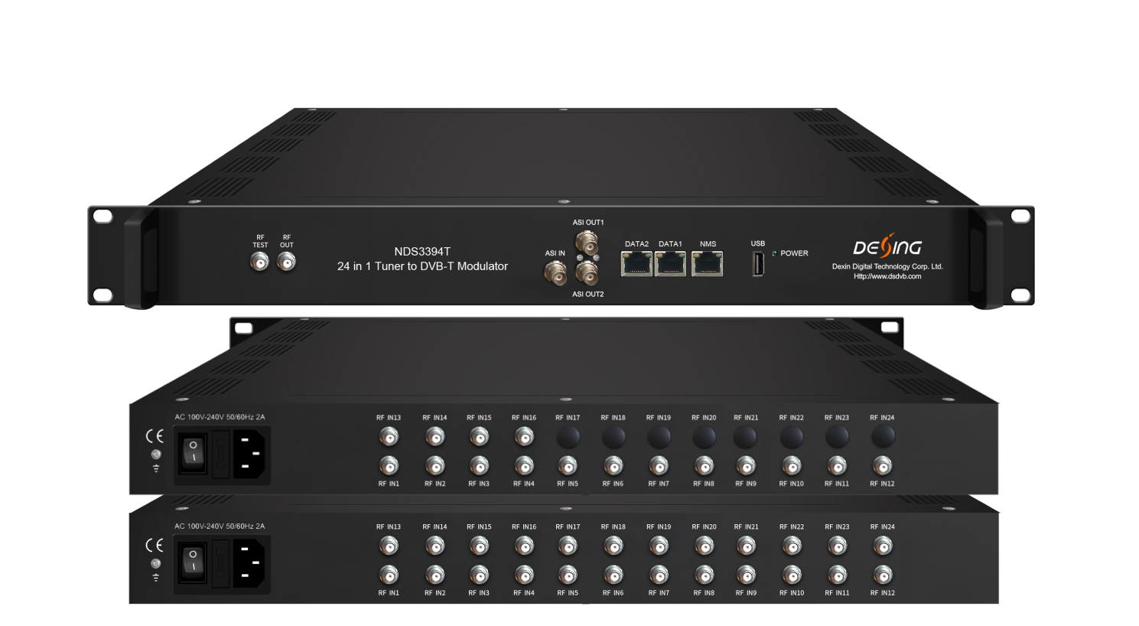Product overview
The FMUSER FUQ-44105R modulator processes 24/16 FTA DVB-S/S2/S2X tuner inputs, 256 IP inputs via GE ports, and ASI input. It performs multiplexing and DVB-T modulation to deliver 8 RF carriers and 8 IP MPTS streams. Controlled via web management with optional dual power supply, this rack-mountable device supports broadcast redundancy in digital terrestrial television systems.
FU-44105T is also characterized with high integrated level, high performance and low cost. It supports dual power supply (optional). This is very adaptable to newly generation broadcasting system.

Key feature
- Supports 24/16 FTA DVB-S/S2/S2X tuners, 256 UDP/RTP IP inputs, and ASI input
- Generates 8 non-adjacent DVB-T RF outputs with 8 mirrored IP MPTS streams
- Performs BISS descrambling (Version B), multiplexing, and PSI/SI editing
- Provides web-based control for configuration and monitoring
- Optional redundant power supply ensures continuous operation
Working Principle
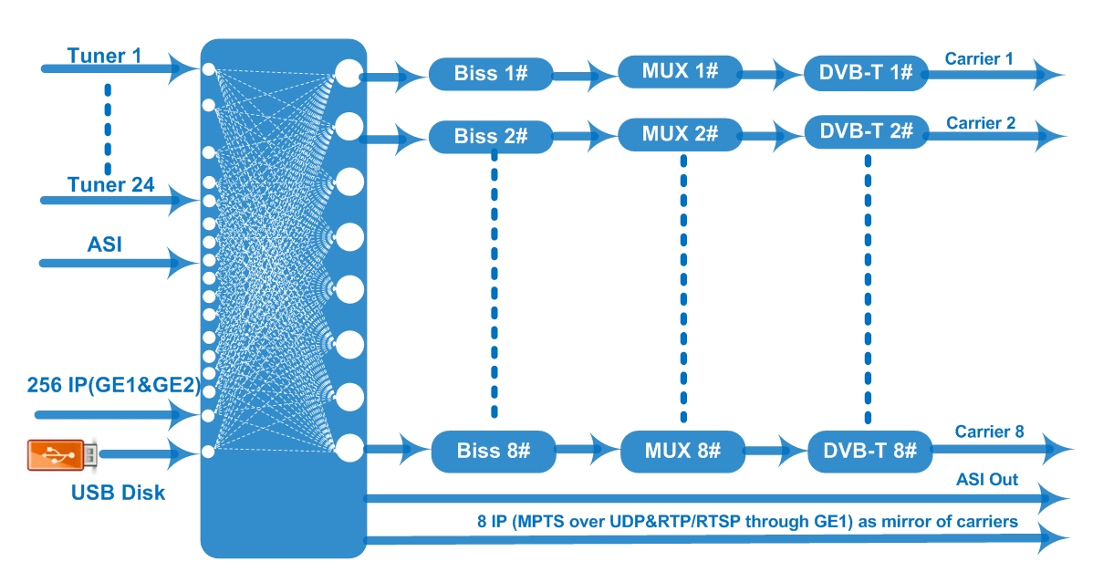

Specifications
Input | 24 or 16 FTA DVB-S/-S2/-S2X Tuner input
Input | 256 IP (GE1&GE2) input over UDP and RTP protocol
Input | 1 ASI input, BNC interface
Input | TS files input and playing via the USB disk (FAT 32)
Input | Tuners | DVB-S |  |  | Frequency In | 950~2150MHz
Input | Tuners |  |  |  | Symbol rate | 0.5~45Msps
Input | Tuners |  |  |  | Signal Strength | - 65~-25dBm
Input | Tuners |  |  |  | FEC | 1/2, 2/3, 3/4, 5/6, 7/8
Input | Tuners |  |  |  | Constellation | QPSK
Input | Tuners |  |  |  | Max input bitrate | ≤120 Mbps
Input | Tuners | DVB-S2 |  |  | Frequency In | 950~2150MHz
Input | Tuners |  |  |  | Symbol rate | QPSK/8PSK /16APSK: 0.5~45 Msps  32APSK: 0.5~40Msps;
Input | Tuners |  |  |  | FEC | QPSK: 1/2, 3/5, 2/3, 3/4, 4/5, 5/6, 8/9, 9/10 8PSK: 3/5, 2/3, 3/4, 5/6, 8/9, 9/10 16APSK: 2/3, 3/4, 4/5, 5/6, 8/9, 9/10 32APSK: 3/4, 4/5, 5/6, 8/9, 9/10
Input | Tuners |  |  |  | Constellation | QPSK, 8PSK, 16APSK, 32APSK
Input | Tuners |  |  |  | Max input bitrate | ≤120 Mbps
Input | Tuners | DVB-S2X |  |  | Frequency In | 950-2150MHz
Input | Tuners |  |  |  | Symbol rate | QPSK/8PSK /16APSK: 0.5~45 Msps  8APSK/32APSK: 0.5~40Msps
Input | Tuners |  |  |  | FEC | QPSK: 1/2, 3/5, 2/3, 3/4, 4/5, 5/6, 8/9, 9/10, 13/45, 9/20, 11/20  8PSK: 3/5, 2/3, 3/4, 5/6, 8/9, 9/10  8APSK: 5/9-L, 26/45-L  16APSK: 2/3, 3/4, 4/5, 5/6, 8/9, 9/10, 1/2-L, 8/15-L, 5/9-L, 26/45, 3/5, 3/5-L, 28/45, 23/36 , 2/3-L, 25/36, 13/18, 7/9, 77/90  32APSK: 3/4, 4/5, 5/6, 8/9, 9/10, 2/3-L, 32/45, 11/15, 7/9
Input | Tuners |  |  |  | Constellation | QPSK, 8PSK, 8APSK, 16APSK, 32APSK
Input | Tuners |  |  |  | Max input bitrate | ≤120 Mbps
Multiplexing | Maximum PID Remapping |  | 256 output per channel
Multiplexing | Function |  | PID remapping (automatically or manually)
Multiplexing |  |  | A/V PID filtering (not for FU-44105T version B)
Multiplexing |  |  | Accurate PCR adjusting
Multiplexing |  |  | Generate PSI/SI table automatically
Modulation | Standard |  | EN300 744
Modulation | FFT |  | 2K 4K 8K
Modulation | Bandwidth |  | 6M, 7M, 8M
Modulation | Constellation |  | QPSK, 16QAM, 64QAM
Modulation | Guard interval |  | 1/4, 1/8, 1/16, 1/32
Modulation | FEC |  | 1/2, 2/3, 3/4, 5/6, 7/8
Modulation | MER |  | ≥42 dB
Modulation | RF out |  | 8 non-adjacent carrier output
Modulation | RF frequency |  | 50~960MHz
Modulation | RF output level |  | -20~+10dBm, 0.1dB step
Stream out | 8 DVB-T RF output (F type interface)
Stream out | 8 IP (MPTS) output over UDP and RTP/RTSP (GE1 only), as mirror of carriers  2 ASI output, one as mirror
System | Network management (WEB)
System | Chinese and English language
System | Ethernet software upgrade
General | Dimension(W*D*H) |  |  | 482mm×230mm×44mm
General | Temperature |  |  | 0~45℃(Operation) ; -20~80℃(Storage)
General | Power |  |  | AC 100V±1050/60Hz; AC 220V±10%, 50/60HZ

About Us
FMUSER is a company specializing in broadcasting and television transmission systems and integrating hotel IPTV systems. The company was established in 2009 and has served over 180 countries worldwide. More than 20,000 television stations, radio stations, and hotel clients from different.

Contact:Tomleequan Email：sales@fmuser.com whatsapp: +8613922702227

