FMUSER FUQ-44105R V3 DVB-T Modulator 24-16 Tuner Inputs 128 IP 2 ASI Input Multi-Standard DVB-S-S2-S2X-C-T-T2-ISDB-T Input 8 DVB-T 8 IP 2 ASI Output Integrated Multiplexing PSI-SI Editing Broadcasting Headend
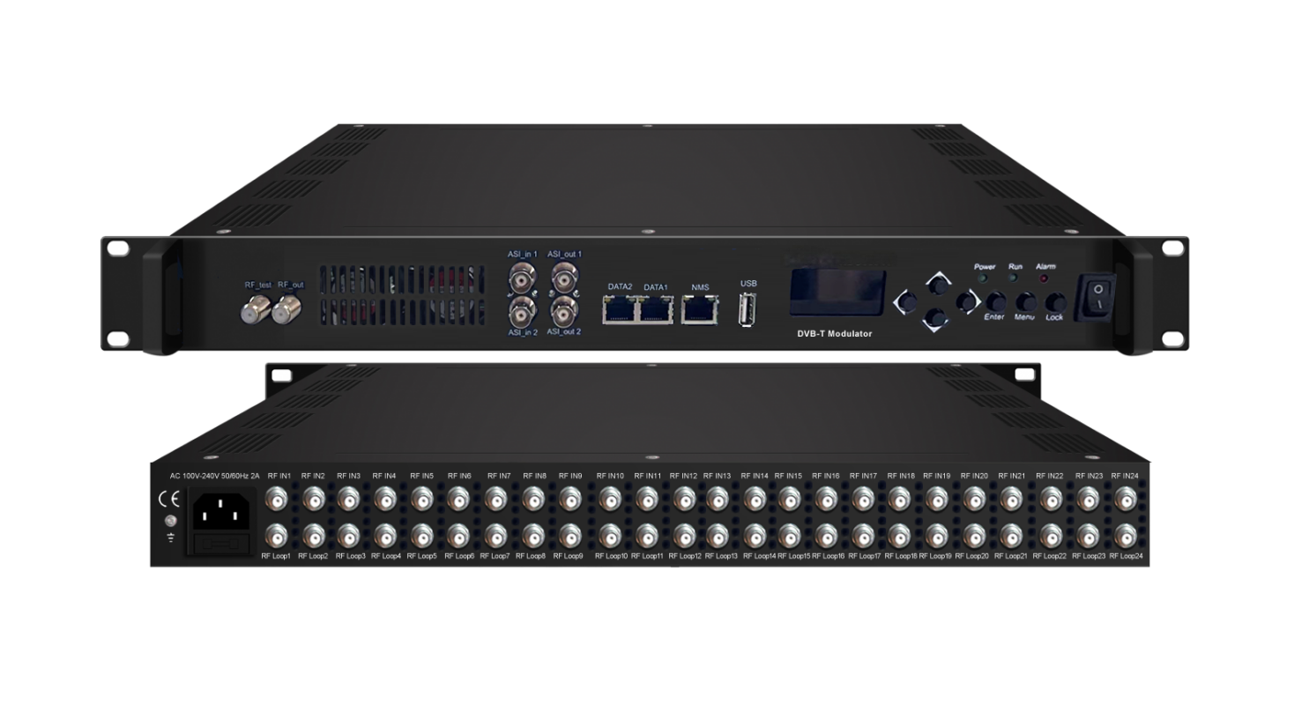Product overview
The FMUSER FUQ-44105R V3 is a DVB-T modulator with 24/16 FTA tuner inputs for DVB-S/S2/S2X, DVB-C/T/T2, or ISDB-T, plus 128 IP inputs and 2 ASI inputs. It modulates signals into 8 non-adjacent DVB-T carriers and outputs 8 IP (MPTS) and 2 TS via ASI. Controlled via web management, this device supports multiplexing and PSI/SI editing. Ideal for broadcast, IPTV, and cable TV systems.FU-44105T is also characterized with high integrated level, high performance and low cost. This is very adaptable to a new generation broadcasting system.

Key feature
Integrated demodulating, re-multiplexing, BISS descrambling, and modulating in one unit.
Supports 4 tuner inputs for DVB-S/S2/S2X or DVB-C/T/T2/ISDB-T standards.
Provides 4 DVB-C RF or 2 DVB-T RF outputs for versatile distribution.
Enables PID pass-through for seamless program identifier transmission.
Features LCD/keyboard and web-based NMS for control and upgrades.
Working Principle
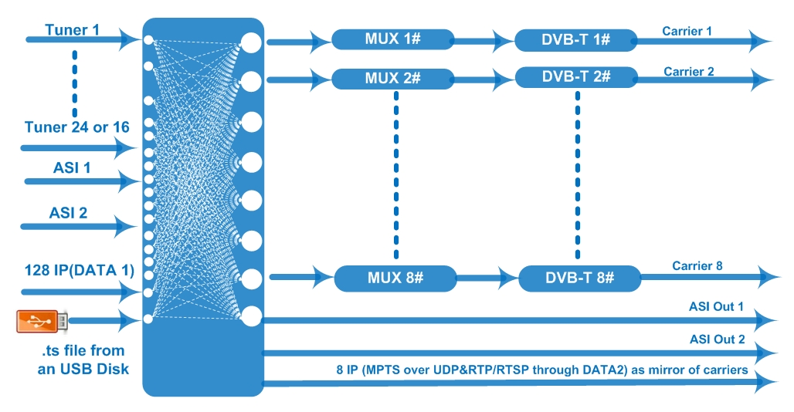

Specifications
Input | 24 or 16 FTA DVB-S/-S2/-S2X or DVB-C/T/T2/ISDB-T Multi-Mode switchable tuner inputs
Input | 128 IP inputs over UDP and RTP protocol
Input | 2 ASI inputs, BNC interface
Input | TS files input by playing ts via the USB disk (FAT 32, USB 2.0)
Input | Tuner Option 1 | DVB-S |  |  | Frequency In | 950~2150MHz
Input | Tuner Option 1 |  |  |  | Symbol rate | 0.5~45Msps
Input | Tuner Option 1 |  |  |  | Signal Strength | - 65~-25dBm
Input | Tuner Option 1 |  |  |  | FEC | 1/2, 2/3, 3/4, 5/6, 7/8
Input | Tuner Option 1 |  |  |  | Constellation | QPSK
Input | Tuner Option 1 |  |  |  | Max input bitrate | ≤120 Mbps
Input | Tuner Option 1 | DVB-S2 |  |  | Frequency In | 950~2150MHz
Input | Tuner Option 1 |  |  |  | Symbol rate | QPSK/8PSK /16APSK: 0.5~45 Msps  32APSK: 0.5~40Msps;
Input | Tuner Option 1 |  |  |  | FEC | QPSK: 1/2, 3/5, 2/3, 3/4, 4/5, 5/6, 8/9, 9/10  8PSK: 3/5, 2/3, 3/4, 5/6, 8/9, 9/10  16APSK: 2/3, 3/4, 4/5, 5/6, 8/9, 9/10  32APSK: 3/4, 4/5, 5/6, 8/9, 9/10
Input | Tuner Option 1 |  |  |  | Constellation | QPSK, 8PSK, 16APSK, 32APSK
Input | Tuner Option 1 |  |  |  | Max input bitrate | ≤120 Mbps
Input | Tuner Option 1 | DVB-S2X |  |  | Frequency In | 950-2150MHz
Input | Tuner Option 1 |  |  |  | Symbol rate | QPSK/8PSK /16APSK: 0.5~45 Msps  8APSK/32APSK: 0.5~40Msps
Input | Tuner Option 1 |  |  |  | FEC | QPSK: 1/2, 3/5, 2/3, 3/4, 4/5, 5/6, 8/9, 9/10, 13/45, 9/20, 11/20  8PSK: 3/5, 2/3, 3/4, 5/6, 8/9, 9/10  8APSK: 5/9-L, 26/45-L  16APSK: 2/3, 3/4, 4/5, 5/6, 8/9, 9/10, 1/2-L, 8/15-L, 5/9-L, 26/45, 3/5, 3/5-L, 28/45, 23/36 , 2/3-L, 25/36, 13/18, 7/9, 77/90  32APSK: 3/4, 4/5, 5/6, 8/9, 9/10, 2/3-L, 32/45, 11/15, 7/9
Input | Tuner Option 1 |  |  |  | Constellation | QPSK, 8PSK, 8APSK, 16APSK, 32APSK
Input | Tuner Option 1 |  |  |  | Max input bitrate | ≤120 Mbps
Input | Tuner Option 2 | DVB-C |  |  | Standard | J.83A(DVB-C), J.83B, J.83C
Input | Tuner Option 2 |  |  |  | Frequency In | 50~960MHz
Input | Tuner Option 2 |  |  |  | Constellation | 16/32/64/128/256 QAM
Input | Tuner Option 2 | DVB-T/T2 |  |  | Frequency In | 50~960MHz
Input | Tuner Option 2 |  |  |  | Bandwidth | 6/7/8 M bandwidth
Input | Tuner Option 2 | ISDB-T |  |  | Frequency In | 50~960MHz
Multiplexing | Maximum PID Remapping |  | 256 output per channel
Multiplexing | Function |  | PID remapping (automatically or manually)/CA Filter
Multiplexing |  |  | A/V PID filtering
Multiplexing |  |  | Accurate PCR adjusting
Multiplexing |  |  | Generate PSI/SI table automatically
Modulation | Standard |  | EN300 744
Modulation | FFT |  | 2K 4K 8K
Modulation | Bandwidth |  | 6M, 7M, 8M
Modulation | Constellation |  | QPSK, 16QAM, 64QAM
Modulation | Guard interval |  | 1/4, 1/8, 1/16, 1/32
Modulation | FEC |  | 1/2, 2/3, 3/4, 5/6, 7/8
Modulation | MER |  | ≥40 dB
Modulation | RF out |  | 8 non-adjacent carrier output within 192MHz bandwidth
Modulation | RF frequency |  | 50~960MHz
Modulation | RF output level |  | -20~+3dBm, 0.1dB step
Stream out | 8 DVB-T carriers output (F type interface)
Stream out | 8 IP (MPTS) output over UDP and RTP/RTSP (DATA2, as mirror of carriers)  2 ASI outputs (2 TS as mirror)
System | Network management (WEB)
System | Chinese and English language
System | Ethernet software upgrade
General | Dimension(W*D*H) |  |  | 482mm×270mm×44mm
General | Temperature |  |  | 0~45℃(Operation) ; -20~80℃(Storage)
General | Power |  |  | AC 100V±1050/60Hz; AC 220V±10%, 50/60HZ

Major Technical Comparison
FU-44105T | v1 | v2 | v3
LCD/KEY Feature | NO | NO | Yes
ASI inputs | 2 | 1 | 2
ASI outputs | NO | 2 for one TS | 2 for two TS
Tuner inputs | 16 | 16 or 24 | 16 or 24 (FTA DVB-S/S2/S2X or  DVB-C/T/T2/ISDB-T Multi-Mode  switchable tuner inputs with loop out)
RF loop out | Yes | No | Yes
IP outputs | 1 MPTS output | 8 MPTS output | 8 MPTS output
USB | N/A | Playing TS | Playing TS
DATA Ports | IP inputs/outputs via GE1 | IP inputs via DATA 1  IP outputs via DATA 2 | IP inputs via DATA 1  IP outputs via DATA2
Reboot in Web after  firmware upgrading | N/A | N/A | Yes

About Us
FMUSER is a company specializing in broadcasting and television transmission systems and integrating hotel IPTV systems. The company was established in 2009 and has served over 180 countries worldwide. More than 20,000 television stations, radio stations, and hotel clients from different.

Contact:Tomleequan Email：sales@fmuser.com whatsapp: +8613922702227

