FMUSER FUQ-44105R DVB-T Modulator 16 Tuner 256 IP 2 ASI Input 8 RF 8 IP Output GE-ASI Interface BISS Descrambling Multiplexing EN300744 Broadcasting Systems
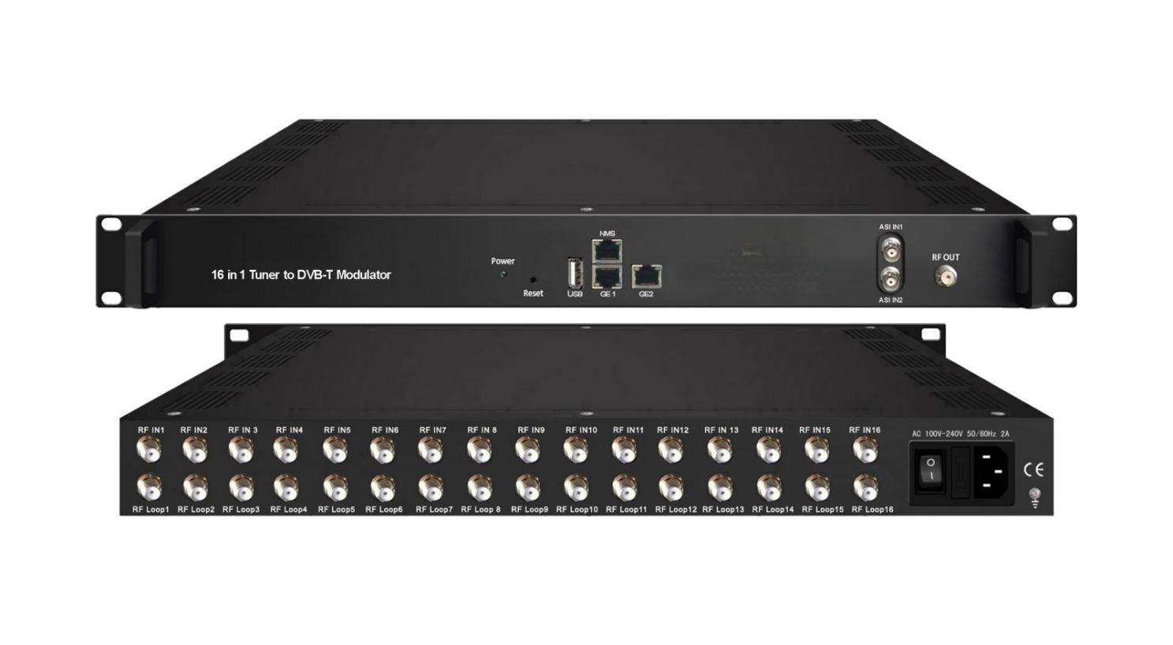Product overview
The FMUSER FUQ-44105R is a DVB-T modulator with 16 FTA tuner inputs, 256 IP inputs via GE1 & GE2, and 2 ASI ports, delivering 8 DVB-T RF outputs and 8 IP outputs. It processes signals through BISS descrambling (version B only), multiplexing, DVB-T modulation, PCR adjustment, and PSI/SI editing. Managed via web-based interface, this modulator is ideal for modern broadcasting systems, ensuring efficient signal distribution and integration.FU-44105T is also characterized with high integrated level, high performance and low cost. It supports dual power supply (optional). This is very adaptable to newly generation broadcasting system.

Key feature
Supports 16 FTA tuner inputs with standards including DVB-C, DVB-T, DVB-S/S2/S2X, ATSC, and ISDB-T.
Features 256 IP inputs and 2 ASI inputs via UDP and RTP protocols for flexible re-muxing.
Delivers 8 DVB-T RF outputs and 8 IP outputs with non-adjacent carriers and MPTS streams.
Includes BISS descrambling (version B only), multiplexing, DVB-T modulation, PCR adjustment, and PSI/SI editing.
Enables web-based management for remote control, updates, and monitoring.
Working Principle
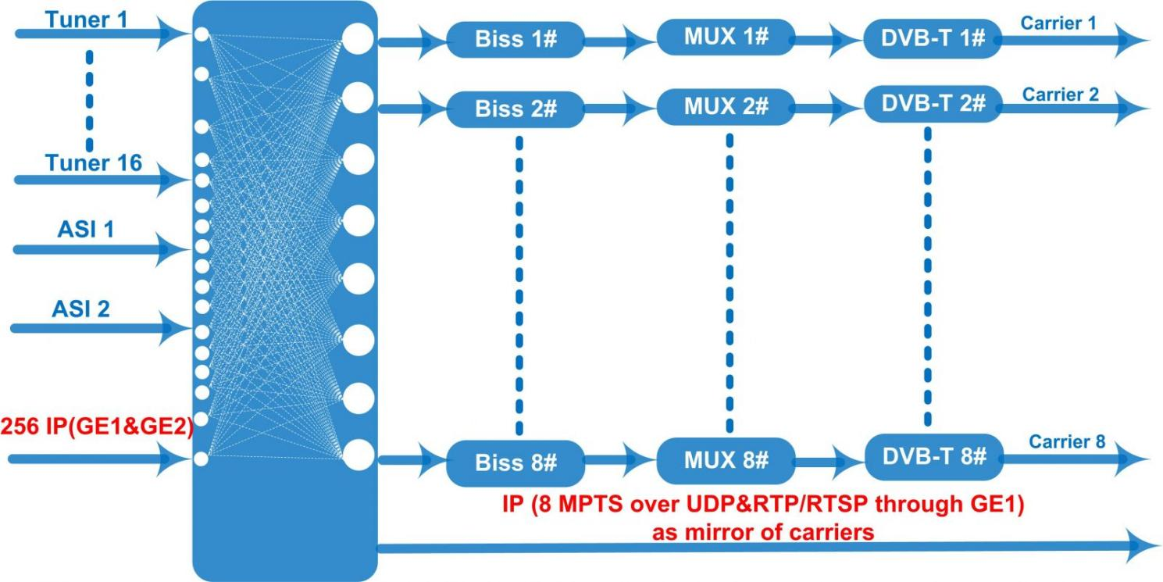

Specifications

Input | 16 DVB-C (DVB-T/(T)/-S/S2/S2X, ATSC, ISDB-T optional) FTA Tuner (DVB-S2X is only for FU-44105T version B)
Input | 256 IP (GE1&GE2) input over UDP and RTP protocol
Input | 2 ASI input, BNC interface
Tuner Section |  | DVB-C |  |  | Standard | J.83A(DVB-C), J.83B, J.83C
Tuner Section |  |  |  |  | Frequency In | 60~890MHz
Tuner Section |  |  |  |  | Constellation | 16/32/64/128/256 QAM
Tuner Section |  | DVB-T/(T) |  |  | Frequency In | 60~890MHz
Tuner Section |  |  |  |  | Bandwidth | 6/7/8 M bandwidth
Tuner Section |  | ISDB-T |  |  | Frequency In | 60~890MHz
Tuner Section | Version 1 | DVB-S/S2 |  |  | Frequency In | 950~2150MHz
Tuner Section | Version 1 |  |  |  | Symbol rate | QPSK 1~45Mbauds  8PSK 1~45Mbauds
Tuner Section | Version 1 |  |  |  | Code rate | 1/2, 3/5, 2/3, 3/4, 4/5, 5/6, 8/9, 9/10
Tuner Section | Version 1 |  |  |  | Constellation | QPSK, 8PSK
Tuner Section | Version 2  (For FU-44105T version B) | DVB-S |  |  | Frequency In | 950~2150MHz
Tuner Section | Version 2  (For FU-44105T version B) |  |  |  | Symbol rate | 0.5~45Msps
Tuner Section | Version 2  (For FU-44105T version B) |  |  |  | Signal Strength | - 65~-25dBm
Tuner Section | Version 2  (For FU-44105T version B) |  |  |  | FEC | 1/2, 2/3, 3/4, 5/6, 7/8
Tuner Section | Version 2  (For FU-44105T version B) |  |  |  | Constellation | QPSK
Tuner Section | Version 2  (For FU-44105T version B) |  |  |  | Max input bitrate | ≤120 Mbps
Tuner Section | Version 2  (For FU-44105T version B) | DVB-S2 |  |  | Frequency In | 950~2150MHz
Tuner Section | Version 2  (For FU-44105T version B) |  |  |  | Symbol rate | QPSK/8PSK /16APSK: 0.5~45 Msps  32APSK: 0.5~40Msps;
Tuner Section | Version 2  (For FU-44105T version B) |  |  |  | FEC | QPSK: 1/2, 3/5, 2/3, 3/4, 4/5, 5/6, 8/9, 9/10  8PSK: 3/5, 2/3, 3/4, 5/6, 8/9, 9/10  16APSK: 2/3, 3/4, 4/5, 5/6, 8/9, 9/10  32APSK: 3/4, 4/5, 5/6, 8/9, 9/10
Tuner Section | Version 2  (For FU-44105T version B) |  |  |  | Constellation | QPSK, 8PSK, 16APSK, 32APSK
Tuner Section | Version 2  (For FU-44105T version B) |  |  |  | Max input bitrate | ≤120 Mbps
Tuner Section | Version 2  (For FU-44105T version B) | DVB-S2X |  |  | Frequency In | 950-2150MHz
Tuner Section | Version 2  (For FU-44105T version B) |  |  |  | Symbol rate | QPSK/8PSK /16APSK: 0.5~45 Msps  8APSK/32APSK: 0.5~40Msps
Tuner Section | Version 2  (For FU-44105T version B) |  |  |  | FEC | QPSK: 1/2, 3/5, 2/3, 3/4, 4/5, 5/6, 8/9, 9/10, 13/45, 9/20, 11/20  8PSK: 3/5, 2/3, 3/4, 5/6, 8/9, 9/10  8APSK: 5/9-L, 26/45-L  16APSK: 2/3, 3/4, 4/5, 5/6, 8/9, 9/10, 1/2-L, 8/15-L, 5/9-L, 26/45, 3/5, 3/5-L, 28/45, 23/36 , 2/3-L, 25/36, 13/18, 7/9, 77/90  32APSK: 3/4, 4/5, 5/6, 8/9, 9/10, 2/3-L, 32/45, 11/15, 7/9
Tuner Section | Version 2  (For FU-44105T version B) |  |  |  | Constellation | QPSK, 8PSK, 8APSK, 16APSK, 32APSK
Tuner Section | Version 2  (For FU-44105T version B) |  |  |  | Max input bitrate | ≤120 Mbps
Tuner Section |  | ATSC |  |  | Frequency In | 30~1000MHz
Tuner Section |  |  |  |  | Bandwidth | 6M
Tuner Section |  |  |  |  | Constellation | 8VSB
BISS Descrambling | Mode 1, Mode E (descramble individual program) (only for FU-44105T version B)
Multiplexing | Maximum PID Remapping |  | 256 output per channel
Multiplexing | Function |  | PID remapping (automatically or manually)
Multiplexing |  |  | A/V PID filtering (not for FU-44105T version B)
Multiplexing |  |  | Accurate PCR adjusting
Multiplexing |  |  | Generate PSI/SI table automatically
Modulation | Standard |  | EN300 744
Modulation | FFT |  | 2K 4K 8K
Modulation | Bandwidth |  | 6M, 7M, 8M
Modulation | Constellation |  | QPSK, 16QAM, 64QAM
Modulation | Guard interval |  | 1/4, 1/8, 1/16, 1/32
Modulation | FEC |  | 1/2, 2/3, 3/4, 5/6, 7/8
Modulation | MER |  | ≥42 dB
Modulation | RF out |  | 8 non-adjacent carrier output
Modulation | RF frequency |  | 50~960MHz
Modulation | RF output level |  | -20~+10dBm, 0.1dB step
Stream out | 8 DVB-T RF output (F type interface)
Stream out | 8 IP (MPTS) output over UDP and RTP/RTSP (GE1 only), as mirror of carriers
System | Network management (WEB)
System | Chinese and English language
System | Ethernet software upgrade
General | Dimension(W*D*H) |  |  | 482mm×300mm×44.5mm
General | Temperature |  |  | 0~45℃(Operation) ; -20~80℃(Storage)
General | Power |  |  | AC 100V±1050/60Hz;  AC 220V±10%, 50/60HZ
Order Guide

 | FU-44105T | FU-44105T (version B) | FU-44105C
DVB-S2X tuner in | × | √ | √
Biss descrambling | × | √ | ×
Scrambling | × | × | √
A/V PID filtering | √ | × | ×
IP Input | 256 | 256 | 512
IP Output | 8 MPTS | 8 MPTS | 1 MPTS

About Us
FMUSER is a company specializing in broadcasting and television transmission systems and integrating hotel IPTV systems. The company was established in 2009 and has served over 180 countries worldwide. More than 20,000 television stations, radio stations, and hotel clients from different.

Contact:Tomleequan Email：sales@fmuser.com whatsapp: +8613922702227

