FMUSER FUQ-4412B QAM Modulator 1ch ASI Input - RF Output DVB-C ITU-T J.83A-B-C QAM Modulation TS Processing RS Encoding Broadcast Satellite Applications 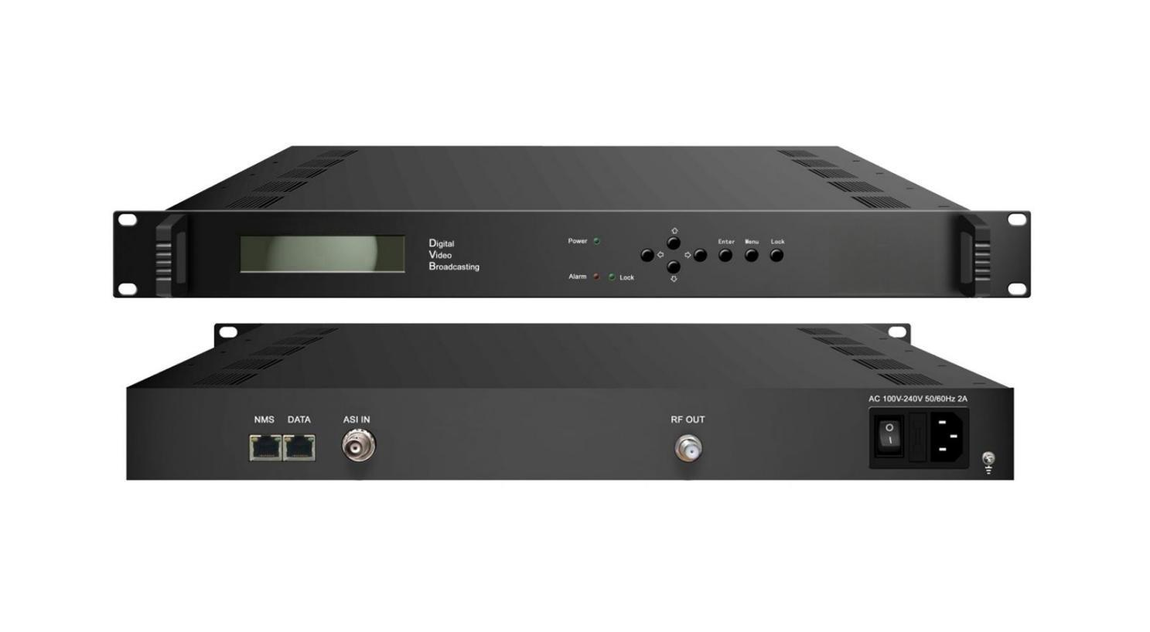Product overview
The FMUSER FUQ-4412B QAM Modulator performs QAM modulation with TS and ASI inputs and RF output. It processes transport streams, applies RS encoding and convolution interlacing, and modulates signals to RF. This device supports local control via LCD/keyboard and remote NMS control. Ideal for broadcasting, interactive services, and news gathering applications.

Key feature

Enables PSI/SI processing with PID filtering, re-mapping, PCR adjustment, and NIT insertion.

Specifications
Input | 1channle ASI input, BNC interface, 75Ω
Modulation | QAM Channel | 1
Modulation | Standard | EN300 429/ITU-T J.83A/B/C
Modulation | Symbol Rate | 5.0~9.0Msps，1ksps stepping
Modulation | Constellation | 16、32、64、128、256QAM
Modulation | FEC | RS(204, 188)
RF Output | Connector | F Type, 75Ω impedance
RF Output | RF Range | 30~1000MHz，1kHzStepping
RF Output | Output Attenuation | -16dBm~+12dBm，0.5dB Stepping
System | LCD/keyboard operating and NMS support
System | English and Chinese interface conversion
System | Ethernet software upgrading
General | Dimension(W*D*H) | 482mm×300mm×44mm
General | Weight | 2.3kg
General | Temperature | 0~45℃(Operation) ; -20~80℃(Storage)
General | Power | AC 110V±10%，50/60Hz； or AC 220V±10%，50/60Hz
General | Consumption | 22W

About Us
FMUSER is a company specializing in broadcasting and television transmission systems and integrating hotel IPTV systems. The company was established in 2009 and has served over 180 countries worldwide. More than 20,000 television stations, radio stations, and hotel clients from different.

Contact:Tomleequan Email：sales@fmuser.com whatsapp: +8613922702227

