FMUSER FUQ-4412C QAM Modulator ASI-IP Input DVB-C 16-256QAM EN300 429-ITU-T J.83A-B-C PID Filtering NIT Insertion for Broadcast Satellite 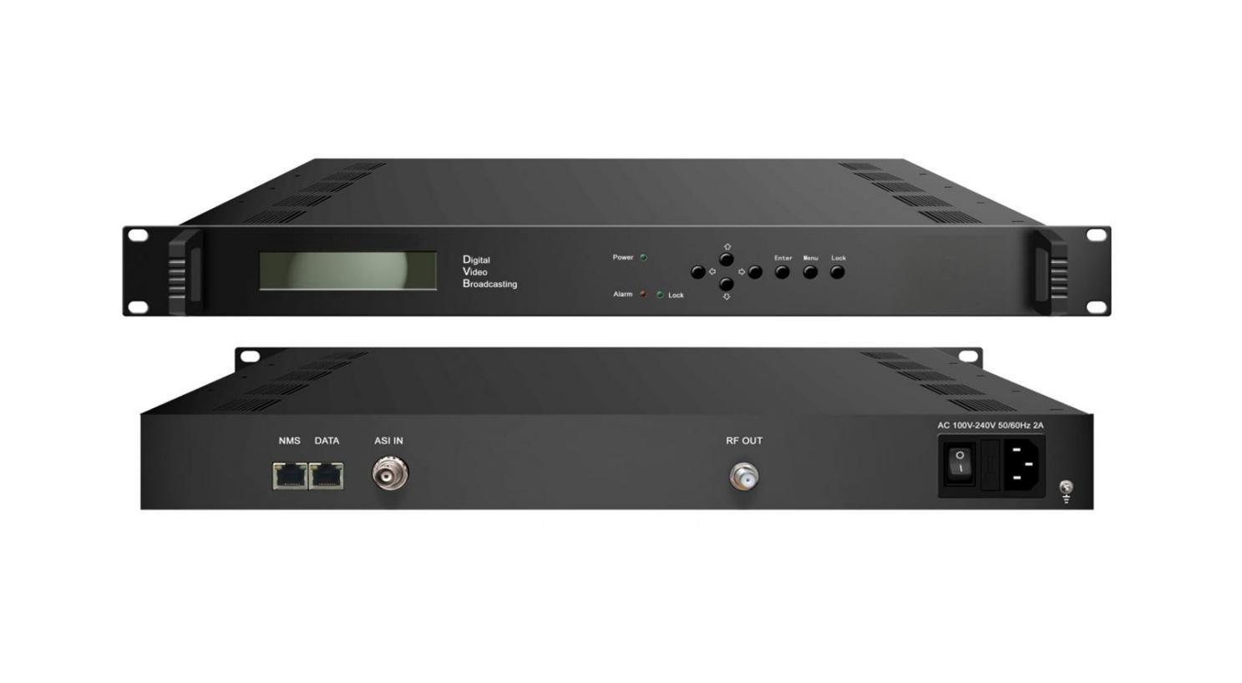Product overview
The FMUSER FUQ-4412C is a QAM modulator supporting ASI and IP inputs for RF output. It processes transport streams with QAM modulation. Features include PID filtering, NIT insertion, and intelligent TS management. Ideal for broadcasting and interactive services.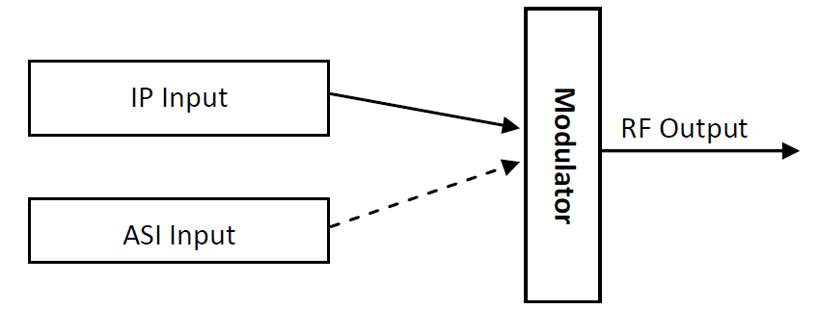
Key feature
Delivers RF output in 30–960 MHz range with 1 kHz stepping and attenuation control.
Specifications
Input | 1 channel ASI input, BNC interface, 75Ω
Input | 1 channel IP (MPTS/SPTS) input over UDP (Unicast/Multicast) (100M Port)
Modulation | QAM Channel | 1
Modulation | Standard | EN300 429/ITU-T J.83A/B/C, GB/T170
Modulation | Symbol Rate | 5.0~7.0Msps，1ksps stepping
Modulation | Constellation | 16/32/64/128/256 QAM
Modulation | FEC | RS (204, 188)
RF Output | Connector | F Type, 75Ω impedance
RF Output | RF Range | 30~960MHz，1kHz Stepping
RF Output | Output Attenuation | -30dBm~0dBm, 0.5dB Stepping
System | LCD/Keyboard operating and web NMS support
System | Ethernet software upgrading
General | Dimension(W*D*H) | 482mm×300mm×44mm
General | Weight | 2.3kg
General | Temperature | 0~45℃(Operation) ; -20~80℃(Storage)
General | Power | AC 110V±10%, 50/60Hz  or AC 220V±10%, 50/60Hz
General | Consumption | 22W

About Us
FMUSER is a company specializing in broadcasting and television transmission systems and integrating hotel IPTV systems. The company was established in 2009 and has served over 180 countries worldwide. More than 20,000 television stations, radio stations, and hotel clients from different.

Contact:Tomleequan Email：sales@fmuser.com whatsapp: +8613922702227

