FMUSER FUQ-4415B DVB-T Modulator 128 IP Inputs 4 Non-Adjacent RF Outputs UDP-RTP DVB-T EN300744 Multiplexing Modulation for DTV Systems 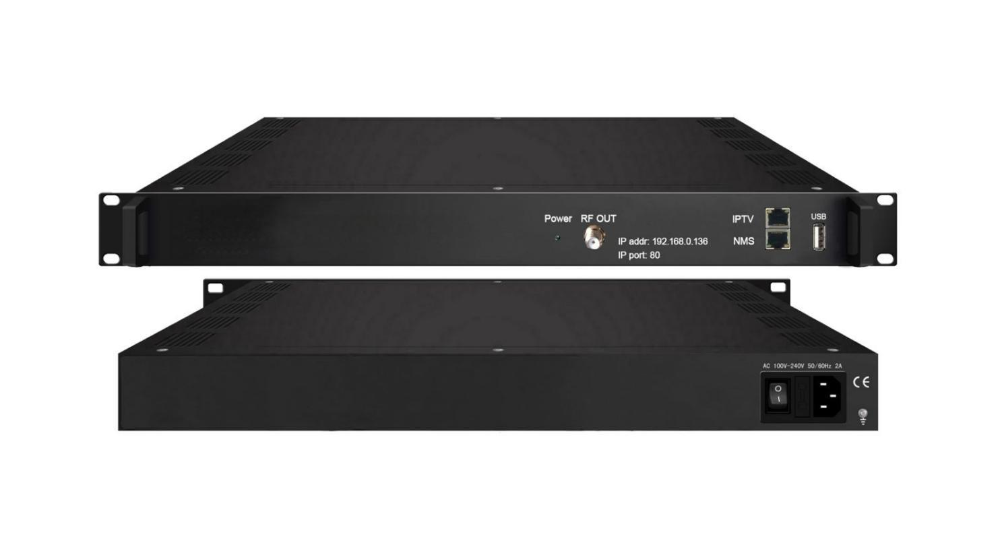Product overview
The FMUSER FUQ-4415B is a DVB-T modulator with 128 IP inputs over UDP/RTP and outputs 4 DVB-T carriers and 4 MPTS streams. It integrates multiplexing and modulating functions for efficient signal processing. Features web-based NMS management for easy control. Ideal for DTV broadcasting systems, providing reliable transmission in modern headend setups.
Key feature
Enables web-based NMS management for monitoring and configuration.
Principle Chart
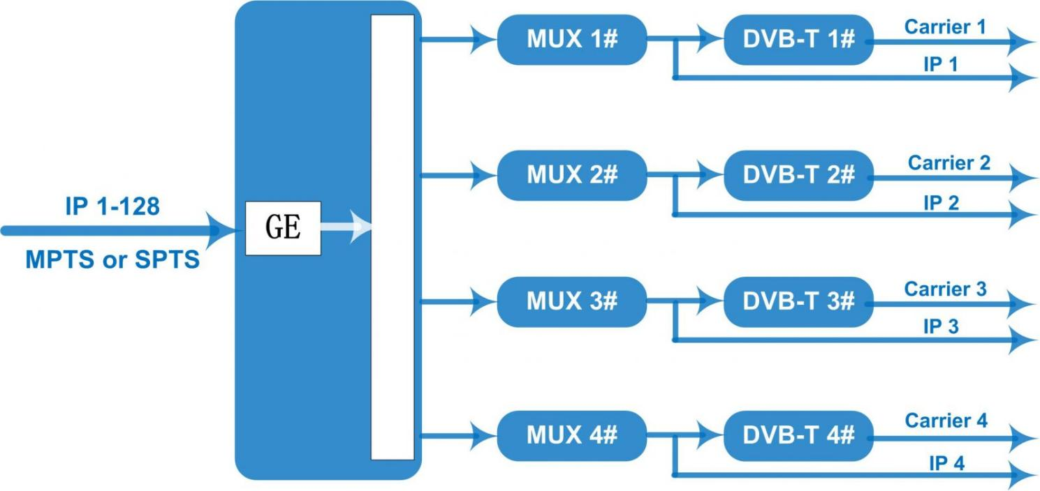

Specifications
Input | 128 IP(SPTS/MPTS) input over UDP and RTP, RJ45, 1000M/100M, Unicast/Multicast
Multiplexing | Maximum PID Remapping | 256 per input channel
Multiplexing | Function | PID Remapping
Multiplexing | Function | Accurate PCR adjusting
Multiplexing | Function | Generate PSI/SI table automatically
Modulation | DVB-T | Standard | EN300744
Modulation | DVB-T | FFT mode | 2K
Modulation | DVB-T | Bandwidth | 6M, 7M, 8M
Modulation | DVB-T | Constellation | QPSK, 16QAM, 64QAM
Modulation | DVB-T | Guard Interval | 1/4, 1/8, 1/16, 1/32
Modulation | DVB-T | FEC | 1/2, 2/3, 3/4, 5/6, 7/8
Modulation | DVB-T | MER | ≥42 dB
Modulation | DVB-T | RF frequency | 50~960MHz, 1KHz step
Modulation | DVB-T | RF out | 1 RF port
Modulation | DVB-T | RF out | 4*DVB-T non-adjacent carriers combined output , 40M total bandwidth limitation
Modulation | DVB-T | RF output level | -28~ -3 dBm, 0.1db step
Stream Out | 4*MPTS over UDP and RTP out (RJ45, 1000M/100M Unicast/Multicast)
System | LCD/Keyboard operating and web-based NMS support
System | Ethernet software upgrading
General | Dimension  (W*D*H) | 482mm×300mm×44.5mm
General | Temperature | 0~45℃(Operation) ; -20~80℃(Storage)
General | Power supply | AC 100V±1050/60Hz; AC 220V±10%, 50/60HZ

About Us
FMUSER is a company specializing in broadcasting and television transmission systems and integrating hotel IPTV systems. The company was established in 2009 and has served over 180 countries worldwide. More than 20,000 television stations, radio stations, and hotel clients from different.

Contact:Tomleequan Email：sales@fmuser.com whatsapp: +8613922702227

