FMUSER FUQ-4415EF Transmodulator 4 Tuner Inputs DVB-S-S2-S2X DVB-C-T-T2-ISDB-T Input 4 DVB-C RF 2 DVB-T RF Outputs BISS Descrambling PID Pass-Through Broadcast Cable TV Redistribution
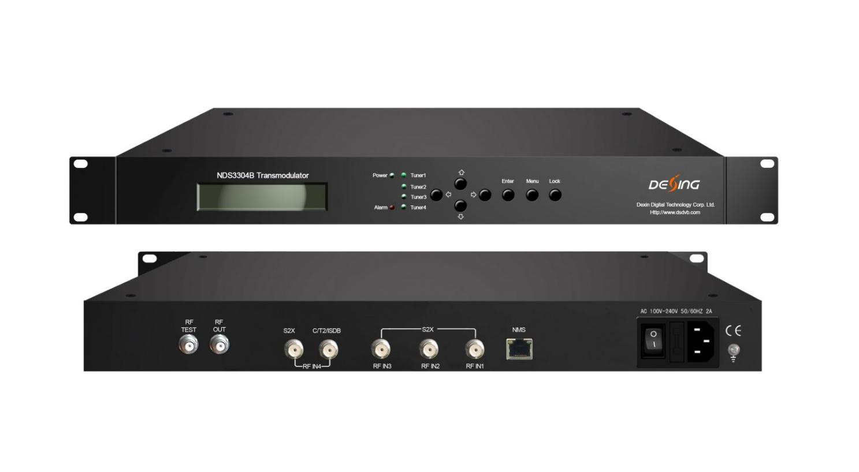Product overview
The FMUSER FUQ-4415EF is a transmodulator with 4 tuner inputs for DVB-S/S2/S2X or DVB-C/T/T2/ISDB-T standards, and outputs 4 DVB-C RF or 2 DVB-T RF signals. It demodulates, re-multiplexes, and modulates signals with embedded BISS descrambling for secure processing. This unit features LCD/keyboard control and web-based NMS for operations and upgrades. Ideal for broadcast, cable TV distribution, and secure content redistribution.
Key Features
Integrated demodulating, re-multiplexing, BISS descrambling, and modulating in one unit.
Supports 4 tuner inputs for DVB-S/S2/S2X or DVB-C/T/T2/ISDB-T standards.
Provides 4 DVB-C RF or 2 DVB-T RF outputs for versatile distribution.
Enables PID pass-through for seamless program identifier transmission.
Features LCD/keyboard and web-based NMS for control and upgrades.Supports 4 tuner inputs for DVB-S/S2/S2X or DVB-C/T/T2/ISDB-T standards.
Provides 4 DVB-C RF or 2 DVB-T RF outputs for versatile distribution.
Enables PID pass-through for seamless program identifier transmission.
Features LCD/keyboard and web-based NMS for control and upgrades.

Principle Chart
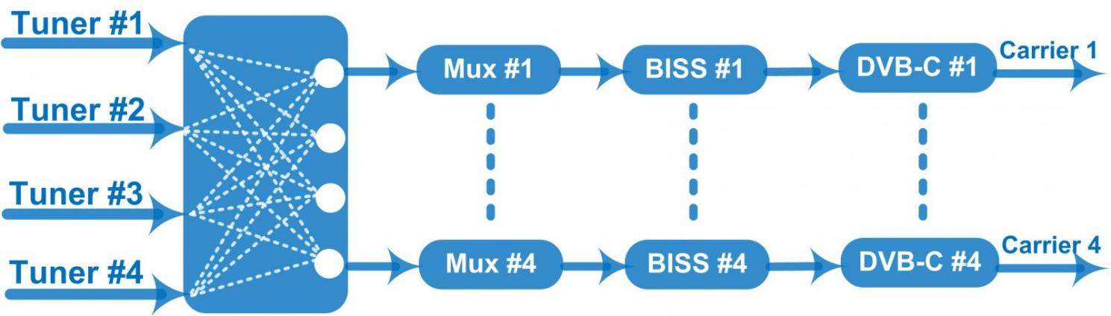
4 DVB-C RF Out

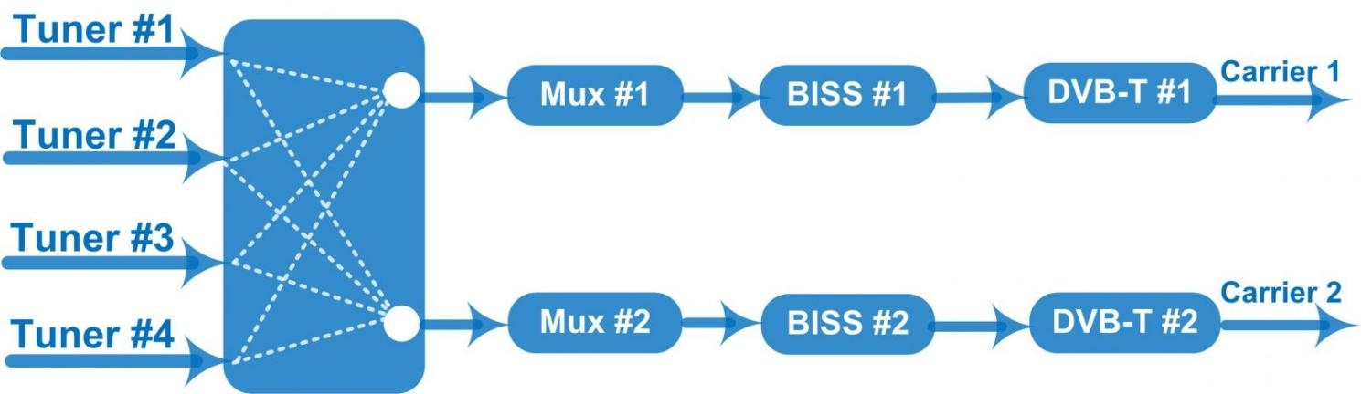
2 DVB-T RF Out

Specifications
Input |  | 4 Tuner input (3*DVB-S/S2/S2X+1*DVB-S/S2/S2X or 1*DVB-C/T/T2/ISDB-T)
Tuner Section | Multi-mode tuners switchable | DVB-C | Input Frequency |  |  | 60 MHz~890 MHz
Tuner Section | Multi-mode tuners switchable | DVB-C | Standard |  |  | J.83A (DVB-C), J.83C | J.83B
Tuner Section | Multi-mode tuners switchable | DVB-C | Constellation |  |  | 16/32/64/128/256 QAM | 64/256 QAM
Tuner Section | Multi-mode tuners switchable | DVB-T/T2 | Input Frequency |  |  | 60 MHz~890 MHz
Tuner Section | Multi-mode tuners switchable | DVB-T/T2 | Bandwidth |  |  | 5/6/7/8 M bandwidth
Tuner Section | Multi-mode tuners switchable | ISDB-T | Input Frequency |  |  | 60 MHz~890 MHz
Tuner Section |  | DVB-S | Input Frequency |  |  | 950-2150MHz
Tuner Section |  | DVB-S | Symbol rate |  |  | QPSK: 0.5~45 Msps
Tuner Section |  | DVB-S | FEC Demodulation |  |  | 1/2, 2/3, 3/4, 5/6, 7/8
Tuner Section |  | DVB-S | Max input bitrate |  |  | ≤140 Mbps
Tuner Section |  | DVB-S2 | Input Frequency |  |  | 950-2150MHz
Tuner Section |  | DVB-S2 | Symbol rate |  |  | QPSK/8PSK/16APSK: 0.5~45 Msps;  32APSK: 0.5~40 Msps
Tuner Section |  | DVB-S2 | FEC Demodulation |  |  | QPSK: 1/2, 3/5, 2/3, 3/4, 4/5, 5/6, 8/9, 9/10  8PSK: 3/5, 2/3, 3/4, 5/6, 8/9, 9/10  16APSK: 2/3, 3/4, 4/5, 5/6, 8/9, 9/10  32APSK: 3/4, 4/5, 5/6, 8/9, 9/10
Tuner Section |  | DVB-S2 | Max input bitrate |  |  | ≤140 Mbps
Tuner Section |  | DVB-S2X | Input Frequency |  |  | 950-2150MHz
Tuner Section |  | DVB-S2X | Symbol rate |  |  | QPSK/8PSK/16APSK: 0.5~45 Msps;  8APSK: 0.5~40Msps;  32APSK: 0.5~40Msps
Tuner Section |  | DVB-S2X | FEC Demodulation |  |  | QPSK: 1/2, 3/5, 2/3, 3/4, 4/5, 5/6, 8/9, 9/10, 13/45, 9/20, 11/20  8PSK: 3/5, 2/3, 3/4, 5/6, 8/9, 9/10, 23/36, 25/36, 13/18  8APSK: 5/9-L, 26/45-L  16APSK: 2/3, 3/4, 4/5, 5/6, 8/9, 9/10,1/2-L, 8/15-L, 5/9-L, 26/45, 3/5, 3/5-L, 28/45, 23/36, 2/3-L, 25/36, 13/18, 7/9, 77/90  32APSK: 3/4, 4/5, 5/6, 8/9, 9/10, 2/3-L, 32/45, 11/15, 7/9
Tuner Section |  | DVB-S2X | Max input bitrate |  |  | ≤140 Mbps
Multiplexing |  | Maximum PID Remapping | 128 per input channel
 |  | Function | PCR accurate adjusting
 |  | Function | Generate PSI/SI table automatically
 |  | Function | PID Remapping
BISS Descrambling |  | Mode 1, Mode E (Up to 60Mbps) (descramble individual program)
Modulation |  | DVB-C | Standard |  | J.83A (DVB-C), J.83B, J.83BC
 |  | DVB-C | Constellation |  | .83A | J.83B | J.83C
 |  | DVB-C |  |  | 16/32/64/128/256QAM | 64/256 QAM | 64/256 QAM
 |  | DVB-C | Bandwidth |  | 8M | 6M | 6M
 |  | DVB-C | MER |  | ≥43dB
 |  | DVB-C | Symbol rate |  | 5.000~7.000Msps adjustable
 |  | DVB-C | RF Out |  | F typed, 75Ω impedance
 |  | DVB-C |  |  | 4*DVB-C RF output (adjacent carriers)
 |  | DVB-C | RF frequency |  | 50~960MHz, 1KHz step
 |  | DVB-C | RF output level |  | -20~ -5dBm, 1 dBm step
 |  | DVB-C | Output Bitrate |  | Max 51.6 Mbps per channel
 |  | DVB-T | Standard |  | EN300744
 |  | DVB-T | Constellation |  | QPSK, 16QAM, 64QAM
 |  | DVB-T | Bandwidth |  | 6M, 7M, 8M
 |  | DVB-T | MER |  | ≥42 dB
 |  | DVB-T | Guard Interval |  | 1/4, 1/8, 1/16, 1/32
 |  | DVB-T | FFT mode |  | 2K,4K, 8K
 |  | DVB-T | MER |  | ≥42 dB
 |  | DVB-T | Code Rate |  | 1/2, 2/3, 3/4, 5/6, 7/8
 |  | DVB-T | RF out |  | F typed, 75Ω impedance
 |  | DVB-T |  |  | 2*DVB-T RF output
 |  | DVB-T | RF frequency |  | 30~999.999MHz, 1KHz step
 |  | DVB-T | RF output Level |  | -20~-5 dBm, 1 dBm step
 |  | DVB-T | Output Bitrate |  | Max 31.668Mbps per channel
System |  | LCD/keyboard and web management
 |  | Language: English
 |  | upgrade via Web
General |  | Dimension (W×L×H) |  | 482mm×180mm×44mm
 |  | Approx weight |  | 4 kg
 |  | Environment |  | 0~45℃(Work)；-20~80℃（Storage）
 |  | Power requirements |  | 100~240VAC, 50/60Hz

About Us
FMUSER is a company specializing in broadcasting and television transmission systems and integrating hotel IPTV systems. The company was established in 2009 and has served over 180 countries worldwide. More than 20,000 television stations, radio stations, and hotel clients from different.

Contact:Tomleequan Email：sales@fmuser.com whatsapp: +8613922702227

