FMUSER FUQ-4417 IP to ISDB-T Modulator 4 IP Inputs-4 IP Outputs 1000M Ethernet ARIB STD-831 Dual Adjacent Carriers PID Remapping Broadcast Headend
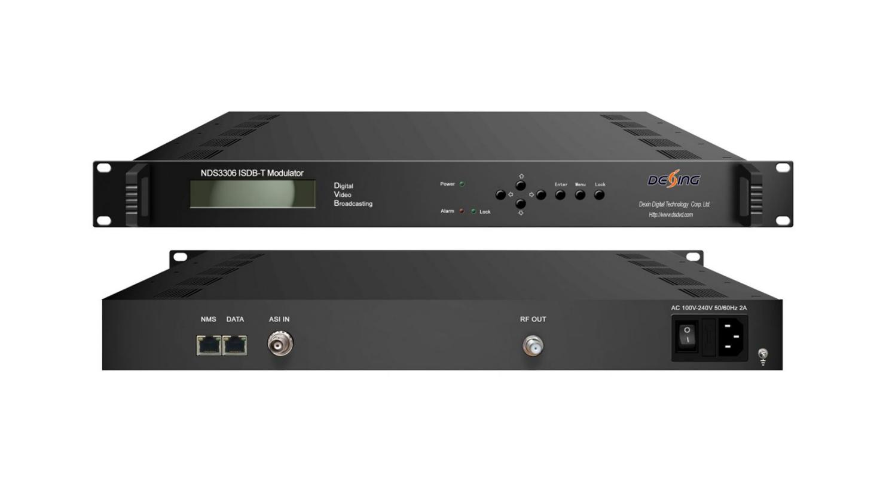Product overview
The FMUSER FUQ-4417 is an IP to ISDB-T modulator that processes 4 IP streams input and output via 1000M port, delivering multiplexed RF output. It modulates IP streams into ISDB-T signals compliant with ARIB STD-831. Control is available through web-based NMS and a front-panel LCD/keyboard. Ideal for broadcast transmission in television and radio industries.
Key feature
- Supports ARIB STD-831 compliance for reliable broadcasting.
- Handles 4 IP streams input/output via 1000M port.
- Delivers multiplexed RF output with dual adjacent carriers and 30–1000MHz/1kHz tuning.
- Features PID remapping and modulation options from DQPSK to 64QAM.
- Offers dual control interfaces: front-panel LCD/keyboard and web-based NMS.

Principle Chart
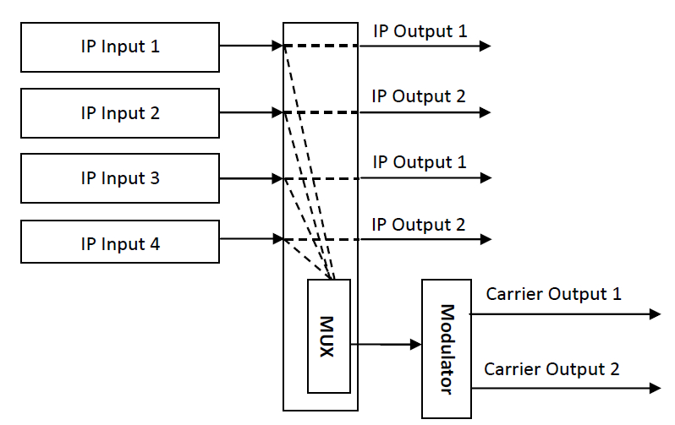

Key feature
* Complying with ARIB STD-831 standard
* 1000M IP port, 4 IP streams input
* Support 4 IP output
* Programs output through RF with multiplexing
* Dual adjacent carriers output
* RF Output frequency range: 30MHz~1000MHz in 1 kHz step
* Support PID remapping
* LCD/keyboard and Web-based NMS operation

Specifications
IP Input | 4* IP (MPTS/SPTS) input over UDP (Unitcast/Multicast) (1000M port based Ethernet)
IP Input | IGMP Snooping: v2, v3
RF Output | Standard |  | ARIB STD-B31
RF Output | Bandwidth |  | 6M
RF Output | Constellation |  | DQPSK, QPSK, 16QAM, 64QAM
RF Output | Guard Interval |  | 1/32, 1/16, 1/8, 1/4.
RF Output | Transmission Mode |  | 2K, 4K, 8K
RF Output | FEC |  | 1/2, 2/3, 3/4, 5/6, 7/8
RF Output | MER |  | ≥42dB
RF Output | Output |  | 30~1000MHz, 1KHz step
RF Output | RF output level |  | -30~ -10dbm (77~97 dbµV), 0.1db step
IP Output | 4*IP output, one for one with the 4 IP input
System | LCD/keyboard operating and Web-based NMS support
System | Ethernet software upgrading
General | Dimension | 482mm×300mm×44mm (W*D*H)
General | Weight | 2.3kg
General | Temperature | 0~45℃(Operation); -20~80℃(Storage)
General | Power | AC 110V±10%, 50/60Hz; or AC 220V±10%, 50/60Hz
General | Consumption | 25W

About Us
FMUSER is a company specializing in broadcasting and television transmission systems and integrating hotel IPTV systems. The company was established in 2009 and has served over 180 countries worldwide. More than 20,000 television stations, radio stations, and hotel clients from different.

Contact:Tomleequan Email：sales@fmuser.com whatsapp: +8613922702227

