FMUSER FUQ-4417J ISDB-T Modulator 24-48 Channels IP to RF Conversion 1024 IP Input ARIB STD-B31 Web-Based NMS Digital TV Broadcast Systems
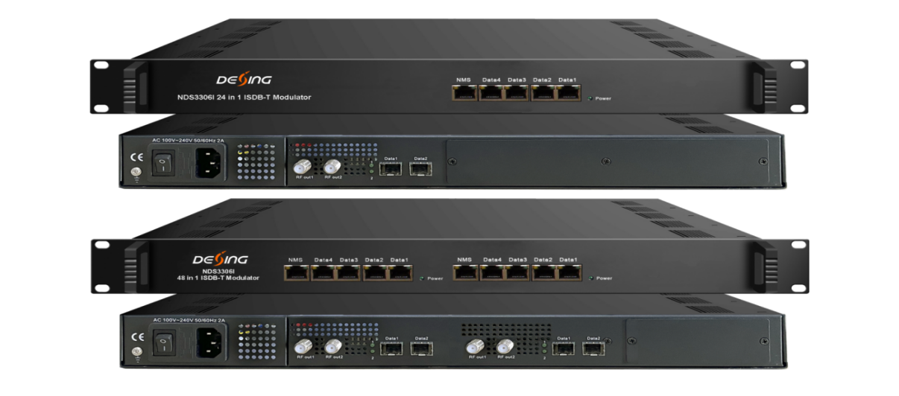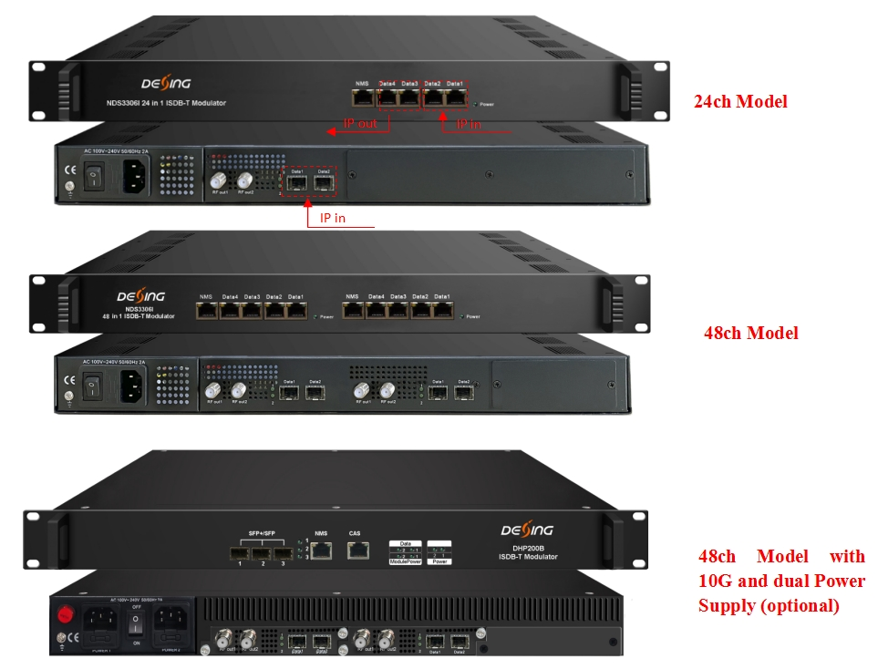
Product Overview
The FMUSER FUQ-4417J is a high-density ISDB-T modulator converting IP streams to 24/48 RF carriers (50-960MHz) through 4xRJ45 and 2xSFP ports. It processes transport streams with PID remapping and PCR correction, featuring web-based control and 1U rack-mount design. Ideal for digital TV headends, cable network upgrades, and multiscreen distribution systems requiring simultaneous RF/IP output.
Key feature
Centralized management via web-based NMS with real-time monitoring
Inner Principle Chart - (24 carriers out per daughter card):
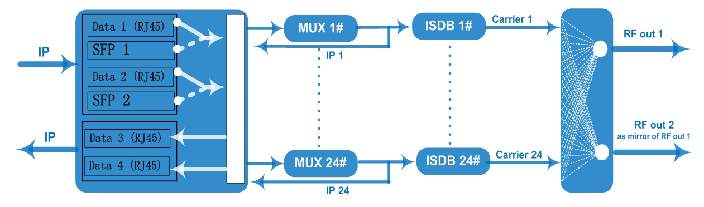
Carrier Setting Illustration
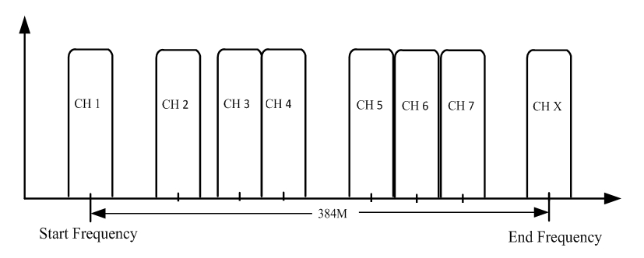

Specifications
Input | Input | Max 1024 IP input through data ports 1 & 2， 100/1000M Ethernet Ports per daughter card (RJ45 and SFP interface alternative)
Input | Transport Protocol | TS over UDP/RTP, unicast and multicast, IGMP V2/V3
Input | Transmission Rate | Max 840Mbps for each GE input
Mux | Input Channel | 1024 IP streams
Mux | Output Channel | 24 (or 48)
Mux | Max PIDs | 256 per channel
Mux | Functions | PID remapping (auto/manually optional)
Mux | Functions | PCR accurate adjusting
Mux | Functions | PSI/SI table automatically generating
Modulation  Parameters | Standard | ARIB STD-B31
Modulation  Parameters | Bandwidth | 6M
Modulation  Parameters | Constellation | QPSK, 16QAM, 64QAM
Modulation  Parameters | Guard Interval | 1/32, 1/16, 1/8, 1/4
Modulation  Parameters | Transmission Mode | 2K, 4K, 8K
Modulation  Parameters | Code rate | 1/2, 2/3, 3/4, 5/6, 7/8
Modulation  Parameters | MER | ≥40dB
Modulation  Parameters | RF frequency | 50~960MHz, 1KHz step
Modulation  Parameters | RF output level | -20dBm~+10dBm(87~117dbµV), 0.1dB stepping
Modulation  Parameters | Output Channel | 24 (or 48) non-adjacent carriers output
RF Output | Interface | 2 F type port mirror out, 75Ω impedance - 24ch model  4 F type port (with 2 ports located in each daughter card), 75Ω impedance - 48ch model
RF Output | ACLR | -50 dBc
IP output | 24 (or 48) IP output over UDP/RTP/RTSP through data ports 3&4, unicast/multicast, 100/1000M Ethernet Ports
System | Web-based NMS management
General | Demission | 480mm×327mm×44.5mm (WxLxH)
General | Weight | 5.5kg
General | Temperature | 0~45℃(operation), -20~80℃(storage)
General | Power Supply | AC 100V±10%, 50/60Hz or AC 220V±10%, 50/60Hz

Order Guide
 | 24ch Model | 48ch Model
1024 IP input to 24ch ISDB-T carriers out, 24 IP out (with single card) | x
1024 x2 IP input to 24ch x2 ISDB-T carriers out,  24 x2 IP out (with two daughter cards) |  | x
10G Ethernet | As per order | As per order
Dual Power Supply | As per order | As per order

About Us
FMUSER is a company specializing in broadcasting and television transmission systems and integrating hotel IPTV systems. The company was established in 2009 and has served over 180 countries worldwide. More than 20,000 television stations, radio stations, and hotel clients from different.

Contact:Tomleequan Email：sales@fmuser.com whatsapp: +8613922702227

