FMUSER FUQ-4417K ISDB-Tb Modulator 8-16 Non-Adjacent Carrier Output 512-1024 IP Input UDP-RTP-RTSP Output ARIB STD-B31 Advanced TS Processing DTV Broadcasting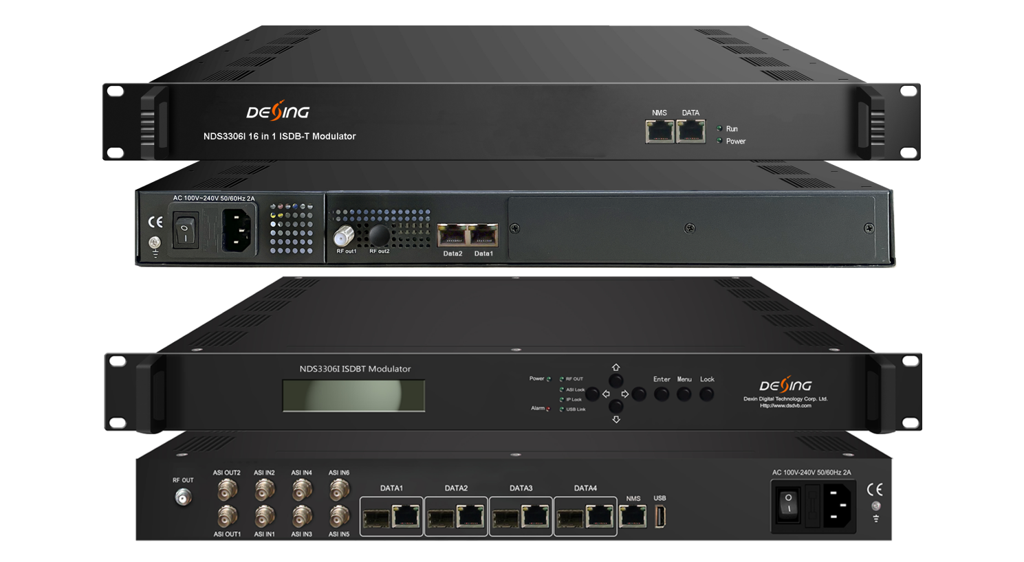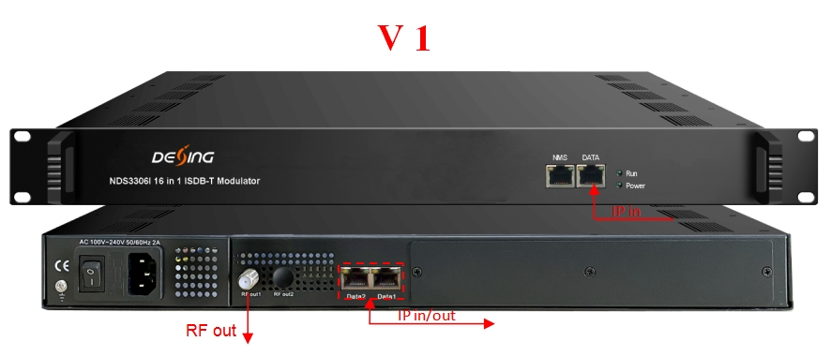
* 3 GE ports for IP input and output
* Support 8 (or 16) multiplexed TS over UDP/RTP/RTSP output
* 8 (or 16) non-adjacent carriers output, compliant to ISDB-Tb (ARIB STD-B31)
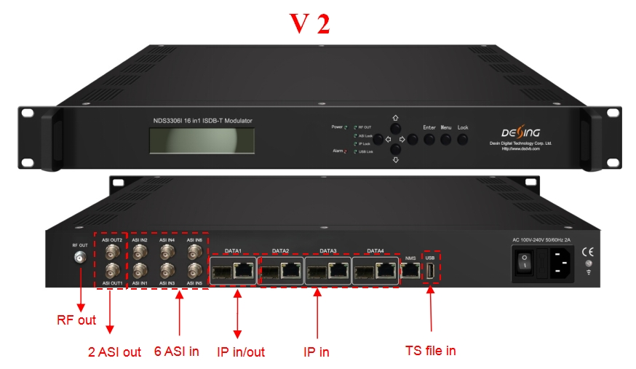
* GE/SFP port alternative, with Data1 bi-directional for data in/out, and Data2-4 one-way for data in
* Supports 6 ASI input and 2 ASI output as mirror, TS file input through USB disk
* Support 8 (or 16) multiplexed TS over UDP/RTP/RTSP output
* 8 (or 16) ISDB-T non-adjacent carriers output, compliant to ARIB STD-B31 standard

Product Overview
The FMUSER FUQ-4417B converts IP streams into 8 or 16 non-adjacent carriers compliant with ARIB STD-B31. It performs modulation for ISDB-Tb broadcasting. Featuring web-based network management for centralized control. Ideal for DTV broadcasting systems and next-gen applications.
Key feature
Supports 8/16 non-adjacent carriers output compliant with ISDB-Tb (ARIB STD-B31).
Delivers 840Mbps throughput per GE input port with SFP/GE alternatives.
Features advanced signal processing including PID remapping, PSI/SI editing, and PCR adjusting.
Provides web-based network management for centralized control.
Offers multi-input support with 6 ASI inputs, USB TS file ingestion, and UDP/RTP/RTSP outputs.
Inner Principle Chart
(V 1, 8ch or 16ch out for option)
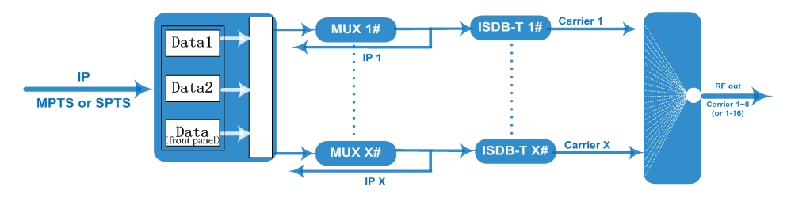

(V 2, 8ch or 16ch out for option)
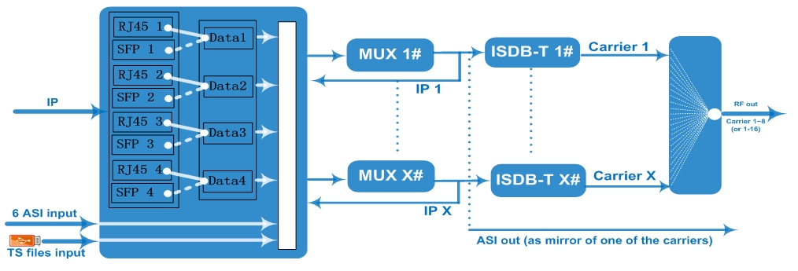

Carrier Setting Illustration:
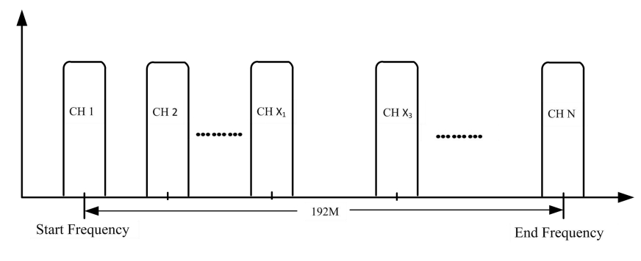

Specifications
Input | Input | Max 512 (or 1024) IP input through 100/1000M Ethernet Port (SFP interface optional) over UDP/RTP, unicast and multicast, IGMP V2/V3, Max 840Mbps for each GE input
Input | Input | 6 ASI input, BNC interface - for V2 only
Input | Input | TS file input through USB disk - for V2 only
Mux | Input Channel | 512 (or 1024)
Mux | Output Channel | 8 (or 16)
Mux | Max PIDs | 256 per channel
Mux | Functions | PID remapping (auto/manually optional)
Mux | Functions | PCR accurate adjusting
Mux | Functions | PSI/SI table automatically generating
Modulation  Parameters | Standard | ARIB STD-B31
Modulation  Parameters | Bandwidth | 6M
Modulation  Parameters | Constellation | QPSK, 16QAM, 64QAM
Modulation  Parameters | Guard Interval | 1/32, 1/16, 1/8, 1/4
Modulation  Parameters | Transmission Mode | 2K, 4K, 8K
Modulation  Parameters | Code rate | 1/2, 2/3, 3/4, 5/6, 7/8
Modulation  Parameters | MER | ≥40dB
Modulation  Parameters | RF frequency | 50~960MHz, 1KHz step
Modulation  Parameters | RF output level | -20dBm~+10dBm(87~117dbµV), 0.1dB stepping
Modulation  Parameters | Output Channel | 8 (or 16) non-adjacent carriers output
RF Output | Interface | 1 F type port, 75Ω impedance
RF Output | ACLR | -50 dBc
TS output | 8 (or 16) IP output over UDP/RTP/RTSP, unicast/multicast  100/1000M Ethernet Ports
TS output | 2 ASI output, one as mirror - for V2 only
System | Web-based NMS management;  LCD+Keyboard management - for V2 only
General | Demission | 480mm×327mm×44.5mm (WxLxH)
General | Weight | 5.5kg
General | Temperature | 0~45℃(operation), -20~80℃ (storage)
General | Power Supply | AC 100V±10%, 50/60Hz or AC 220V±10%, 50/60Hz

Order Guide:
 | V1 |  | V2
 | 8ch model | 16ch model | 8ch model | 16ch model
512 IP input to 8ch ISDB-T carriers out, 8 IP out | x |  | x
1024 IP input to 16ch ISDB-T carriers out, 16 IP out |  | x |  | x
6 ASI input, and TS files input by USB disk |  |  | x | x
2 ASI mirror out |  |  | x | x
LCD+Keyboard management |  |  | x | x

About Us
FMUSER is a company specializing in broadcasting and television transmission systems and integrating hotel IPTV systems. The company was established in 2009 and has served over 180 countries worldwide. More than 20,000 television stations, radio stations, and hotel clients from different.

Contact:Tomleequan Email：sales@fmuser.com whatsapp: +8613922702227

